The candidates listed here represent the Statewide Offices of:
- Governor
- Lieutenant Governor
- Attorney General
Other candidates listed represent those for election on the southside of Hampton Roads and the cities of South Hampton Roads.
Endorsed REALTOR® Champions are identified by a ✓ and a RED * and are most likely to support REALTOR® issues, our industry, and your business.

Contact Government Affairs: GAD@hrra.com

Voter Guide 2025

GOVERNOR:
LOCAL ELECTIONS 2025
ELECTION 2025 IN SOUTH HAMPTON ROADS IS FOR CONSTITUTIONAL OFFICES ONLY.
COMMISSIONER OF THE REVENUE
cOMMONWEALTH’S aTTORNEY
sHERIFF
tRESURER

Please note: These elections are for Chesapeake, Norfolk, and Virginia Beach.


Winsome Earl Sears (R) Abigail Spanberger(D)

LIEUTENANT GOVERNOR:
John Reid (R)
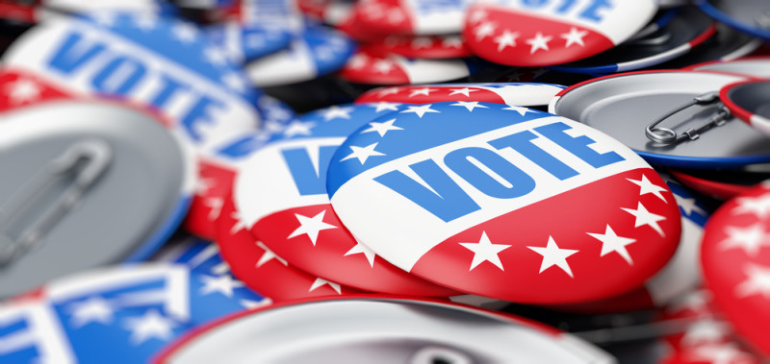
Ghazala Hashmi (D)
Marlow Jones (I)

ATTORNEY GENERAL
Jason Miyares (R)
Jay Jones (D)

HOUSE OF DELEGATES
Nadarius Clark (D-84)
Felisha Storm (R-84)
- Don Scott (D-88) *
Karen Robbins Carnegie (D-89)
Michael Lamonea (R-89)
Rodney Nickens (D-90)
- Jay Leftwich (R-90) *
- Cliff Hayes (D-91)
Bonita Anthony (D-92)
- Jackie Glass (D-93) *
Phil Hernandez (D-94)
Andrew Pittman (R-94)
- Alex Askew (D-95) *
Kelly Convirs-Fowler (D-96)
Kyle Pasquarella (R-96)
- Michael Feggans (D-97) *
Tim Anderson (R-97)
Cheryl Smith (D-98)
- Barry Knight (R-98)*
Cathy Porterfield (D-99)
- Anne Ferrell Tata (R-99) *
Elizabeth Willis Richards (D-100)
- Robert Bloxom (R-100) *

