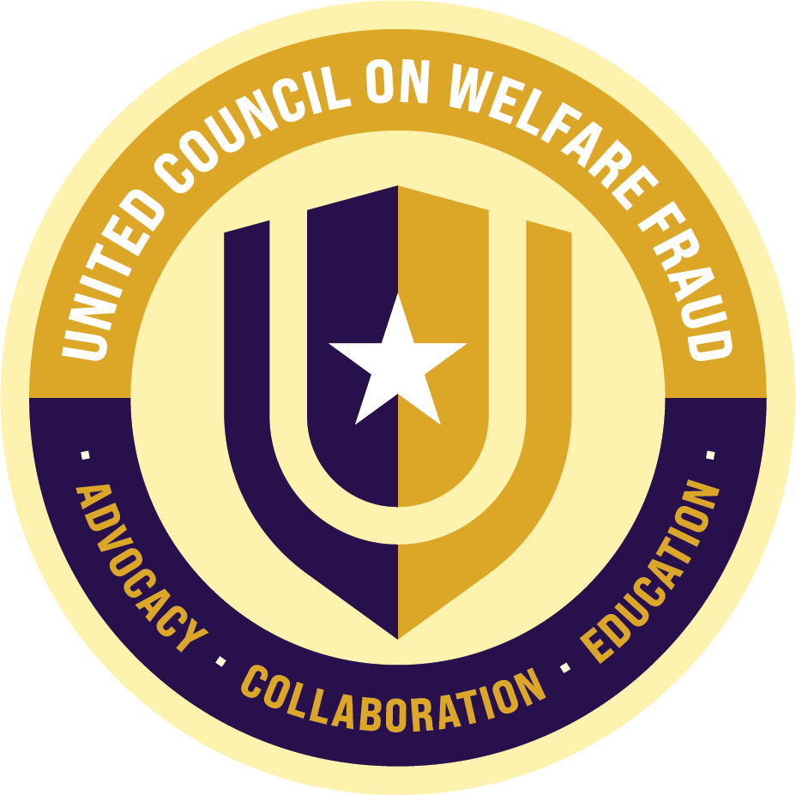

OMNI William Penn hotel – 530 WILLIAM PENN PLACE, PITTSBURGH, pa
UCOWF 53RD NATIONAL TRAINING Conference  SEPTEMBER 1 – 3, 2026 |   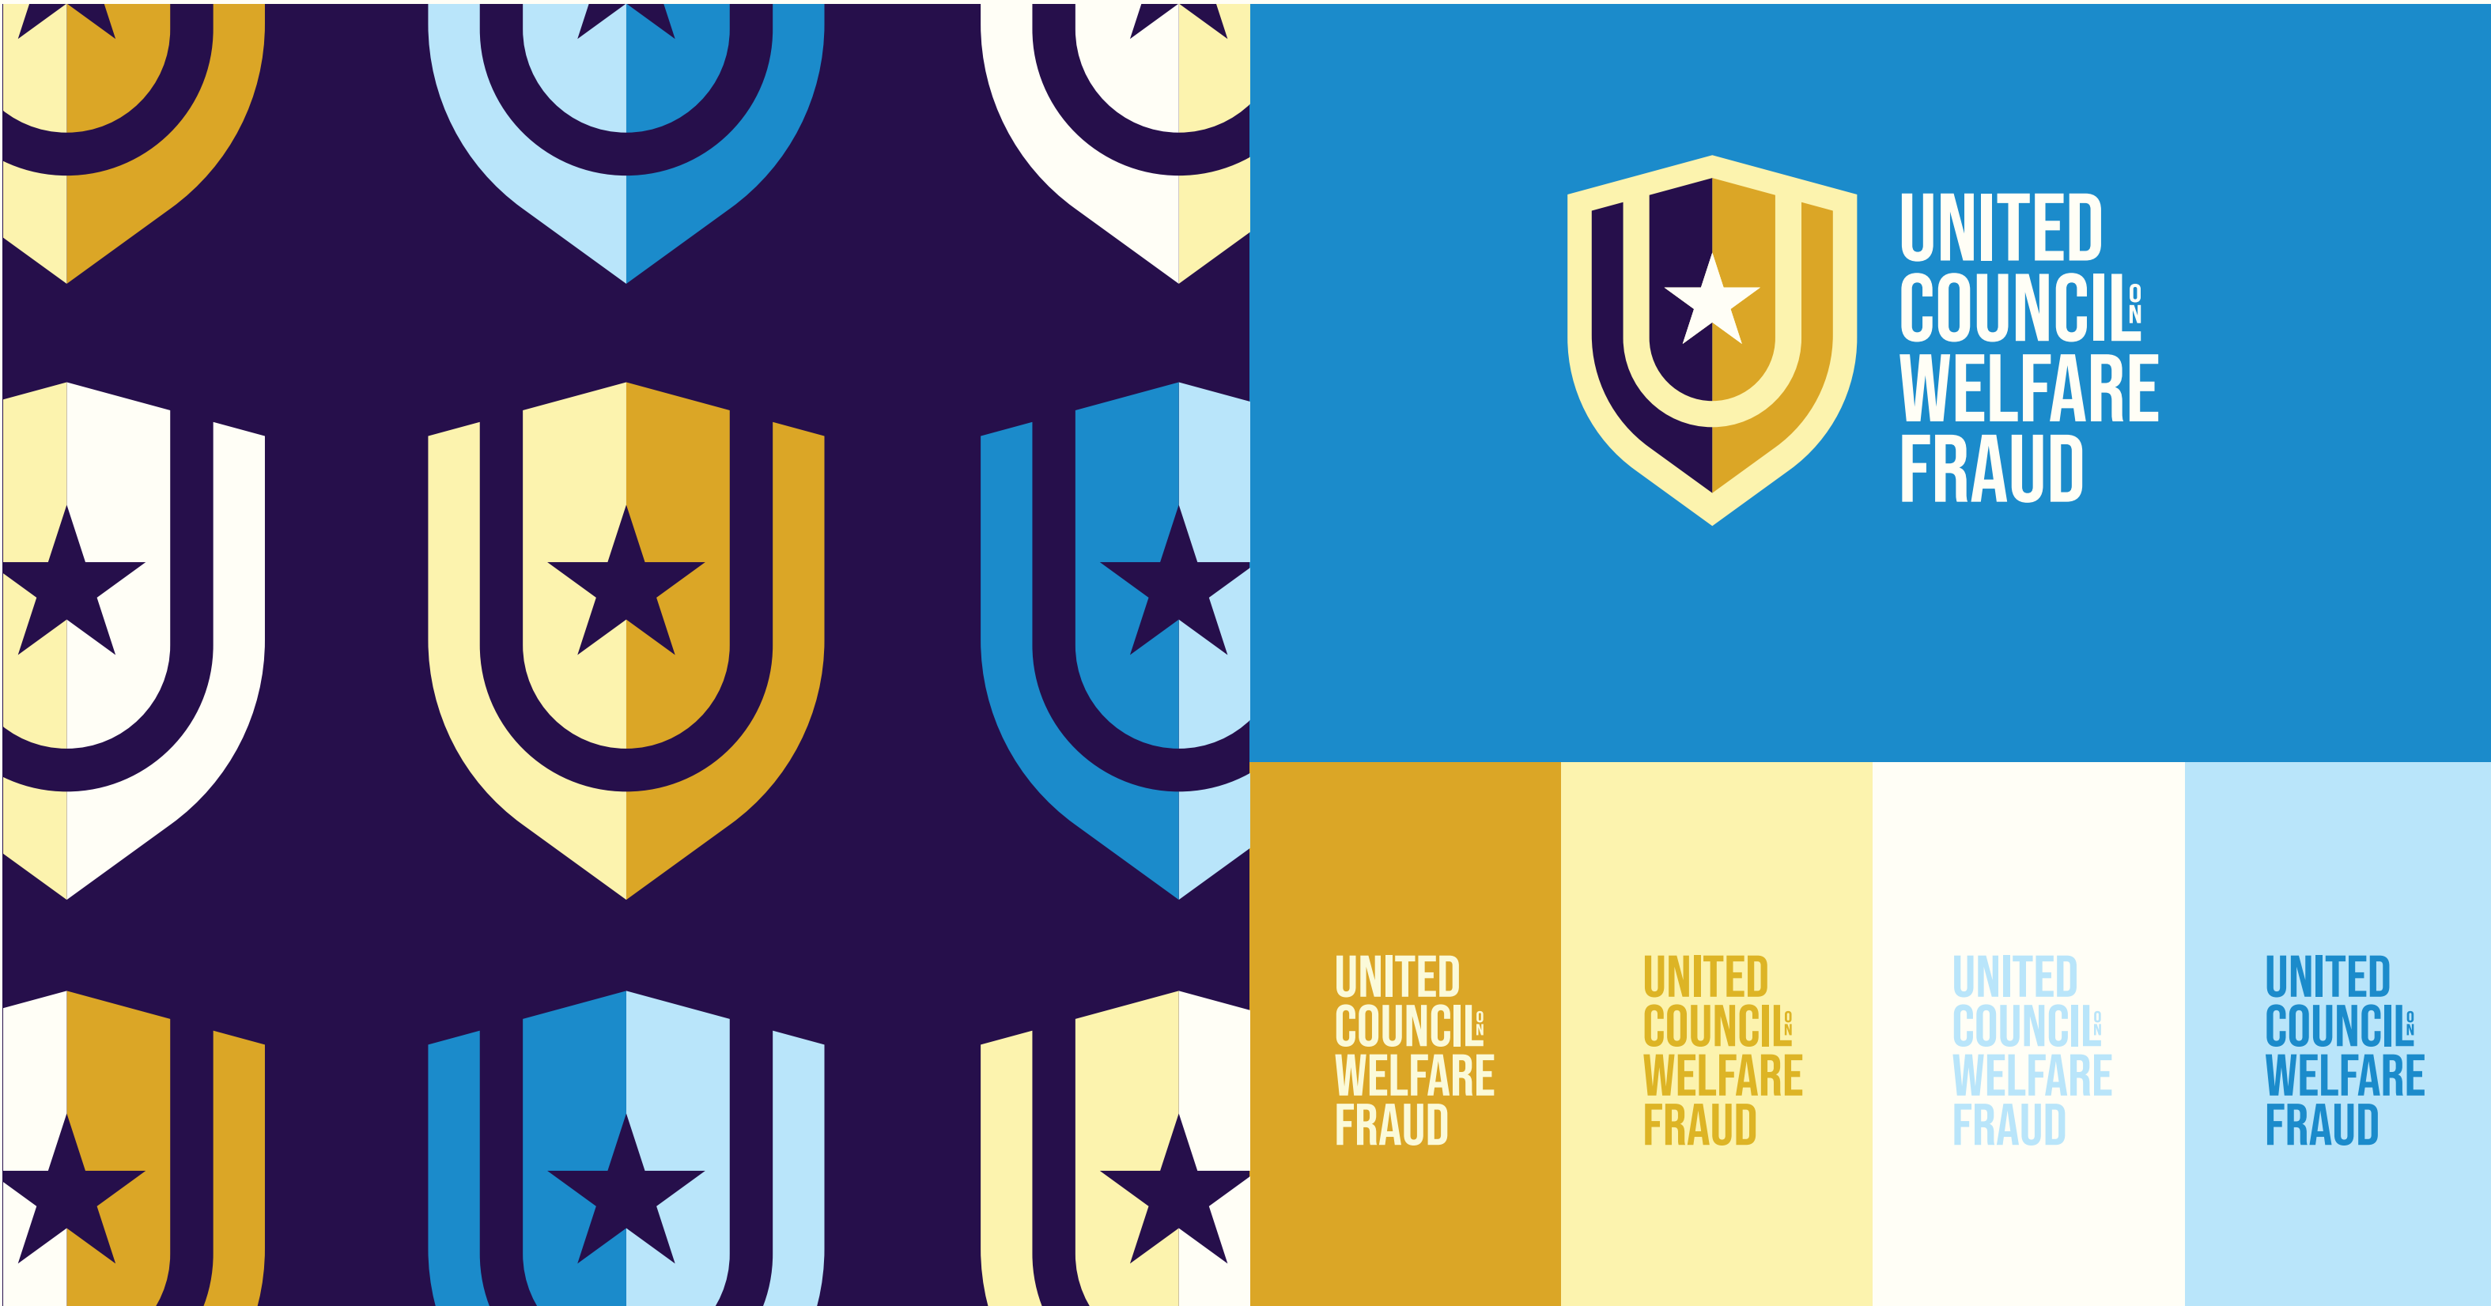  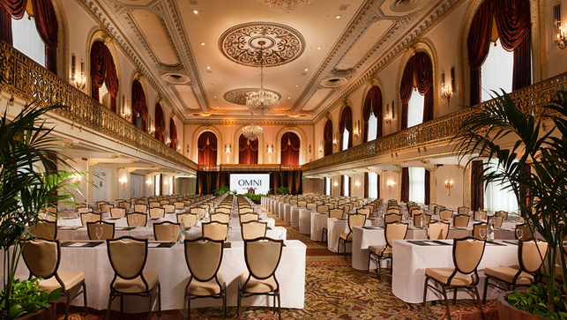  the Special government per diem Room Rate of $136 per night (plus 14% tax) is available only to conference attendees, participants, and ucowf guests.  For more information, call 785 447-5424  United council on welfare fraud, inc., po box 164 Westmoreland, ks 66549
Registration Opens
DECEMBER 1, 2026
ucowf.net/national-conference/
Featuring: 18 hours of specific training to combat welfare fraud ● Certification testing ● Networking opportunities ● Annual UCOWF Awards luncheon ● Board of Directors elections ● hear from federal program officials ● Q&A with partners and congressional representatives
For more information contact the UCOWF Business Manager, Laura Lindsey, at 785 477-5424

