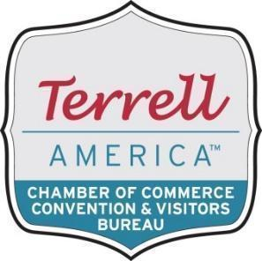
Community & Tourism Division
Chuck Schmidt, Vice Chair
Goal: Implement activities, encourage participation, and increase promotion of tourism in the Terrell area through strategic events, community partnerships, and destination-driven marketing.
Host / Coordinate / Promote Tourism-Related Activities

Major Chamber-Led Events
- Terrell Jubilee
Continue to host and coordinate this signature annual festival.
- July 4th Fireworks Celebration
Coordinate the annual fireworks display at the Terrell Municipal Airport.

Partnership Events with the City of Terrell
- Terrell Taco Festival
- Planes, Trains & Automobiles (NEW)
A dynamic new event celebrating Terrell’s aviation, rail, and automotive heritage — replacing both British Bash and the Terrell Mural Walk. This event showcases our history, our museums, our murals, and our community’s love of classic cars and aviation.
- City of Terrell Christmas Tree Lighting
- Stanley Ballard Sr. Christmas Parade
Additional Tourism & Community Activities
- Promote local museums and cultural sites.
- Support community traditions that attract visitors to Terrell:
  - Happy Days in Terrell America (National Mom & Pop Business Day)
  - Run for the Wall – May
  - Shop Home for the Holidays (Small Business Friday & Saturday)
  - Social Science Club Tour of Homes – December
- Promote Terrell’s geocaching tour.
- Promote digital guided tours of historic homes and murals.
- Continue to explore new opportunities that strengthen tourism appeal.

Tourism Promotion
- Director of Marketing & Events will continue to build a tourism-focused network and enhance visibility for Terrell.
- Produce and distribute the Discover Terrell Visitor’s Guide annually.
- Maintain the Discover Terrell website and Visit Widget promoting attractions, accommodations, dining, retail, and events.
- Utilize Chamber/CVB website for tourism messaging and cross-link to Discover Terrell.
- Manage social media dedicated to tourism marketing.
- Distribute Terrell visitor information to Visitor Centers statewide.
- Strengthen relationships with hotels and local industries.
- Maintain TourTexas.com listings and review lead reports.

Community Affairs
- Support small businesses and promote downtown events including:
  - Downtown Candy Walk
  - Christmas Parade
  - Downtown Trick-or-Treat
  - Small Business Shopping Days
- Support local museums.
- Host community business mixers.
- Support TISD clubs and extracurricular activities.

Members wishing to participate with the committee directing the Tourism Division should contact:
Chuck Schmidt
Cruise Planners
(972) 800-8268 – chuck.schmidt@cruiseplanners.com

Tourism Division Committee Members:
Karla Dunson, The Terrell Tribune
Tori Gray, Terrell Chamber of Commerce/CVB
Alison Walker, Ex Officio, City Of Terrell
Jayne McFadin, Terrell Coffee Co.

