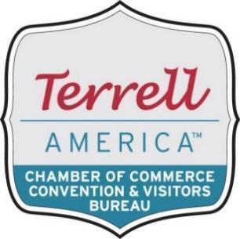

Legislative Advocacy Division
Harold Wilson, Vice Chairman

Goal – Develop and promote an inclusive approach to providing a voice, services, and sense of belonging to all potential business members in the region.

Marketing & Public Relations

- Create and launch target ads to support pressing issues.
- Set social media goals to support key public-policy priorities.

Representing Business

- Advocate for business issues and champion favorable public policy at the local, state, and national levels.
- Support and sign policy positions that impact our business community, as guided by the Texas Business Association and the U.S. Chamber of Commerce.
- Be vigilant in identifying the regulatory challenges of our members and monitor proposals from local, state, and national regulators in order to respond appropriately.
- Maintain a leading role in convening and sharing information that highlights issues facing our regional companies.
- Host “Meet the Candidates” forums during election cycles to ensure voters and businesses have direct access to candidates and their positions.

Members wishing to participate with the committee directing the Legislative Advocacy & Community Development Division should contact:

Harold Wilson, Association of Breezy Hill Park
Terrell, Texas 75160
T: (972) 551-1487
harold.wilson17@yahoo.com

Legislative Advocacy & Community Development Division Committee
Matthew Baker, American National Bank
Angie Cooper, Terrell Chamber of Commerce & CVB
Raylan Smith, City Of Terrell
Dr. Washington, Ex Offico, Terrell ISD

