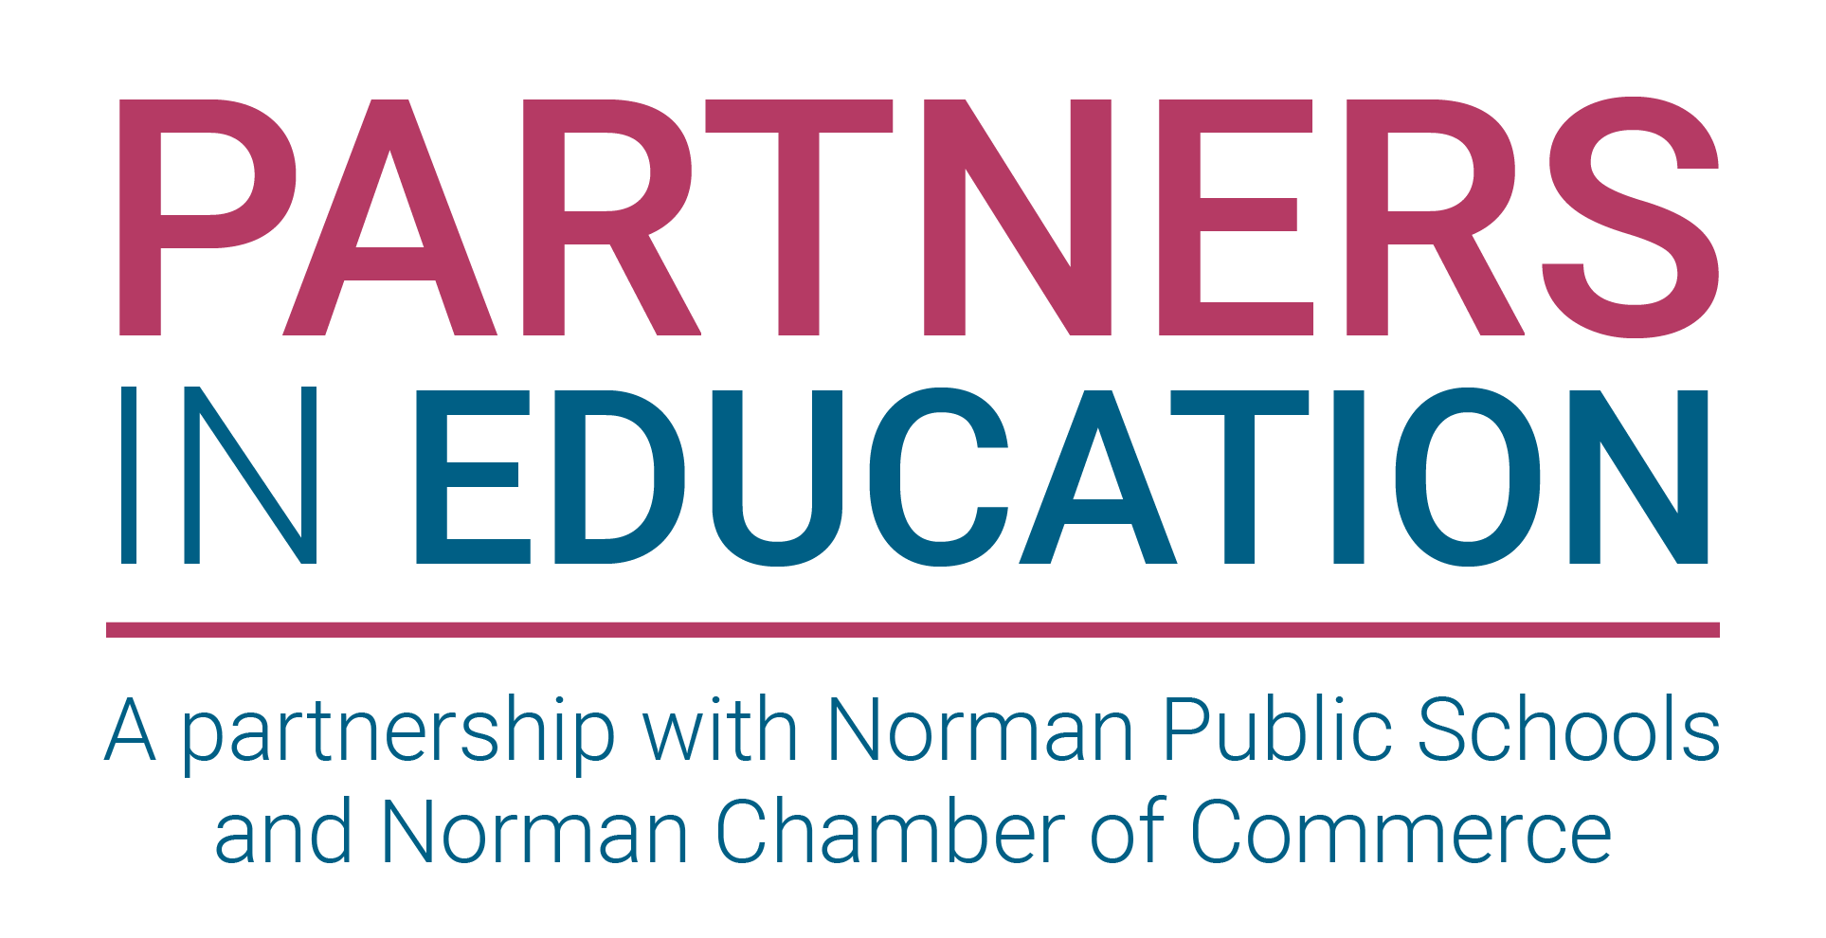
Partners In Education Portal Request Acceptance Guide

Before You Begin
- Save the portal link as a bookmark for future access. Partners In Education Portal Link for Chamber
- Partner Acceptance Of A New Request

Step 1: Open the Portal
Open the bookmarked link and navigate to the portal homepage.

Step 2: On the Dashboard, you will select Available Requests
You can then view all available requests and select those that you would like to help with. Requests will indicate whether the school site is requesting financial assistance, specific items, or volunteers.

Step 3: Select Add to my TO DO List
An email will be sent to the site principal once you add the item to your To Do List.
Step 4: Begin Communication With Site Principal

If you have any questions or need assistance, please contact Carla Atkinson at 405-573-2502 or email catkinson@normanps.org

