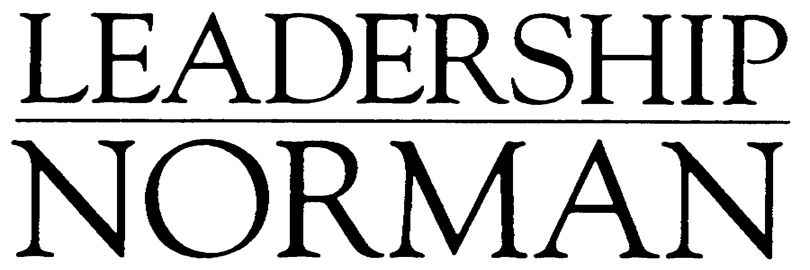
APPLICATION
2024-2025

What is the purpose of Leadership Norman?
Leadership Norman is a program designed to identify, motivate, and place emerging leaders to develop their potential for community leadership. This is accomplished by stimulating an interest in the quality of life in Norman, and by providing a common meeting ground of shared concerns among leaders from all sectors of the community. It prepares participants for more active involvement in the community.

Program Objectives
- Expand participants’ leadership potential by increasing their knowledge of critical issues facing the community and connecting them to current community leaders.
- Expose participants to qualities of leadership: goal setting, management styles, and interpersonal relationships
- Provide information about the key organizational structure within the community
- Motivate potential leaders to assume responsibilities and opportunities inherent in the program
- Increase volunteerism

Program Activities
- Participants will meet for 13 sessions, including one Saturday. Graduation will take place after all the sessions.
- Class project outside of class time

Selection
- Participants must live or work in Norman.
- Thirty individuals will be selected through a blind selection process.
- All applicants must submit two letters of recommendation.
- Leadership Norman does not discriminate on the basis of age, sex, race, religion or national origin.
- Due to the limited class size, applicants who are not selected are encouraged to reapply in subsequent years.
- Tuition is $550

Timeline
Applications must be submitted by 5:00 p.m. on Friday, August 16, 2024. Applications should be emailed to Chan Klingensmith, chan@normanchamber.com. Applicants, whether selected or not, will be notified by the beginning of September. Orientation will be held Thursday, September 19, 2024.

Who is eligible?
- Leadership Norman participants must live or work in Norman.

Leadership Norman is a program of the



Leadership Norman Class Schedule
2024-2025

Dates, times, and locations are subject to change

Session | Date | Time
1 – Orientation | Thursday, September 19 | 5:30 – 9:00 pm
2 | Friday, September 20 | 9:00 am – 4:00 pm
3 | Thursday, October 24 | 8:30 am – 4:00 pm
4 | Thursday, November 7 | 8:30 am – 4:00 pm
5 | Thursday, November 21 | 5:30 – 9:00 pm
6 | Thursday, December 12 | 5:30 – 9:00 pm
7 | Thursday, January 9 | 8:30am – 4:00 pm
8 | Thursday, January 23 | 8:30am – 4:00 pm
9 | Thursday, February 6 | 8:30 am – 4:00 pm
10 | Saturday, March 1 | 8:30 am – 12:30 pm
11 | Thursday, March 6 | 8:00 am – 4:00 pm
12 | Thursday, April 3 | 8:30 am – 4:00 pm
13 | Thursday, April 24 | 8:30 am – 4:00 pm
14 – Graduation | Thursday, May 8th | 5:30 – 8:30 pm

Please consider the time commitment required to participate in Leadership Norman. Any participant missing more than one session may be asked to withdraw from the class.

Personal Information
Applications must be submitted by
5 p.m. August 16, 2024

Application must be typed.
Name (First, Middle Initial, Last, Suffix if any):

Name you wish to be called (i.e., “Will” instead of “Willard”):
Current Place of Employment:

Job Title:
Job Responsibilities:

Previous employers including military service:
Business Address (Street, City, Zip):
Home Address (Street, City, Zip):
Home Phone: | Business Phone: |  | Cell Phone:
Preferred Email:

Length of residence in Norman:
Have you previously applied to Leadership Norman?
These optional questions are included to assist in creating a class with a mix of gender, age, and racial/ethnic backgrounds. Applicants are not required to answer.
Birth Date: | Gender: | Race/Ethnic Background:
Education: Name of School Degree Year
Honors, Awards, Recognitions (since high school):
Business/Professional Affiliations:
Have you ever served on a Board? If so, how long?

Community Involvement: Please include educational, civic, religious, political, athletic or community organizations in which you have been active.
If your community involvement has been limited by any circumstances in the past, please explain.
What is something most people don’t know about you?
What do you consider to be your most significant leadership contribution(s) or achievement(s) related to your community involvement, unrelated to your occupation/vocation?
What do you believe are Norman’s unique advantages, excluding the University of Oklahoma? What are the challenges? Please explain in 150-200 words.
What makes an outstanding community leader? Which of those assets would you bring to Leadership Norman, and which of those assets do you hope to develop? Please explain in 150-200 words.
Why do you want to be a part of Leadership Norman?
Letter of Recommendation
Please include two letters of recommendation.

Tuition
If accepted into the Leadership Norman program, you or your employer/sponsor will be billed for the $550 tuition fee. Who is responsible for your tuition? Applicant Employer Sponsor Request scholarship

Tuition Assistance
This section only needs to be completed and included if you are requesting tuition assistance.

You are encouraged to seek sponsorship if your employer is not assisting with tuition. Potential sponsors include professional, civic or religious groups of which you are a member. A limited number of scholarships may be available through the Norman Chamber of Commerce.

Are there any circumstances that should be considered in your request for assistance? If so, please elaborate.

Requests for tuition assistance are not part of the selection process and in no way affect the selection of any candidate.

Name Amount Requested

Source(s) of Support for Tuition (check all that apply)

___Applicant
___Employer
___Board
___Others

Attendance
Participants who miss more than one session may be asked to withdraw from the program. If you plan to miss more than one session, please explain.

Employer Commitment (if applicable)
This application has the approval of this organization and the applicant has our full support, including the time required to participate in Leadership Norman.

Supervisor’s Printed Name Supervisor’s Signature Date

Applicant’s Confirmation
I understand the above commitments and agree to them by signing this application.

Applicant’s Printed Name Applicant’s Signature Date

Completed applications should be emailed to Chan Klingensmith, chan@normanchamber.com.

Thank you for applying for Leadership Norman!

