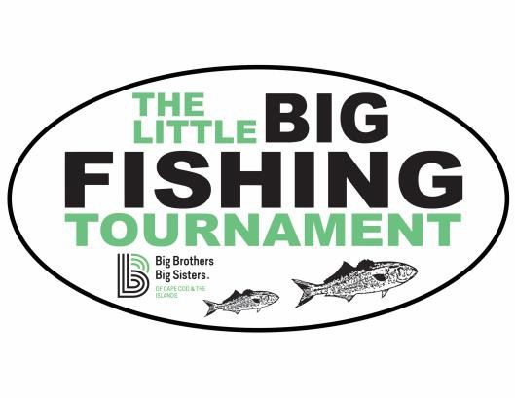

FOR IMMEDIATE RELEASE:

# MEDIA CONTACT:

Kristin Gayle, E.J. Jaxtimer Builder, Inc., 508-778-4911, [kristin@jaxtimer.com](mailto:kristin@jaxtimer.com)

# The Little Big Fishing Tournament Raised Over $182k for Big Brothers Big Sisters of Cape Cod and the Islands

HYANNIS, MA, ISSUED June 24, 2025…… On Thursday, June 19, 2025, the 5th Annual Little Big Fishing Tournament reeled in an impressive $182,695 for Big Brothers Big Sisters of Cape Cod and the Islands, marking another successful year.

The tournament brought together a formidable fleet of 32 boats and 160 anglers, all eager to test their skills in the waters off Cape Cod. The two-day event culminated on Thursday evening with a celebration at Baxter's Fish 'N Chips, the tournament's generous sponsor and host. The evening featured an exciting ceremony filled with raffle prizes, a live auction that sparked competitive bidding, and finally, the much-anticipated awards ceremony. Medals and accolades were proudly presented to both adult and junior anglers who brought in the heaviest striped bass and bluefish.

The outstanding success of this year's tournament is a testament to the community's unwavering support and will directly enable Big Brothers Big Sisters of Cape Cod and the Islands to continue its vital mission. This significant contribution ensures the organization can maintain and expand its crucial work in supporting at-risk youth across the community, guaranteeing that every child in need receives the invaluable mentorship and support they deserve. "Since we started the tournament in 2021, the tournament has raised over $857,000 for Big Brothers Big Sisters of Cape Cod and the Islands! We would not be able to raise all of this money without the generosity from our local community," stated E.J. Jaxtimer, underscoring the deep impact of community involvement.

The core mission of Big Brothers Big Sisters of Cape Cod and the Islands is to forge transformative, one-to-one professionally-supported relationships between caring adult mentors and children from under-resourced families. This partnership empowers children to thrive, achieve their full potential, and ultimately contribute to healthier families, more vibrant schools, brighter futures, and stronger communities. Through three innovative program models, the organization diligently works to ensure that more children are provided with the opportunity to connect with a mentor, creating lasting positive change in their lives.

A heartfelt and special thank you is extended to the Baxter family and Baxter's Fish 'N Chips for their exceptional sponsorship and for graciously hosting the tournament year after year, providing the perfect setting for this impactful event.

To learn more about The Little Big Fishing Tournament, please visit [www.jaxtimer.com/thelittlebigfishingtournament](http://www.jaxtimer.com/thelittlebigfishingtournament)