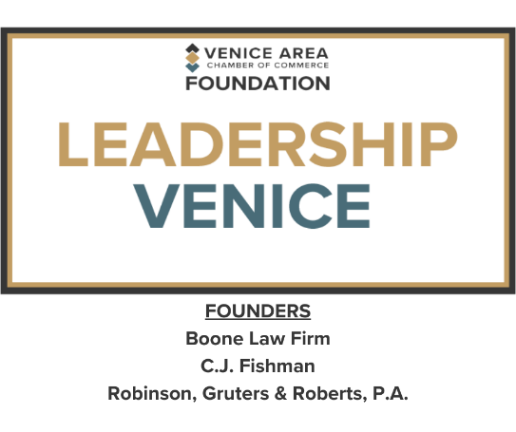

**LEADERSHIP VENICE CLASS OF 2025**

Bethany Behrmann, Engel & Volkers

Joe Carter, Gulf Coast Community Foundation

Kathryn Custer, YMCA of SW Florida

Michelle DiCapua, Sarasota County Sheriff’s Office

Nick Dumas, City of Venice

Chris Fagley, Fourthought Private Wealth

Susan Fetherolf, Sarasota Memorial Hospital

Hollie Fritschle, Wound RX

Pete Harvey, Visit Sarasota

Brad Johnson, Sarasota County

John LaCivita, Willis Smith Construction

Anya Latin, British Open Pub

Johnny Marshall, DG Advisors

Chloe Nelson, Venice Gondolier/Daily Sun Newspaper

Louis Valery, Venice Area Chamber of Commerce

Torri Zarnowski, Berlin Patten Ebling