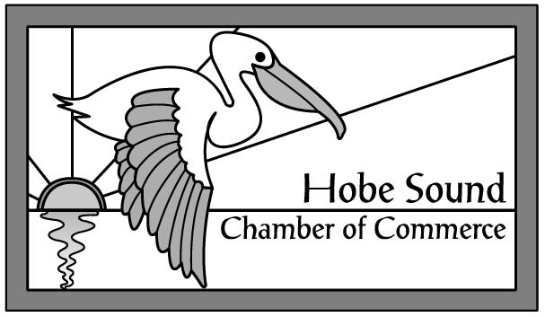 Membership Has Its Privileges

These benefits are available Only to Members of the Hobe Sound Chamber of Commerce

- FREE Recognition as a new member in the quarterly edition of The Pelican (distribution 5,800)
- FREE News & Press Releases posted on Chamber website – www.hobesound.org
- FREE Listing and Link on the Chamber website ($175 value)
- Opportunity to upgrade your website Listing
- FREE Conference room and kitchen facilities available for you to meet with your staff and clients
- FREE Notary Public services
- FREE New Member Orientation & Networking
- FREE Pelican newsletter mailed quarterly directly to you
- FREE News You Can Use e-newsletter weekly
- Advertisement opportunities in The Pelican newsletter (distribution 5,800) & Chamber Website
- Email advertising opportunities to over 800 contacts
- FREE Opportunity to participate in Hobe Sound’s Annual Christmas Parade
- FREE Listing of career opportunities
- FREE Business cards/brochures space available in the Chamber / Hobe Sound Welcome Center
- FREE On-site Ribbon Cutting Ceremony and picture in The Pelican (distribution 5,800)
- Monthly networking opportunities at Luncheons, Business After Hours & Breakfasts for your entire staff
- Opportunity to showcase your business at the 2-day Festival of the Arts (30,000 attendees)
- FREE Leads and referrals by Chamber staff and volunteers
- Discounted entrance to breakfasts and business after hours socials
- FREE Alphabetical and industry listing in Preferred Business/Community Guide (distribution 5,000)
- Opportunity to advertise in the Preferred Business/Community
- FREE Membership decal for your storefront or business vehicle
- FREE Business counseling sessions provided by SCORE
- FREE access to Chamber’s Small Business Assistance Group providing small business owners with advice, resources and mentorships by privately meeting with a diverse committee of experienced business professionals
- FREE attendance at Quarterly Coffee Talk
- Opportunity to learn communication and leadership skills through the Chamber-sponsored Toastmasters International Club, Hobe Sound Toasters
- Volunteer leadership opportunities on various committees throughout the year
- Numerous promotional opportunities at Golf Tournament, Festival of the Arts, Christmas Parade & Progressive Dinner
- 50% discount on membership to BJ’s Wholesale Warehouse

