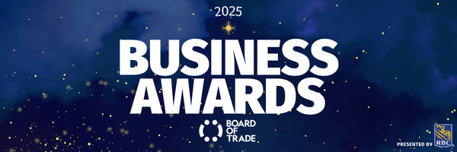

NOMINATION FORM | Opportunity Seeker Award

Business Name:
Contact Name:
Contact Title:
Contact Email:

Award Description
Is your business an innovator? Strategic thinker? Sees opportunity where others see obstacles? Is creativity and ingenuity at the heart of what you do? Maybe you deployed new ways to communicate and connect with your customers, or you were able to build new relationships with market segments that you didn’t connect with before. Perhaps you established or enhanced a stellar communications, sales, and/or marketing strategy or invested in an idea that is now starting to show profit.
If this sounds like your business, we want to hear your story! Please tell us how you believe your out-of-the-box thinking sets your business apart from others when seeking opportunities.

Eligibility Criteria
- Must be a member in good standing of the Board of Trade.
- Noted contributions/actions must have taken place from September 2024 to September 2025.
- Demonstrates sound communication, sales, and/or marketing strategy.
- Demonstrates creative thinking and agility in forging new possibilities and opportunities.
- Analytics, data, or evidence that supports new relationships established or markets entered (i.e., social engagement, followers, increased sales, etc.).

Nomination Form
- How did you know you needed to change your approach to sales and/or marketing this past year?
- Tell us about the communications, sales, and/or marketing strategy you built to guide you in building new relationships or connecting with a market segment(s) that you didn’t connect with before.
- What analytics, data, or evidence can you share that proves your plan worked (i.e., you built new relationships or entered new markets)?
Please note: You can attach a PDF or video file in place of copying the letter into the text box should you wish to do so. If this is the case, please note the file name and format in the above response section.
- Is there anything else you’d like to share?

PLEASE NOTE: By submitting this nomination package, you are confirming that all the above-noted actions are true and accurate, and occurred between September 2024 and September 2025. Nomination forms must be completed in full and uploaded through our website to be considered for judging. Nominations are open from July 10th to September 16th, 2025 at 11:59 p.m. (NDT).
Should you have questions on your nomination application please reach out to: Shanelle Clowe-Hillier, sclowe@bot.nf.ca

