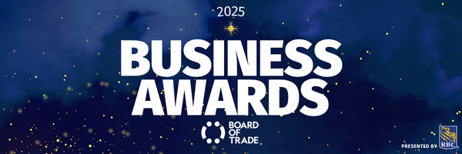

NOMINATION FORM | Business Builder Award

Business Name:
Contact Name:
Contact Title:
Contact Email:

Award Description
This award recognizes a business that has made major moves over the past year. Whether through increased demand, rising sales, team expansion, or market growth. Did your business experience an increase in popular demand for your product(s) and/or service(s)? Did you see a significant growth in sales, market share, or team this past year (September 2024 to September 2025)? If your business has taken measurable steps to leap forward, you could be our next Business Builder.

Eligibility Criteria
- Must be a member in good standing of the Board of Trade.
- Noted contributions/actions must have taken place from September 2024 to September 2025.
- Demonstrate growth by % in sales and net income, or other appropriate metrics, year-over-year to prove that 2025 was a significant growth or development year for your business.
- Analytics, data, or evidence that supports your entry. Nominees must show metrics for building of business and market share – this may be a return on the bottom line, expansion in team, or otherwise.

Nomination Form
- Tell us about this past year compared to others – how has your business grown and what was unique about 2024-2025 that led to significant success?
- Explain what steps you took, or what new product/service/approach you implemented, to meet or exceed sales objectives this past year.
- Please share data to illustrate growth by % in sales and net income, or other appropriate metrics, year-over-year to prove that 2024 was a significant growth or development year for your business.
Please note: You can attach a PDF or video file in place of copying the letter into the text box should you wish to do so. If this is the case, please note the file name and format in the above response section.
- Is there anything else you’d like to share?

PLEASE NOTE: By submitting this nomination package, you are confirming that all the above-noted actions are true and accurate, and occurred between September 2024 and September 2025. Nomination forms must be completed in full and uploaded through our website to be considered for judging. Nominations are open from July 10th to September 16th, 2025 at 11:59 p.m. (NDT).
Should you have questions on your nomination application please reach out to: Shanelle Clowe-Hillier, sclowe@bot.nf.ca

