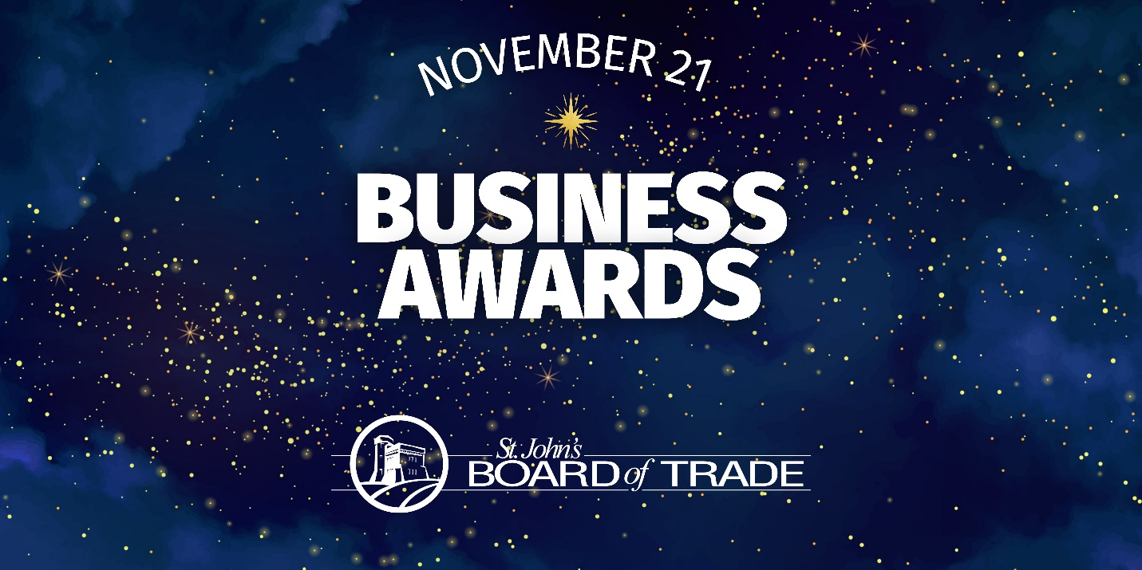

NOMINATION FORM | Boundary Pusher Award

Business Name:
Contact Name:
Contact Title:
Contact Email:

Award Description

This award celebrates those businesses that think differently. A “boundary pusher” means you’re the type of business who isn’t afraid to take a risk or two to stay competitive. You’re the bold business that everyone is paying attention to and trying to figure out what you have in that secret sauce – surely a dash of courage, leadership, and some uncertainty (just the way you like it!).

If you tend to operate your business differently, we want to hear from you. Whether you pivoted to focus your business in a different direction, or if you expanded, altered or changed your offering, including your products and/or services, please tell us how you applied a new or unexpected way of thinking to the way you do things and inspire others (staff, colleagues, partners, etc.) to do the same.

Eligibility Criteria
- Must be a member in good standing of the St. John’s Board of Trade.
- Noted contributions/actions must have taken place from September 2023 to September 2024.
- Demonstrate an innovative approach to the way the business operates and/or meets its primary objectives.
- Demonstrate an understanding of the market and what mechanisms the business has used to respond to change.
- Explain how you changed any products/services that you offer and the rationale for doing so.
- Two (2) testimonials from customers who benefited from your business offering.

Nomination Form
- How did you know you needed to think differently this past year? Please tell us what challenges or opportunities you faced this past year, and how changing your offering was necessary or beneficial.
- Explain how you changed the product or service that you offer and your rationale for doing so. This could be the way in which your business operates or how you meet your primary objectives. Please provide data or proof points, if available.
- Tell us about why this approach showed innovation or a new way of thinking for your business.
- Please share two testimonials from customers who benefited from your new business offering.
  - TESTIMONIAL 1:
Please note: You can attach a PDF or video file in place of copying the letter into the text box should you wish to do so. If this is the case, please note the file name and format in the above response section.
  - TESTIMONIAL 2:
Please note: You can attach a PDF or video file in place of copying the letter into the text box should you wish to do so. If this is the case, please note the file name and format in the above response section.
- Is there anything else you’d like to share?

PLEASE NOTE: By submitting this nomination package, you are confirming that all the above-noted actions are true and accurate, and occurred between September 2023 and September 2024. Nomination forms must be completed in full and uploaded through our website to be considered for judging.

