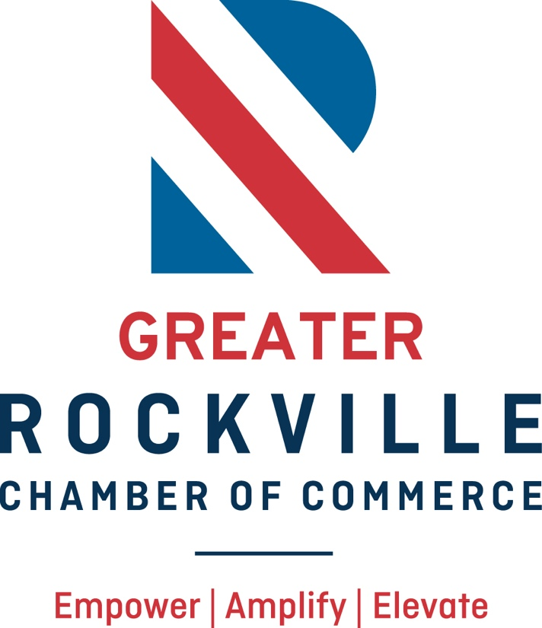

2026 Information Packet
About the Chamber
The Greater Rockville Chamber of Commerce is the voice of the business community in Greater Rockville.

Vision statement
We empower, amplify, and elevate businesses in the Greater Rockville community.

Mission statement
To foster an environment for businesses to succeed
through our leadership, advocacy, and community partnerships.
2026 Board of Directors & Chamber Staff
OFFICERS

Chair of the Board – Kerri Donnelly - Montcare
Vice Chair – John Flood – Flood Law
Secretary – Ryan Malet - Shulman Rogers
Treasurer – Lori McConnaughey – First National Bank of Pennsylvania
Past Chair – Pam Clark – Clark Communications

DIRECTORS

Alberto Zegada – PEPCO
Babita Singh – Wesbanco Bank
Becky Briggs – Our Gift Biz
Brian Barkley – Barkley & Kennedy, Chartered
Cerena Anderson – The Preston
Cliff Veirs – C. Clifton Veirs Agency
Daniel Campos - Campos Financial Group
Jared Rosen – Epic Events
Josh Bender – Bender JCC
Josh Nolan – Morguard (Rockville Town Square)
Latrion (Lacy) Fields - Therapeutic Salon Spa
Leslie Keenan – Intelligent Office
Mike Hwang - AstraZeneca
Muhammad Kehnemouyi – Montgomery College
Quincy Inman – Cornerstone Montgomery
Rebekah Kleinman – Coldwell Banker Realty
Samantha Morash – DARCARS Automotive Group
Trinh Le - SERVPRO of Rockville-Olney

Ex Officio:
Linda Moran – City of Rockville
Cindy Rivarde – REDI (Rockville Economic Development, Inc.

MEET YOUR CHAMBER TEAM:
Marji Graf, President & CEO | marji@rockvillechamber.org
Dawn Hipsley, Administrative Coordinator | dawn@rockvillechamber.org
Connie Rhind Robey, Member Engagement Director | connie@rockvillechamber.org
Getting Started
Welcome!

When you join the Greater Rockville Chamber you will be assigned an ambassador from our membership committee. This person will reach out to schedule a meeting and officially welcome you to the Chamber. Your picture along with your new member plaque will be taken and posted to our social media channels. The ambassador will get to know you better and work on supporting you in making beneficial connections within the Chamber.

Member Website

Upon joining the Chamber, you will be sent login credentials for the Member Information Center. This site can be accessed by logging in on the top right-hand corner of the Chamber’s homepage at http://www.rockvillechamber.org/

Access to the Member Information Center (MIC) allows you to fill out your business directory listing, post events, and peruse other members’ promotions, business info, news, and events. Additionally, you can sign up for our Chamber-featured events through the MIC.

E-Newsletter
On the first of every month, the Chamber sends out an e-newsletter highlighting our upcoming events and welcoming new members. We send out weekly friendly reminders to register for events and committee meetings.

Return on Investment
Advocacy and Leadership
- Chamber representation before City and County elected officials and staff on legislative and executive branch issues affecting Chamber member interests.
- Opportunity to serve on the Chamber Board of Directors to impact upon and lead the Chamber’s growth and participation in Rockville area business preservation, opportunity, and expansion objectives.

Business Exposure and Marketing
- A business listing in our online and printed membership directory.
- Assistance with ribbon cuttings and grand openings. (Main Street package)
- Opportunity to host networking events at your location (Achiever and above) and be featured in our member newsletter that reaches over 3,000 opt-ins and website.
- Post company news, jobs and events on our website.
- Increase your reach on social media by tagging us. Use the following tags, and we will help get the word out:
  - Facebook @RockvilleChamber
  - Twitter @chamberrock
  - Instagram @rockvillechamberof commerce
  - LinkedIn @rockville-chamber-of-commerce

Events and Relationship Builders
- Speaker series: Panel discussions covering topics such as energy, real estate market, cybersecurity, access to capital, economic development many more relevant business topics.

- Monthly Coffee: Breakfast at a member location where you get to know the people sitting around you in a slightly more intimate setting. 2nd Fridays of the month.

- Monthly Cocktails & Commerce: Monthly networking happy hours, which typically bring over 70 business professionals. 3rd Thursday of the month.

- Monthly Young Professionals events. See website for details

Inclusion in the Maryland Federation of the Maryland Chamber of Commerce
- All Rockville Chamber members with fewer the 10 full-time employees are automatically members of the Maryland Federation of the Maryland Chamber of Commerce.
- As a member of the Maryland Federation, the voice of small businesses will be heard at the state level through Calls to Action, and Inclusion in statewide initiatives, surveys, and coalitions. You can also receive reduced member pricing for MD Chamber signature events and UPS discounts.

10 Mastermind Groups

- Nonprofit Mastermind: Tackles issues that impact the nonprofit community and how best to do business in today’s market. Second Monday of every month from 9:30 am -10:30 am on Zoom.
Facilitated by Josh Bender, Bender JCC
- Women’s Business Mastermind: An opportunity to learn from one another about issues that might be facing women in business. Meets the 3rd Thursday of every month from 9:00 am- 10:00 am on Zoom.
Facilitated by Anita Segreti of Capital Point Insurance.
- Business Owner Mastermind: Collaborative Success Hub – Dive into a realm of collaboration and mutual support. Our monthly sessions meet the first Tuesday of the month from 8:30 am to 9:30 am on Zoom, and are your avenue to navigate through entrepreneurial/business challenges with confidence. Facilitated by Tim Fahey of Dirigo Agency Inc.
- Emerging Leaders Mastermind: Facilitating business connections and professional development from the perspective of professionals under the age of 40. Meets monthly. Also hosts quarterly in person events.
Facilitated by Collin Wong and Jeffrey Varrasso.
- Real Estate Group: Facilitated by Trinh Le. The group brings together anyone who touches the real estate market. Meets in person on the 4th Thursday at 9:30am. Email Trinh directly. trinh@servpro5186.com
- Longevity Ready Mastermind (formerly Communications & Aging) The Longevity Ready Mastermind brings together business, healthcare, nonprofit and community leaders to explore innovative strategies that help organizations thrive in an economy shaped by longer lives. Through collaboration, education, and shared best practices, members develop ideas that create more age-friendly, inclusive, and resilient businesses and communities. As demographics, workforce needs, customer expectations, and caregiving responsibilities continue to evolve, organizations that anticipate change will be positioned to succeed. This mastermind is designed for Chamber members who want to stay ahead of emerging trends, strengthen their organizations, expand their networks, and make a meaningful impact in the community.
Facilitated by Kerri Donnelly of Georgetown Home Care. Meets in person the last Tuesday of the month at 12:30 at the Chamber office

- Health & Wellness mastermind Connect, collaborate, and grow with like-minded health and wellness professionals and enthusiasts in the greater Rockville area. Whether you own or represent a health and wellness business, are curious about what local businesses have to offer, want to deepen your knowledge of health and wellness topics, or are simply looking to expand your network – this is the community for you. Each month, we bring together business owners, practitioners, and wellness advocates for an engaging virtual mastermind designed to spark meaningful conversations, share insights, and build lasting relationships across the local health and wellness landscape.
Facilitated by Mike Jewett of Alloy Personal Training.
- Hospitality & Events Mastermind for people in hospitality, events, venues, catering and related businesses to share ideas, solve problems and help each other grow through referrals, connections and best practices. 3rd Tuesday every month, Facilited by Jared Rosen of Epic Events.
- Physicians Mastermind for doctors, dentists, who need help with IT, loans/grants, billing systems etc. Meets on zoom on the 4th Thursday of the month at 4pm.
- AI at the Table: A 60-75 minute monthly Masterclass about AI, automation, and the tools changing how business gets done. Every session ends with a take-home toolkit (checklist, template, framework). Facilitated by Cerena Anderson of The Preston. We meet the last Thursday of every month from 8:30am-10am at The Preston.

3 Committees
- Public Policy: The Public Policy Committee monitors and advises the Chamber on legislative and regulatory issues on the City, County, and State levels and promotes the interests of our membership. Meets the 2nd Tuesday of the month at 2:00 -3:00pm on zoom.
Facilitated by Brian Barkley, Barkley & Kennedy, Chartered.
- Ambassador: The Membership Committee serves as Ambassador for the Chamber in our community and supports our local businesses with a focus on member recruitment and retention. The committee strives to enhance the new member experience to ensure members are maximizing the use of their membership.
The Committee:
- Provides an ambassador for each new member.
- Connects new members with existing members.
- Makes themselves available for promotional pictures with new member plaques.
The Membership Committee meets on the 2nd Monday of each month from
1:30 pm -2:30 pm on zoom.
Facilitated by Trinh Le, SERVPRO and Dan Campos, Campos Financial Group
- Marketing: The Marketing Committee focuses on promoting the Chamber's value proposition to existing members, potential members, and the local business community. This committee promotes Chamber resources and events by creating messaging, and collateral, and developing strategies to increase overall brand awareness. The Marketing Committee meets on zoom the 3rd Tuesday of each month on zoom from 9 am – 10 am.
Facilitated by Margaret Doan, PIXLink Studio.

Ribbon Cuttings

Celebrate your new business location or expansion with a ribbon-cutting celebration. The Chamber will help with organization, invitations to elected officials, and event management, invitations and photographer. Main Street package or above.

Certificates of Origin

We provide free certificates of Origins for chamber members and $50 each for non-members.

Cost Savings Programs

- Constant Contact Savings: The Greater Rockville Chamber has partnered with Constant Contact to save you money on your email marketing needs. You can save up to 25% as an active Chamber member when you sign up with Constant Contact. This deal also applies to those that are existing Constant Contact customers.

- Chamber Energy Purchasing Cooperative: The Greater Rockville Chamber has partnered with CQI Associates, which is administering and managing an energy purchasing cooperative designed to save on business energy costs.

- Conference room rental $100/hr

- Staples Business Advantage

- Elite Supplemental Benefits

