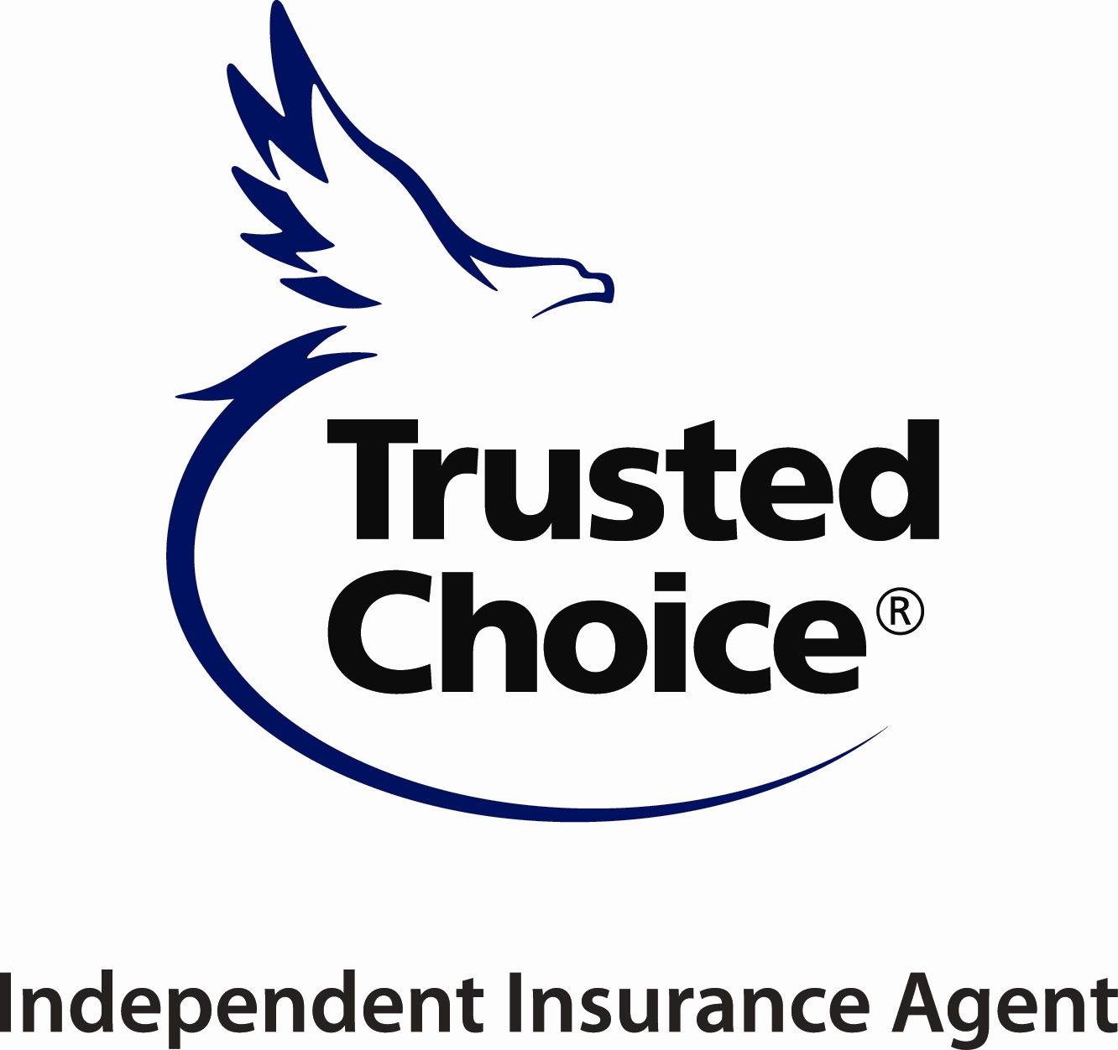
ALABAMA INDEPENDENT INSURANCE AGENTS

141 LONDON PARKWAY, BIRMINGHAM, AL 35211
PHONE 205-326-4129
www.aiia.org

2024 “TOP UNDERWRITER”
AWARD

NOMINATION FORM

- NOMINATING PARTY
This nomination is being submitted by:

NAME_________________________________________________________________

AGENCY______________________________________________________________

PHONE__________________________________ EMAIL_______________________

- NOMINEE

NAME OF NOMINEE___________________________________________________

COMPANY_____________________________________________________________

PHONE______________________ EMAIL___________________________________

- QUALIFICATIONS

This award goes to an exceptional underwriter, who excels at their job. This is someone that emulates top qualities of an underwriter – clear communication, willingness to help, time sensitive, always does the best for their agents and company.

Please give examples of how your underwriter has gone above and beyond for their clients.

_____________________________________________________________________________________

_____________________________________________________________________________________

_____________________________________________________________________________________

_____________________________________________________________________________________

Page 2

_____________________________________________________________________________________

_____________________________________________________________________________________

_____________________________________________________________________________________

_____________________________________________________________________________________

_____________________________________________________________________________________

_____________________________________________________________________________________

_____________________________________________________________________________________

_____________________________________________________________________________________

_____________________________________________________________________________________

_____________________________________________________________________________________

_______________________________________________
Signature – Nominating Party

Alabama Independent Insurance Agents, Inc.

Please return nomination for “TOP UNDERWRITER” to:

Attn.: Michelle McKee
141 London Parkway
Birmingham, AL 35211
Email: mmckee@aiia.org

Nominations need to be returned no later than Tuesday, April 9th
to have awards made prior to Convention.

