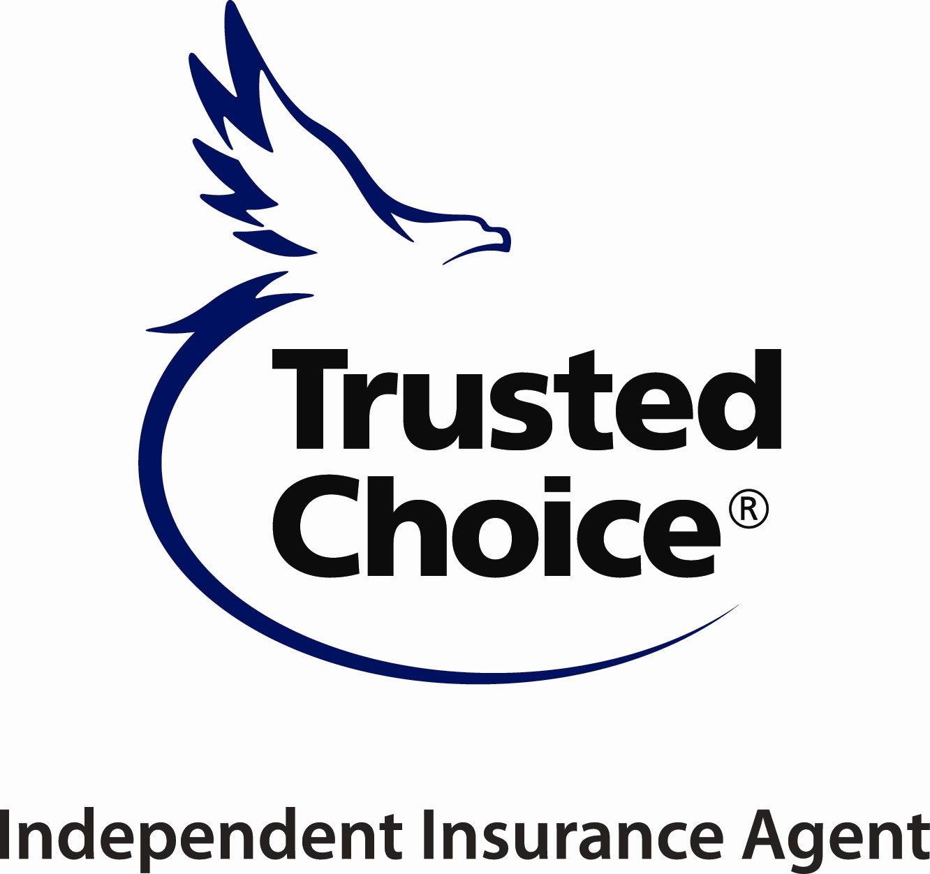
ALABAMA INDEPENDENT INSURANCE AGENTS

141 LONDON PARKWAY, BIRMINGHAM, AL 35211
PHONE 205-326-4129
www.aiia.org

2024 “COMMUNITY IMPACT”
AWARD

NOMINATION FORM

- NOMINATING PARTY
This nomination is being submitted by:

NAME_________________________________________________________________

AGENCY/COMPANY____________________________________________________

PHONE__________________________________ EMAIL_______________________

- NOMINEE

NAME OF NOMINEE___________________________________________________

AGENCY/COMPANY___________________________________________________

PHONE______________________ EMAIL___________________________________

- QUALIFICATIONS

This award goes to either an agent or a company representative that makes a difference in their community by volunteering and giving back. This could be giving back to a nonprofit, their church, school system, etc.

Please give examples of their selfless actions or tell a great story.

_____________________________________________________________________________________

_____________________________________________________________________________________

_____________________________________________________________________________________

_____________________________________________________________________________________

Page 2

_____________________________________________________________________________________

_____________________________________________________________________________________

_____________________________________________________________________________________

_____________________________________________________________________________________

_____________________________________________________________________________________

_____________________________________________________________________________________

_____________________________________________________________________________________

_____________________________________________________________________________________

_____________________________________________________________________________________

_____________________________________________________________________________________

_______________________________________________
Signature – Nominating Party

Alabama Independent Insurance Agents, Inc.

Please return nominations for “COMMUNITY IMPACT” to:

Attn.: Michelle McKee
141 London Parkway
Birmingham, AL 35211
Email: mmckee@aiia.org

Nominations need to be returned no later than Tuesday, April 9th
to have awards made prior to Convention.

