

****

**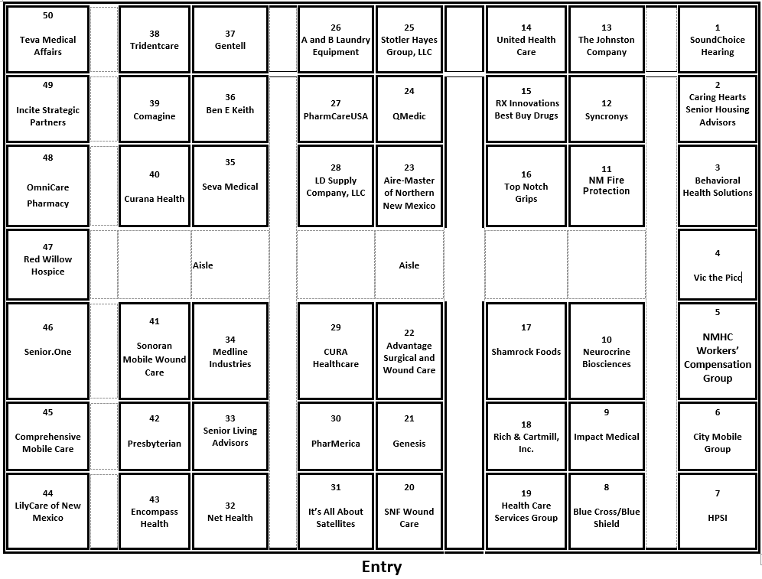**

A & B Laundry Equipment



Brittany Stanforth

Damon Stanforth

505-832-9000

2558 Highway 41

Moriarty, NM 87035

[www.aandblaundryequipment.com](http://www.aandblaundryequipment.com)

Booth 26

A&B Laundry Equipment is a leading commercial laundry equipment supplier in New Mexico & West Texas. Founded in 2005, we’re a family-owned and -operated company willing to assist you in any needs you have. From service to parts and sales, we have your commercial laundry equipment needs covered. A&B Laundry Equipment is dedicated to providing the highest quality of sales, service and parts for the commercial laundry equipment industry.

**Founded in 2005 | Long-Lasting Products | Friendly Customer Service Team | Financing Offered**

Advantage Surgical & Wound Care

Amanda Moen

Regional Sales Manager

Cell:  314-922-7949

Email: [amoen@advantagewoundcare.org](mailto:amoen@advantagewoundcare.org)  
Website: [www.AdvantageWoundCare.org](http://www.AdvantageWoundCare.org)

Booth 22

Competent wound care clinicians are a necessary asset and essential in providing quality, cost-effective wound care. A competent clinician with advanced clinical knowledge and skills will improve healing outcomes while maintaining best practice and regulatory compliance.

The Advantage Certified Wound Nurse (ACWN) program is a live two-day course created for long-term care nurses caring for residents in post acute care. Our course is designed to build a strong foundation for nurses (LVN/RN) to become excellent wound care clinicians.

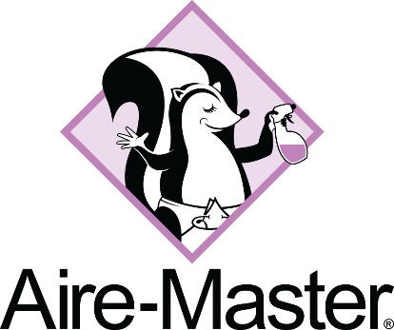Aire-Master of Northern New Mexico

Aire-Master of Northern New Mexico

Jay Rivera

Owner

email : jay.rivera@airemaster.com

Cell: 623-326-8354

Website: airemaster.com

Booth 23

Aire-Master eliminates odors and creates memorable first impressions in healthcare facilities. Our scent solutions evoke comfort, calmness, hunger, and positive memories. As a full-service company, we provide safe odor control and fragrance programs—using only our deodorizer and essential oils, never harsh chemicals—serving healthcare facilities across the entire state of New Mexico.

Behavioral Health Solutions



Sarah Dirks

SVP of Business Development

2200 Paseo Verde Parkway #190

Henderson NV 89052

Phone: 702-589-4871 Cell: 646-404-4235

Email: Sarah.Dirks@bhs.health

Booth: 3

Behavioral Health Solutions (BHS) is a comprehensive behavioral health provider group focused on nursing homes – both long term and skilled care offering psychiatry services, therapy, and psychology to senior living facilities with a full team of providers, including Regional Psychiatrists. We participate in the psych pharm (GDR) meetings and provide regular in-person rounding with our Nurse Practitioners. BHS is currently partnered with over 200 facilities in Nevada, Arizona, Colorado, Utah, Idaho, New Mexico, and Washington. We are familiar with the management and unique needs of behavior programs in these states.

Ben E. Keith Company

Joyce Lamilla

Director, Healthcare & Nutrition Solutions

jdlamilla@benekeith.com

(817) 304-8599

Booth: 36

At Ben E. Keith Foods, we’ve been proudly serving the industry since 1906, offering quality products for over 119 years. As a privately owned and operated company, we offer greater efficiency and flexibility—free from the constraints of shareholders. Our commitment to exceptional service is reflected in our sales representatives, who provide unmatched customer support.

Ben E. Keith Foods is now the nation’s fifth largest broad-line foodservice distributor servicing customers in 21 states.

Our distribution centers are located in:

Albuquerque; New Mexico

Oklahoma City, Oklahoma

Texas- Dallas/Fort Worth; Houston; San Antonio; and Amarillo;

Little Rock, Arkansas

Gainesville, Florida

New Brockton, Alabama

Linwood, North Carolina

Ben E Keith distributes quality food service products including fresh produce & bread, dairy, frozen foods and meats, grocery, disposables, chemicals, equipment & supplies. With an inventory of over 20,000 items in most of our warehouses, we can meet every health and nutritional requirement for your operation.

At Ben E. Keith, we are committed to building long-term partnerships, collaborating to create customized solutions that fit your daily needs. Let’s discuss how our team can help elevate your culinary department and enhance your dining experiences.

Our team goes beyond distribution, offering resources and expertise to support your unique needs:

• Customizable base menus developed every six months

• A team of Registered Dietitians ready to modify your menu

Ask us about our value-added services to strengthen your business including In-Service Training, Holiday and theme menus, and many other Nutritional Resources.

Let’s schedule a time to discuss!

Blue Cross Blue Shield New Mexico

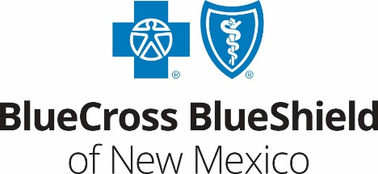

Brenda J. Hodges

Community Affairs Rep, NM External Affairs

505-816-4244

5701 Balloon Fiesta Parkway NE,

Albuquerque, NM 87113

[www.bcbsnm.com](http://www.bcbsnm.com)

Booth 8

Blue Cross and Blue Shield of New Mexico’s Long Term Care Provider Representatives are here to connect face to face and answer any questions you might have about BCBSNM.

Caring Hearts Senior Housing Advisors

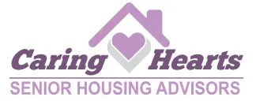Barrie Benson

Certified  Senior Advisor, CSA

Certified  Placement Referral Specialist, CPRS

Owner

505-259-9225

[barrie@caringheartsforyou.com](mailto:barrie@caringheartsforyou.com)

Booth: 2

Established in 2012, Barrie Benson, owner of Caring Hearts Senior Housing Advisors has been dedicated to helping families find the appropriate senior living option here in our Albuquerque and Rio Rancho area. As a Certified Senior Advisor and a Certified Placement and Referral Specialist, for independent, assisted living or memory care option, her extensive experience and deep passion for helping others drives everything she does at Caring Hearts.

Stop by her booth to check out her new guide, “Navigating Senior Living in New Mexico”

City Mobile Group

Jena Breckenridge

Managing Director

524 Richmond Drive SE

Albuquerque, NM 87106

(504) 512-3237

[info@citymobilegroup.com](mailto:info@citymobilegroup.com)

citymobilegroup.com

Booth: 6

Our organization and tech-enabled mobile application provides healthcare facilities with credentialed clinicians 7-days a week with extended working hours to accommodate the wide range of shifts – uber for per diem shifts, short term contracts, temp to perm, perm placements for RNs, LPNs, CNAs, respiratory, therapy, allied, and dietary services

\*Joint Commission Certified Organization

\*Facilities Set your own rates for clinicians

1. \*Consolidated billing linked to geo tracked timekeeping

\*AI Powered comprehensive scheduling

1. \*Standardized processes ensure consistent, high-quality care
2. \*Achieve 100% shift fulfillment
3. \*Prescreened local or travel clinicians

Comagine Health



Shannon Cupka

[scupka@comagine.org](mailto:scupka@comagine.org)

Booth: 39

Comagine Health is a national, nonprofit, health care consulting firm. We work collaboratively with patients, providers, payers and other stakeholders to reimagine, redesign and implement sustainable improvements in the health care system.

As a trusted, neutral party, we work in our communities to address key, complex health and health care delivery problems. In all our engagements and initiatives, we draw upon our expertise in quality improvement, care management, health information technology, analytics and research.

We invite our partners and communities to work with us to improve health and redesign the health care delivery system.

Comprehensive Mobile Care

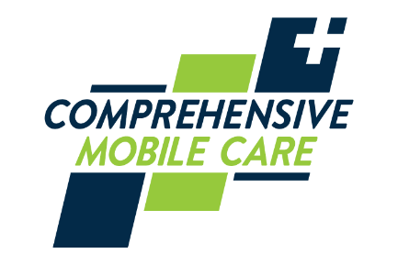Laura Hodges

Account Manager

21175 N. 9th Pl.

Phoenix, AZ 85024

lhodges@compmobileplan.com

Booth: 45

Comprehensive Mobile Care is a family-owned and operated organization that was founded in 1997 by President and CEO Daniel Goldsmith. With more than 24 years of experience and a spotless ethical and legal record, we approach healthcare with compassion and thoughtfulness. We, through the Providers, have provided portable services for well over 500,000 individual patient visits to over 500 facilities across the country, and we continue to grow and expand our reach to those in need.

It is our mission to work harmoniously with facilities to create a higher standard of care for participants and residents and provide professional, ethical, and compassionate services.

CURA Healthcare

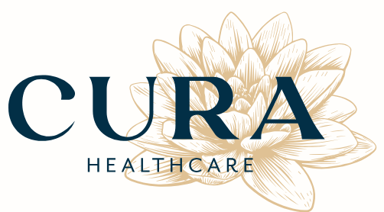

Christine Lafrenz

8226 Menaul BLVD NE #610

Albuquerque, NM 87110

(505) 413 3719

C.lafrenz@cura-healthcare.com

Booth: 29

Cura is a distinctive, women-led healthcare company operating across New Mexico. We pride ourselves on being a diverse, all-encompassing healthcare provider with a robust team of highly-qualified medical professionals. Our team includes board-certified physicians, psychiatrists, psychologists, certified physician assistants, nurse practitioners, registered nurses, and medical assistants.  
  
With a dedication to excellence, our experts embody our commitment to delivering superior healthcare services. This isn't merely a profession to us - it's our passion. Our drive is to transform the quality of care for our patients, consistently striving to exceed expectations in every interaction

Curana Health

Calla Lovrien

Director of Business Development

Calla.lovrien@curanahealth.com

877-279-5960

8911 North Capital of Texas Hwy

Building 1, Suite 1110

Austin, Texas 78759

Booth: 40

Curana Health is dedicated to transforming the healthcare experience for seniors and partnering with skilled nursing and senior living operators in their adoption of value-based care models.

We are the largest provider of senior living primary care services in the country. Backed by innovative technologies, our partnership models empower senior living communities to provide exceptional care for their residents

Encompass Health Rehabilitation Hospital of Albuquerque

Devin Lujan

7000 Jefferson St. NE

Albuquerque, NM 87109

[Devin.Lujan@EncompassHealth.com](mailto:Devin.Lujan@EncompassHealth.com)

Phone: 505-563-4044

Cell: 505-730-6404

Fax: 866-558-2078

Booth: 43

Encompass Health Rehabilitation Hospital of Albuquerque is a leading provider of inpatient rehabilitation for stroke, brain injury, hip fracture, neurological and other complex conditions. When you choose Encompass Health Rehabilitation Hospital of Albuquerque for your rehabilitation, you receive compassionate care from an expert team of physical, occupational and speech therapists; physicians; nurses; dietitians; pharmacists; and case managers who work together to create a plan to help you meet your unique goals. At Encompass Health Rehabilitation Hospital of Albuquerque, we are committed to helping you get back to what matters most.

Genesis Healthcare



Christina Lopez

[christina.lopez@genesishcc.com](mailto:christina.lopez@genesishcc.com)

Meliss Regensberg

[melissa.regensberg@genesishcc.com](mailto:melissa.regensberg@genesishcc.com)

Booth: 21

Genesis Healthcare, Inc. (“Genesis”) is one of the nation's largest post-acute care providers with nearly 250 skilled nursing centers and senior living communities in 22 states nationwide. Genesis and its subsidiaries employ more than 30,000 people, each one dedicated to the delivery of high-quality, personalized health care to all patients and residents. There are currently 22 Genesis Skilled Nursing Facilities in New Mexico, including 1 CCRC (Continuing Care Retirement Community) in Las Cruces, which offers SNF, Assisted Living, Independent Living, and Memory Care.

Gentell

1516745532955_PastedImage

Victoria Porter | MBA, GWC

Regional Manager

267-431-9851 | Cell

800-840-9041 | Office

1000 Floral Vale Blvd, Suite 400

Yardley, PA 19067

[www.gentell.com](http://www.gentell.com/)

Booth: 37

Gentell is the largest vertically-integrated wound care company in the world. We offer efficient, affordable wound care solutions for a variety of care settings, both in the United States and internationally.

Healthcare Services Group

Rachel Kinney

Director of Business Development

859-588-0156

rachel.kinney@hcsgcorp.com

Booth: 19

Healthcare Services Group delivers exceptional Housekeeping, Laundry, Dining and Nutritional services to an ever-changing and growing healthcare market. Since 1976, our focus has been on providing professional management of ancillary services to thousands of facilities all over the country. Our Purpose, Fostering Fulfillment in Communities, allows us to stay motivated on delivering the highest quality service and resident experience in the facility communities in which we operate. For more information, Rachel Kinney, MS-MPH, RD, LDN, rachel.kinney@hcsgcorp.com or 859-588-0156.

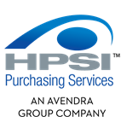HPSI

Ben Gillie

Cell: 801-706-2167

[gillie-gideon@hpsionline.com](mailto:gillie-gideon@hpsionline.com)

Booth: 7

HPSI offers significant benefits for organizations seeking procurement help, leveraging the collective buying power of thousands of members, including healthcare providers, educational institutions, and hospitality businesses across the U.S. Through an extensive network of local and national contracts, HPSI delivers substantial volume discounts and competitive prices on a wide range of quality name-brand products, services, and equipment. Clients benefit from cost savings through group purchasing, access to a broad portfolio of vetted suppliers, streamlined procurement processes, and the expertise of a networked team of procurement specialists, ensuring efficient and cost-effective solutions tailored to diverse organizational needs.

Impact Medical

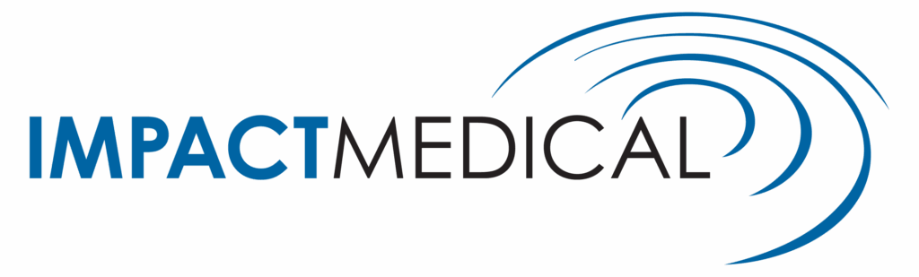Marc Fleury

Territory Manager - Arizona & New Mexico

mfleury@impactmedicalkc.com

(402) 926-9014

Booth: 9

Impact Medical empowers long-term care and skilled nursing facilities by providing essential medical supplies through innovative billing solutions. Our proprietary technology ensures maximum savings, and our expert support team helps streamline processes so your staff can focus on what matters most – resident care.

Impact Medical’s technology integrates with your EMR to proactively identify eligible residents. We’re a true, one-stop shop for Part B supplies, including:

Wound care dressing

Enteral feeding

Catheter supplies

Tracheostomy supplies

Ostomy supplies

Incite Strategic Partners



Mike Dean

Partnership Development

Mike.Dean@inciteSP.com

Booth: 49

We specialize in solutions that raise the bar for every stage of the senior journey. We know the industry and recognize the trends and the need to deliver better quality, outcomes, and cost-efficiency. We’ve built lasting partnerships with providers seeking to drive savings, share insights, and enhance the senior living experience. The team of experienced and dedicated staff at Incite Strategic Partners offers unparalleled senior living and purchasing expertise with intimate knowledge about the long term care and senior living sectors.

It’s All About Satellites (Since 1996) – DIRECTV for BUSINESS Authorized Dealer - TV Systems & Programming – Patient Engagement Technology - Wi-Fi Networks – Broadband Internet

Barry Conley

President, Sound Marketing, Inc.

10415 Comanche Rd NE.

Albuquerque, NM 87111

Phone: (505)296-9423

Email: barry@itsallaboutsatellites.com

Website: itsallaboutsatellites.com

Booth: 31

Since 1996 we have been dedicated to providing Assisted Living, Long Term Care, Senior Living, and Healthcare Facilities with the best entertainment and patient engagement technology options. Better entertainment and staff/patient engagement helps you have happier residents, patients, and families.

• TV Systems (Stream LIVE TV over Your Wi-Fi!)

• Broadband Internet

• Wi-Fi Networks (100% coverage means no dead spots!!)

• Patient Engagement Technology

• Digital Signage

We are dedicated to serving the healthcare industry and helping assisted living, healthcare, and senior living facilities keep your residents satisfied and engaged with the very best and most affordable TV systems and services including streaming TV options, broadband internet access, WiFi networks, and digital signage. We not only take care of existing facilities; we also can provide engineering services for facilities that are in the planning stage.

You deserve fanatical customer service and we take our promise to provide it seriously. Our commitment to you is 24/7/365 technical support with remote system management capability.

**LD Supply Co**

Justin Ellis

Sales Manager

Mobile- 575-513-7611

Office- 505-247-2246

1503 12th St NW

Albuquerque, NM 87104

jellis@ld-supply.com

www.ldmed.co

Booth: 28

**Where it Matters Most: At the Intersection of Resident Safety, Operational Efficiency, and Cost Control**

**Your Complete Environment of Care Partner**

LD Supply specializes in infection prevention, environmental services, and cleaning solutions for healthcare facilities across the continuum of care. We partner with industry-leading manufacturers like Altra Solutions, Metrex Research, Medegen, Graham, and FilMop to deliver integrated solutions for hand hygiene, disinfection, floor care, dietary consumables, and facility maintenance. Our curated product portfolio ensures you get best-in-class solutions—not just house brands—while simplifying your procurement through a single, trusted distributor relationship.

**Local Service, Regional Coverage, National Contracts**

Expert Support: Our Account Executives provide onsite training, product education, and ongoing support tailored to your facility's needs.

Regional Strength: Comprehensive coverage across New Mexico, Southern Colorado, West Texas, and Northwest Arizona with local decision-making authority.

National Purchasing Power: Authorized distributor for Vizient, Provista, and NuEdge GPO contracts, delivering enterprise-level pricing to facilities of all sizes.

**LilyCare of NM**

Tomi Segotta

Clinical Director

4811 Hardware Dr NE Ste C-1

Albuquerque, NM 87109

Email: [tsegotta@lilycare.org](mailto:tsegotta@lilycare.org)

Phone: 505.808.3202

Fax: 505.554.1335

Booth: 44

LilyCare is more than a service, we're family. Whether you're at home or in a care facility, we're by your side when you need us most. With compassion, respect, and unwavering dedication, we support you and your loved ones through every stage of the journey. Providing exceptional hospice care is not just our mission — it's our promise to the community we proudly serve.

Medline Industries, Inc.



Kim Hamm

Division Sales Manager

Post Acute Sales

Medline Industries, LP

www.medline.com

Booth: 34

Medline is the largest privately held manufacturer and distributor of medical supplies uniquely positioned to provide products, education and support across the continuum of care. Our ability to bring best practices from one care setting to another — from large healthcare systems and independent physician practices to home health patients and their families, is what sets us apart. Our team is made up of clinicians, researchers, engineers, financial experts and 1,200 direct sales representatives with outstanding expertise. They know the healthcare business from the bottom up and top down.

NetHealth

Janine Savage

President, Value-Based Care Solutions

[janine.savage@nethealth.com](mailto:janine.savage@nethealth.com)

Booth: 32

Net Health is first in post-acute analytics and a trusted partner for over 25 years. Improve quality outcomes and succeed in value-based care with powerful insights to identify resident risk, determine care planning priorities, and manage facility performance from Net Health’s Value-Based Care Solutions for Skilled Nursing.

Neurocrine Biosciences



Travis Smith

LTC Account Representative

TrSmith@neurocrine.com

Booth: 10

Neurocrine was founded in 1992 by Wylie Vale, Ph.D., of the Salk Institute for Biological Studies, where he contributed to Nobel Prize–winning work in endocrinology, and award-winning Stanford University neurologist Lawrence Steinman, Ph.D. Since then, we have been developing treatments for rare and under-addressed diseases, sometimes in collaboration with other pharmaceutical companies.

The company’s diverse portfolio includes FDA-approved treatments for tardive dyskinesia, chorea associated with Huntington’s disease, classic congenital adrenal hyperplasia, endometriosis and uterine fibroids, as well as a robust pipeline including multiple compounds in mid-to-late phase clinical development across our core therapeutic areas.

**New Mexico Fire Protection, LLC**



Terri Spiak

2700 Broadbent Pkwy NE STE A

Albuquerque, NM 87107

[tspiak@nm-fp.com](mailto:tspiak@nm-fp.com)

Phone: (505)879-4995

Cell: (505)507-7692

Fax:  (505)872-2533

Booth: 11

We offer a broad range of services to give our customers efficient 24/7 service. NMFP is one of only five area companies possessing a NM State Certification of Fitness in all three areas of licensing: alarms, sprinklers, and specialty suppression. Other services include fire extinguishers, fire door inspection, backflow testing/installation/repair. Employee training is a priority to ensure quality service delivery.

NM Health Care Workers' Compensation Group

Peggy Martinez

Office Manager

505-880-1088

pmartinez@nmhca.org

Booth: 5

Established in 1991, the New Mexico Health Care Workers' Compensation Group (NMHC-WCG) provides a local, hands-on workers' compensation solution for the long-term care profession. NMHCWCG strives to provide competitive and stable premiums by working with individual members to improve safety in their facilities.

Omnicare: A CVS Health Company

Bryanna Francis-Sales Executive

[bryanna.francis@omnicare.com](mailto:bryanna.francis@omnicare.com)

9019 Washington St. NE, Suite B-1

Albuquerque, NM 87113

Phone: 224-230-1857

Email: [bryanna.francis@omnicare.com](mailto:bryanna.francis@omnicare.com)

Booth: 48

From comprehensive pharmacy services and cost-saving clinical programs to user-friendly electronic tools that support a variety of medication management functions, Omnicare pharmacy, a CVS Health company, consistently delivers a wide range of practical and innovative solutions to help your staff deliver real care, in real time.

PharMerica

Matt Massey

Pharmacy Director

2720 Broadbent Pkwy Ste A,

Albuquerque, NM 87107

C: (502) 658-7731

[Matt.Massey@pharmerica.com](mailto:Matt.Massey@pharmerica.com)

Booth: 41

(1991 & 1999 NMHCA Outstanding Business Associate) - Comprehensive LTC Pharmacy Services. PharMerica Pharmacy is the oldest and most experienced provider of pharmaceutical services for long-term care facilities in New Mexico. PharMerica offers facilities a solid advantage over the competition through refined technology, clinical expertise, and customized healthcare services designed to help residents maintain longer, healthier, more independent lifestyles. PharMerica has developed a ground-up program to meet the changing needs of the assisted living facility population. We also specialize in adult residential care facilities, children's residential treatment centers, facilities for developmentally disabled individuals, and ICF/IID. PharMerica's clinical expertise in high-acuity settings means insight, experience, and market-leading information tools.

PharmcareUSA

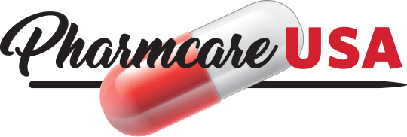Doris Page

VP Customer Care and Corporate Compliance

PharmcareUSA

Mobile Phone (970) 250-2044

Email [doris@pharmcarecorp.com](mailto:doris@pharmcarecorp.com)

Website  [www.pharmcareusa.com](http://www.pharmcareusa.com/)

Booth: 27

With over 20 years of experience, we are proud to operate in 20 states across the country, providing a comprehensive range of pharmacy services to meet the needs of long-term care facilities and their residents. Our team of licensed pharmacists and certified technicians are dedicated to providing personalized and compassionate care to every patient. We understand the importance of efficient and reliable pharmacy services, and we are committed to ensuring that our clients receive the highest level of quality care.

Presbyterian Health Plan

Presbyterian Health Plan

Esli Ornelas

9521 San Mateo Blvd NE 87113

eornelas2@phs.org

Phone: 505-267-0135

Cell: 505-267-0135

Booth: 42

At Presbyterian, we exist to improve the health of the patients, members and communities we serve. We are striving to improve access to health care, health insurance coverage, and opportunities for exercise, healthy food and community resources throughout the state. Presbyterian Medicare Advantage Plans are designed with the needs of New Mexicans in mind. We offer an array of Medicare health plans including HMO, PPO, HMO-POS and Dual Special Needs plans.

QMedic

Brooke Miller

44 School Street Suite B5

Boston MA 02108

bmille@qmedichealth.com

Phone: 877-241-2244

Fax: 617-904-1745

Booth: 24

QMedic is a Personal Emergency Response Device provider and manufacturer specializing in proactive monitoring. We are a team comprised of former nurse care managers, sales executives, and technologists with a passion for supporting members within the aging population and those with disabilities

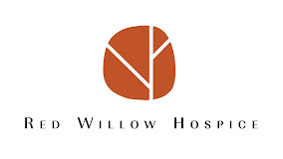Red Willow Hospice

Melissa Martinez

1925 Aspen Dr Suite 901A,

Santa Fe, NM 87505

melissa@redwillowhospice.com

(575) 737-1811

Booth: 47

Red Willow Hospice was founded with patient care in mind. Red Willow Hospice is locally owned and operated by dedicated, long-term residents of the community. We are committeed to providing access to elite hospice care in northern New Mexico. We offer our patients qulity, integrative healthcare in the comfort of their own homes, long-term care settings, and assisted living facilities. We pride ourselves on our innovative approach to holistic hospice care. We invite you to find out more about our organization, team, and the services we offer.

Rich & Cartmill, Inc.

Sloan Roller

2738 East 51st Street

Suite 400

Tulsa, OK, 74105

[sroller@rcins.com](mailto:sroller@rcins.com)

918-398-1979

Emily Long

2738 East 51st Street

Suite 400

Tulsa, OK, 74105

[elong@rcins.com](mailto:elong@rcins.com)

918-629-5407

Braedan Warwick

2738 East 51st Street

Suite 400

Tulsa, OK, 74105

[braedanw@rcins.com](mailto:braedanw@rcins.com)

918-408-0057



Booth: 18

Rich & Cartmill, Inc. is an independent insurance agency located in Tulsa, Oklahoma. We are a Top 100 independently owned insurance agency and are one of the oldest and largest in the country. We specialize in placing insurance for Senior Living Facilities. At Rich & Cartmill, Inc., we have an exclusive contract with Pharmacists Mutual which is an admitted carrier that features great coverage and competitive rates. We also have other exclusive contracts that can write General/Professional Liability and Worker’s Compensation. In addition to these lines of coverage, we can also write D&O, EPLI, and auto lines.

Rx Innovations & Best Buy Drugs

Jake Kocherhans

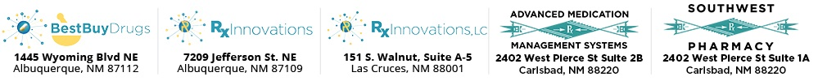7209 Jefferson St. NE

Albuquerque, NM 87109

Phone: 505-881-4601

[Jake@rxinnovations.net](mailto:Jake@rxinnovations.net)

Booth: 15

Rx Innovations & Best Buy Drugs services all types of Long-Term Care organizations including but not limited to DD Waiver’s, ALF’s, Skilled Nursing, Rehab centers and Hospices. We support medication management and all aspects of pharmaceutical needs such as prescription medications, OTC medications, medical supplies, MAR’s, medication reviews, facility licensing, etc. at no additional charge. We offer board required on-site pharmacist consulting at very competitive rates, this includes pick up and destruction of discontinued medications, on-site meetings, employee training, with up to date state and federal regulatory education at no additional charge. We offer Custom medication packaging. Our blister card packaging and multidose packaging along with traditional vials and bottles makes assisting with medications more efficient and therefore saves staffing time and helps prevent common medication errors.

We also assist in obtaining refills from prescribers and can provide a free pharmacy web portal to give staff up to date information on refill status and prescription processing. Reordering can be completed on the web portal which streamlines the reordering process. Large Enough to Help, Small Enough to Care

Senior Living Advisors



Mario Romero

Owner

[mario@seniorlivingadvisorsnm.com](mailto:mario@seniorlivingadvisorsnm.com)

505.289.1910

Booth: 33

As a locally owned and operated family business, Mario and Darla are committed to helping you and your family find the ideal living solutions tailored to your specific needs. We have over 20 years combined experience working with seniors in various capacities including assisted living, memory care, home health care, and hospice services.

At Senior Living Advisors, our primary goal is to support you and your loved ones when navigating the extensive range of living options available to seniors in our community. We are driven by compassion to serve others, particularly seniors. Our personalized approach involves meeting with you directly to guide you through every step of the process. Whether you’re seeking an Independent Living Community, an Assisted Living Community, or a Memory Care home, we’re here to assist you, regardless of the complexity of your needs.

Senior.One



Tim Hart

CEO

thart@senior.one

M: (404) 583-3519

610 Gold Ave SW Suite #202

ABQ NM 87102

Booth: 46  
  
We're committed to transforming the aging experience for every senior by eliminating care fragmentation, and providing continuous, patient-centered navigation from the first care decision to the last.

Senior.One combines technology with personalized care guidance by local licensed social workers. Our software serves as a digital home base, connecting and creating a unified network across the continuum of care. Our local licensed social workers leverage this comprehensive system to coordinate care effectively, guiding seniors through decisions and transitions.

By integrating advanced technology, expert human guidance, and continuous support, Senior.One creates a comprehensive solution to navigate the complex senior care landscape. We bridge the gaps in the fragmented industry, providing the tools and expertise needed for informed decision-making and seamless care coordination throughout the aging journey.

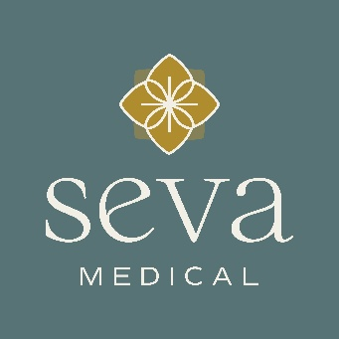Seva Medical – Mobile Primary Care

BobbieJo Covey

Chief Operating Officers

11120 NE 33rd Place, Suite 202

Bellevue, WA 98004

b.covey@sevamedical.org

Booth 35

Seva Medical delivers mobile primary care across Albuquerque, Rio Rancho, and coming soon to Santa Fe through experienced Nurse Practitioners and Physician Assistants, providing compassionate, consistent healthcare directly in Assisted Living and Memory Care communities. Our routine in-person visits reduce transportation needs and ensure continuity of care.

In addition to in-person visits, our telemedicine services include:

• Urgent move-ins within 12 to 24 hours to support your marketing team, complete PPOC paperwork, and assign a primary care provider

• Monthly medication reviews to maintain state compliance

• Support for non-emergency issues like urinary symptoms and wound care referrals

• Coordination of home health and hospice referrals

• Partnerships with mobile labs for blood draws, urine pickups, and other diagnostics

• After-hours night and weekend triage available to your staff

Our Chronic Care Management program proactively monitors high-risk residents and develops personalized care plans focused on prevention and wellness.

We accept Medicare, Medicaid, Aetna, BCBS, Humana, Navajo Nation, Presbyterian Health, Railroad Medicare, Tricare, Cigna, Western Sky, United Healthcare/Oxford, and can verify VA eligibility.

There are no fees or contracts required for communities or patients to partner with Seva Medical. We look forward to supporting your team and helping your residents get the care they need—when and where they need it.

Shamrock Foods

Rich Jackson

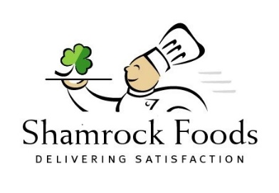District Sales Manager – Healthcare

22000 E 28TH Ave

Aurora, CO 80019

M: (719) 426-0409

Rich\_Jackson@ShamrockFoods.com

Booth: 17

Shamrock Foods began in 1922 with a small dairy in Tucson, Arizona. One hundred years later, we’re still family-owned, forward-thinking, and managed by the same principles of treating associates as family, and customers and suppliers as friends. And the values that brought us here are the same ones that will guide us into the future.

Today Shamrock Foods is a nationally-ranked, family-owned and -operated, Forbes 500 company and is the largest independent foodservice distributor in the West. Shamrock Foods serves restaurant, healthcare, hospitality and institutional foodservice customers throughout the Western US with six warehouses located in Arizona, Colorado, New Mexico, Southern California, Montana and Idaho. Shamrock Foods Company specializes in the manufacturing and distribution of quality food and food-related products through a family of companies, including Shamrock Farms – one of the largest family-owned and operated dairies nationwide.

Shamrock Foods offers a specialized management and healthcare sales team, including Registered Dietitians, Certified Dietary Managers, Registered Sanitarian, and Chefs, to ensure your success. From regulatory guidance to controlling costs, our mission is to drive resident and guest satisfaction. For a fresh approach to the unique needs and challenges of the healthcare industry, hospitals, long-term care and other institutional programs trust the dedicated, experienced healthcare team at Shamrock Foods. After all, we offer solutions for special dietary needs, nutritional analysis, compliance with regulations, menu cycling and more. We’ll go far, together as one Shamrock family.

SNF Wound Care

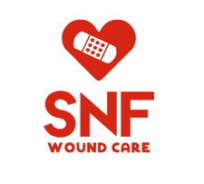

Dr. Payam Tehrani, M.D.

SNF Wound Care

310.270.6181 (cell)

833.DR.WOUND (office phone)

833.379.6863 (office fax)

Booth: 20

SNF Wound Care ensures quality Wound Care continuity and consistency across the board for our Partnered Skilled Nursing Facilities by placing your patients at the center of the care continuum.

Sonoran Mobile Wound Care

Caroline Kerr

Territory Director, NM

Sonoran Mobile Wound Care

704-860-3755

caroline@sonoranvein.com

[www.sonoranvein.com](http://www.sonoranvein.com)

Booth 41

A chronic wound or ulcer that does not heal within four weeks’ time frame, despite adequate management, may require advanced care with our outpatient program. The wound care specialist at Sonoran focus on using patient evaluations to determine the treatment that will be most effective for you and your condition. Saving patients from unnecessary or avoidable lower limb amputations is our mission! Services offered include testing, treatments, and follow-up care for patients with limb-threatening conditions such as diabetic foot ulcers, advanced peripheral vascular disease, acute infections, and deformities. Amputations related to the complications of peripheral vascular disease, or diabetes mellitus, are the most common cause of lower-extremity amputations. Approximately 50,000-60,000 major lower-extremity amputations are performed each year in the U.S. because of diabetes-related complications.

SoundChoice Hearing

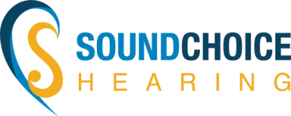

Chrissy Pease   
Hearing Specialist

4811 Hardware Dr. NE Suite C-2

Albuquerque, NM 87109

5600 Coors Blvd NW Suite A-5

Albuquerque, NM 87120

505.341.1300

[chrissy@soundchoiceofabq.com](mailto:chrissy@soundchoiceofabq.com)

Booth: 1

When it comes to customer service in the hearing health care industry, our providers have over 50 years of experience changing lives for the better for people experiencing hearing loss!

We have become experts in providing excellent patient care. SoundChoice Hearing has become advocates in outreach, marketing and networking within the hearing community and have built strong relationships with many hearing specialists, audiologists, senior care representatives and primary care physicians.

We are passionate about educating the public regarding untreated hearing loss and the many implications. We offer free hearing tests and consults to adults over the age of 18 and we accept all insurance. SoundChoice would like to partner with the community to assist patients with their journey to a better quality of life through better hearing!

Stotler Hayes Group, LLC

Ashley Harrison Shudan

Senior Partner, Client Development Director

297 Willbrook Blvd.

Pawleys Island, South Carolina, 29585

843.235.9871

888.497.7390

[www.stotlerhayes.com](http://www.stotlerhayes.com).

Booth: 25

Stotler Hayes Group, LLC is a national, boutique law firm focused on optimizing recovery for health care providers through Medicaid, Medicare, private collections, training, and education. Our attorneys are licensed in, and represent clients before, federal and state courts and agencies in a majority of states around the country.

**SYNCRONYS Health Information Exchange**

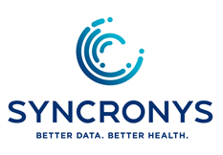Phil Gibbs, MHA  
SYNCRONYS  
Director of Customer Engagement

5338 Montgomery Boulevard NE, Suite 400

Albuquerque, NM  87109                                            
505.336.2096  
[pgibbs@syncronys.org](mailto:pgibbs@syncronys.org)

<https://www.syncronys.org/>

Booth: 12

SYNCRONYS is the designated health information exchange for the state of New Mexico, committed to the delivery of critical and comprehensive patient care data to hospitals, health plans, Federally Qualified Health Centers, pharmacies, clinicians, and public health. SYNCRONYS understands the importance of continuously evolving the health information sharing ecosystem to engage all stakeholders successfully and sustainably in the process of health information sharing.

**Teva Medical Affairs**



John Moore

Clinical Science Liaison

(888) 838-2872

400 Interpace Pkwy #3, Parsippany, NJ 07054

john.moore@tevapharm.com

Booth: 50

Teva Medical Affairs is dedicated to advancing patient care through scientific excellence, education, and collaboration with the healthcare community. We partner with clinicians, researchers, and advocacy organizations to address unmet medical needs and improve health outcomes across a wide range of therapeutic areas. At Teva Medical Affairs, our commitment is to empower healthcare providers and support patients in achieving better health and quality of life.

**The Johnston Co., Inc.**

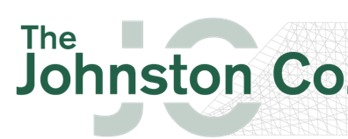

Kevin Givens

Sales Engineer

Office 505-343-8190

Mobile 505-250-1291

4800-B Hardware Dr. NE

Albuquerque, NM  87109

Email: [kevingivens@tjc-nm.com](mailto:kevingivens@tjc-nm.com)

Web: [www.tjc-nm.com](http://www.tjc-nm.com)

Booth 13

The Johnston Co. is a small, locally owned independent sales agency representing commercial and industrial HVAC equipment manufacturers for the New Mexico and El Paso, TX communities.  Since its inception in 1967, The Johnston Co. prides itself on the relationships it has developed with the contractors, facility managers, and engineers it serves.  Current NMHCA customers include La Vida Llena Retirement Community, Joe Gomez, Facilities Services Director.

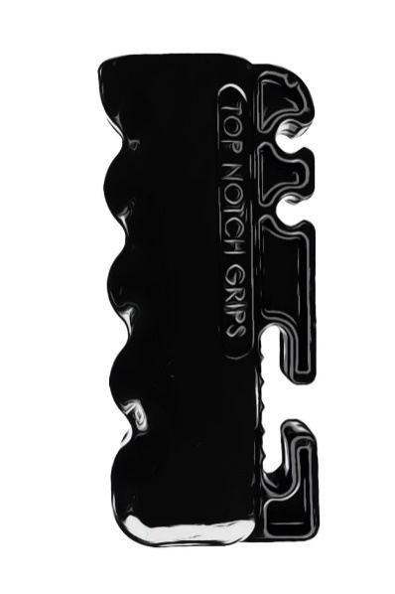Top Notch Grips

Cody Turnbow

Inventor/CEO

126 W Creek Rd

Capitan NM 88316 Phone: 575.354.0958

Cody: 575.635.0222 or Piper 970.759.9350

cody@topnotchgrips.net, piper@topnotchgrips.net

Booth: 16

Introducing Top Notch Grips - a revolutionary solution to wheelchair management.

Having worked in Skilled Nursing and Long-Term Care Facilities for over 20 years,

our founder understands the challenges of handling portable oxygen tanks. With

approximately 40% of nursing homes patients on oxygen, it's vital to address the

issues caused by draping tanks over wheelchair handles. Falling backward or forward

can damage the tank or cause discomfort for the patient. Additionally, tangled tubing

and unsanitary dragging are common problems. Our patented design features a wide

notch to secure straps and two small notches to neatly hold nasal cannulas. Wouldn't it be nice to avoid costly Infection Control citations at your facility?

Experience peace of mind with Top Notch Grips.

TridentCare

Angela Ledford | Corporate Sales Executive

Southwest Region: TX, NM

TridentCare | www.TridentCare.com

Carrollton, TX 75006

Mobile: (469) 271-5995

Email: Angela.Ledford@tridentcare.com

Booth: 38

Each day, tens of thousands of patients nationwide receive**portable diagnostic services wherever they live, work or play.   X-ray, Ultrasound, PICC services and more**provided promptly and safely in the home, workplace, rehab facilities, skilled nursing facilities, correctional institutions, government agency clinics or wherever you are.

With over 35 years of combined operational experience, servicing a wide variety of patients and clients across 40 states, TridentCare offers a consistency and economies of scale that regional providers cannot.

TridentCare delivers a low cost, high quality level of care option –  in a respectful, compassionate manner to maximize the comfort & care of your patients. We partner with you to serve patients, employees, families or residents safely and efficiently ONSITE at an agreed upon location, facility or in the home.

United Health Care

Alyssa Capone

NM Associate Director of Marketing

Cell: 505.720.9280

Alyssa\_capone@uhc.com

Booth: 14

At UnitedHealthcare Community & State, our mission is to help people live healthier lives and to make the health system work better for everyone. We are committed to implementing community-based solutions that expand access to care, improve population health outcomes, and advance health equity for people across New Mexico. To learn more, visit UHCCS.com/NM.

Vic the Picc, LLC

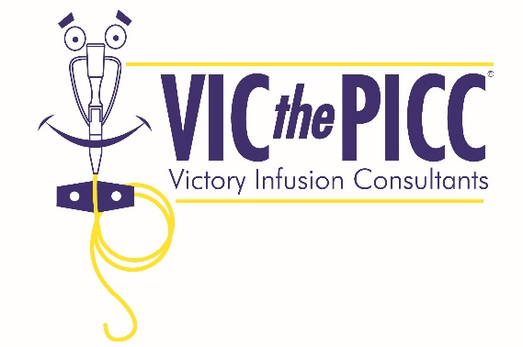

Tyler Burton

VP of National Accounts

1351 E. Pine St. Ste F

Lodi, CA 95240

tburton@victhepicc.com

Booth: 4

VIC the PICC, LLC is a comprehensive Vascular Access Company. We provide PICC (Peripheral Inserted Central Catheter), Midline & Peripheral IV Insertions, DeCloting and Removal Services as well as offering Continuing Education, Precepting and Consulting for Hospitals, Long-term Care and other Healthcare facilities. We are the Industry Leader in using ECG Technology for PICC Confirmation.