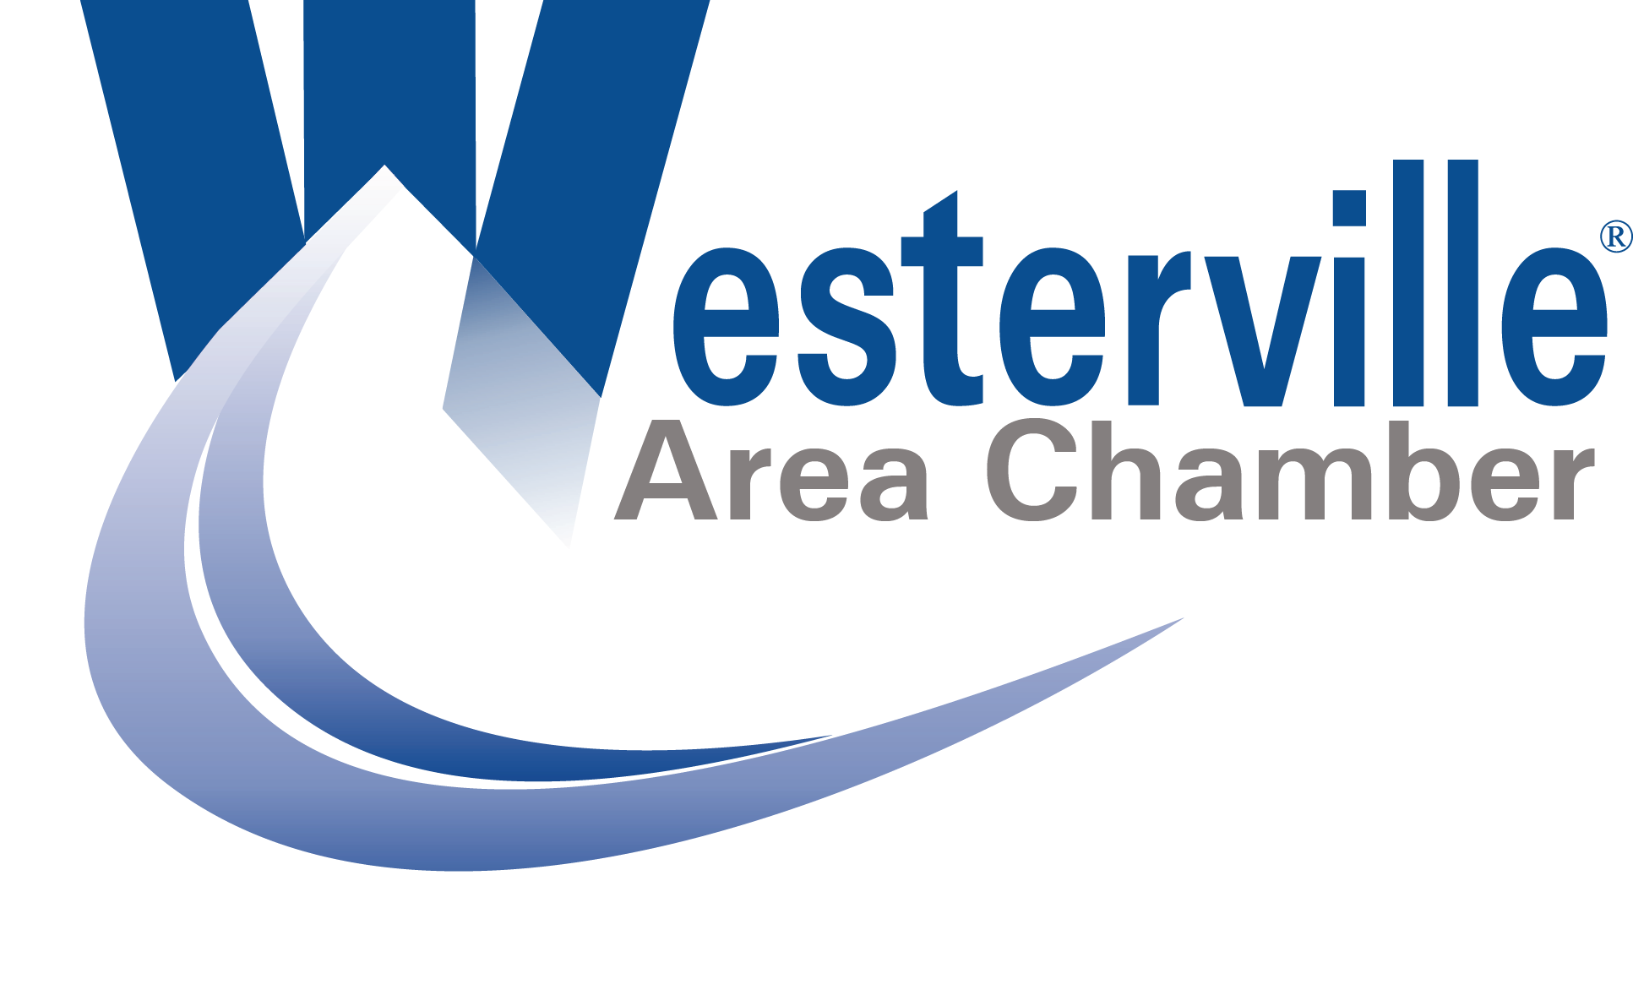

Westerville Area Chamber of Commerce Logo Agreement

In consideration of the following agreement, the Westerville Area Chamber of Commerce agrees to license the entity or individual signing below (“licensee”) to use the Chamber Membership Logo (2025 version printed above) during 2025.

**Approved uses of this logo include:**

· Company business cards

· Company websites, on the condition that the website is linked to [www.westervillechamber.com](http://www.westervillechamber.com)

· Printed and electronic materials pertaining to Membership Group Benefit Plans

· Any other use of this logo with prior written permission from the Westerville Area Chamber of Commerce

**This logo may not be used in any manner that:**

· Implies the Westerville Area Chamber of Commerce endorses any product, company or service

· Implies the communication is from the Westerville Area Chamber of Commerce

· Modifies the logo in any way (logo can only be displayed in the following colors: PMS 288 Blue, Black or White)

The use of the logo is limited to indicating that the licensee is a member of the Westerville Area Chamber of Commerce. The term of the license is for 2025. The licensee must be a member of the Westerville Area Chamber of Commerce and in good standing with the Chamber. The agreement terminates immediately when the licensee ceases to be a member. This agreement is not assignable by the licensee.

The Westerville Area Chamber of Commerce retains the rights to review any usage of the logo. Any use of the logo not specifically provided for in this document is prohibited. The Westerville Area Chamber of Commerce reserves the right to terminate or modify permission to display the logo and may request that the member modify or delete any use of the logo, which, in the Westerville Area Chamber’s sole judgment, does not comply with this agreement. The use of the logo must not violate the intellectual property rights of any state or federal laws.

The licensee agrees to indemnify and hold the Westerville Area Chamber of Commerce harmless against any loss, damage, or expense including any attorney fees arising out of any third party claim related to use of the logo under the terms and conditions of this agreement. By signing below, individually in the case of a sole proprietorship or as an authorized representative on behalf of the member company, I agree to all conditions set forth in this licensing agreement. This agreement is valid during 2025.

_____________________________________________

Company Name (Please Print)

**Chamber Office Use Only**

Westerville Area Chamber of Commerce Representative

Signature Date

_____________________________________________

Name and Position (Please Print)

_____________________________________________

E-mail

_____________________________________________

Phone Number

_____________________________________________

Signature of Authorized Date Company Representative

**Return completed logo agreement to: Westerville Area Chamber of Commerce, 99 Commerce Park Dr., Suite A, Westerville, OH 43082 or e-mail to info@westervillechamber.com. Questions? Call the Chamber Office at 614-882-8917.**