Home Maintenance and Service
Acorn Mini Storage
Better Air LLC
Cannon River Tree Care
Central Air Heating & Cooling
Culligan Water Conditioning
Junk Truck MN LLC
Kopack Home Inspections
Northfield Rent ‘N’ Save
ROJAS All Pros Companies
Self-Storage Dundas
Seykora Asphalt Maintenance and Paving
Internet & Phone Services
Cannon Valley Phone Repair
Northfield WiFi
Landscaping & Nurseries
A-Team Landscaping Inc.
Paisley Gardens
Knecht’s Nurseries & Landscaping
Terpstra Landscape Supply
Lodging
Fairfield Inn & Suites Northfield
Froggy Bottoms River Suites
Marketing Services
By All Means Graphics/Entertainment Guide
Engage Print/NCG, Inc
Graphic Mailbox
Johnson House Creative
Neuger
Media
Northfield News/Cannon Valley Printing
The One/KYMN Radio
Museums & Galleries
Northfield Arts Guild
Northfield History Center
Photography
Bridgette Hallcock Photography
Jonny Weaver Storytelling
Silverthorn Photography, LLC
Recreation & Sports
Cannon Rivers Outdoor Club
Cannon Valley Cinema 10
Division Street Dance
Flaherty’s Northfield
Northfield Area Family YMCA
Northfield Dance Academy
Northfield Gymnastics Center
Northfield Golf Club
Summit Golf Club
Willinger’s Golf Club
Retail
Antiques of Northfield
Cannon Valley Veterinary Clinic Retail Store
Champion Sports
Content Bookstore
Family Fare
Fine Fettle
Fireside Orchard & Garden
Homebody Refill Market
Ikigai Pottery
Judy’s Floral
Larson’s Printing
Mainstream Boutique of Northfield
Makeshift Accessories
Marketplace @ 416
Mercado Local
MGM Wine & Spirits
MN THC CO
Monarch Gifts
Northfield Framing & Fine Art
Northfield Liquor Store
Northfield Olive Oils & Vinegars
Northfield Yarn Store
Northside Boards & Scooters
Paisley Gardens
Rare Pair
Rokaturas
Slumberland
Soulstice Boutique
The Boho Peacock
The Goat
The Measuring Cup
The Secret Attic
The White Barn Boutique
VB Games & More
Verbena Vinyl
Vintage Etc
Schools/Child Care
Arcadia Charter School
Little Village Early Learning
Montessori Children’s House
Northfield Montessori
Open Door Preschool
Senior Living Services
The Neighbor Lady
Veterinarians and Animal Services
Cannon Valley Veterinary Clinic
In the Dog House
Prairie’s Edge Humane Society

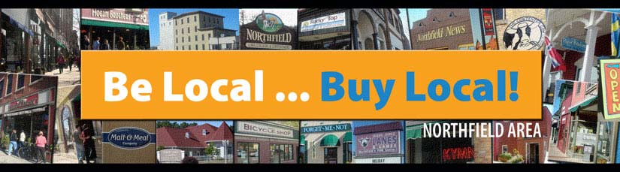

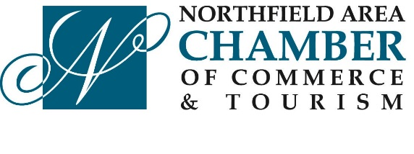

CHAMBER BUCKS
PARTICIPANTS

The Chamber Bucks Program is designed to help promote local Chamber Member businesses in the Northfield and Dundas area!

- Chamber Bucks can be spent like cash at participating businesses in the Northfield and Dundas Area
- Chamber Bucks can only be used at the Northfield or Dundas business locations unless noted (*)
- Chamber Bucks cannot be redeemed for cash
- No change will be given
- Use the entire amount of the Chamber Buck
- Chamber Buck participants are ever changing, scan the barcode below to be directed to the Chamber’s website for the most current list:

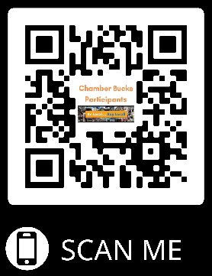

Automotive – Gas & Convenience
Kwik Trip – Dundas & Laurel Court
Ziggy’s
Automotive
CarStar Northfield Auto Body
CarTime Auto Center
Doug’s Auto Service
LKQ Corp- Auto Salvage
Nate’s Garage, Inc.
Northfield Automotive
Raider Automotive /Valley Autohaus
Sota Chevrolet
Witt Bros. Service
Business & Professional Services/Coaching
Midwest ActionCoach
Cannon River Coworking
Carleson Consulting
Roots to Sky Consulting, LLC
Cleaning & Laundering Companies
Consider It Clean
Endres Window Cleaning
ServiceMaster by Ayotte
Clinics & Medical
Cannon Pointe Chiropractic
Corbett Chiropractic & Health
Haugen Chiropractic
Northfield Eye Physicians & Surgeons
Northfield Hospital & Clinics & Rehabilitation
Northfield Women’s Center
Richie Eye Clinic
River Valley Eye Professionals
Sterling Pharmacy
Torrey Pines Direct Primary Care
Computers & Support
Aldrich Technology Consulting
Cannon Valley Phone Repair
SM Tech Solutions
Sol-Information Systems (SOL-IS)
Construction & Contactors
Johnson Reiland Builders & Remodelers
Millersberg Construction
NCC Builders, Inc.
Pollock Construction
ProBuilt Construction, LLC
R/T Construction
Simonson Home Solutions
Steve Schmidt Homes

Contractors – Electrical, HVAC & Plumbing
Benjamin Franklin Plumbing/One Hour Heating & Air
Guth Electric
Keith Pumper Plumbing & Heating
Streitz Heating & Cooling, Inc.
Dental Services
Heritage Dental Care
Professional Dental Group
Minnesota Orthodontics
Direct Sales
Joe Mama’s BBQ Sauce & Seasons
Norwex
Mary Kay- Jean Wakely
Event Centers
Armory Square Northfield
Faribault Art Center/Paradise Center for the Arts
FiftyNorth
Revival on Main
Ruth’s on Stafford
The Gardens of Castle Rock
The Grand Event Center
Farm & Lawn Care
Midwest Machinery Co.
Minnesota Ag Group
Tractor Supply Co.
Food & Drink
Applebee’s
Cake Walk
Carbone’s Pizza & Sports Bar
Chapel Brewing
Cottage Fare & Tearoom
Culvers of Northfield
Dairy Queen
Dawn’s Corner Bar
Delicious Pupusas Cheverri
El Tequila Mexican Family Restaurant
Family Fare
Fireside Orchard & Gardens
George ’s Vineyard
Gran Plaza
Han’s Kitchen
Hogan Brothers Acoustic Café
James Gang Coffeehouse & Eatery
Just Food Co-op
Keepsake Cidery
L & M Bar & Grill & Patio
Loon Liquors & Pizzeria
MGM Wine & Spirits
Northfield Golf Club
Northfield Liquor
Quarterback Club
Reunion
ROSEMARY Italian Kitchen & Bar
Ruth’s on Stafford

Subway
The Blast Northfield
The HideAway Coffee House & Wine Bar
The HideAway Vault
The R Bar
Tin Tea LLC
Udder Buddies
VFW # 4393
Willinger’s Golf Club
Yolks On Us
Hardware Stores
Lampert Lumber
Northfield Ace Hardware
Health & Wellness
Achieve Health & Wellness
Awakened Healing Center
Bridge Square Barbers
Cannon Hair Co.
Cannon River Acupuncture
Cannon River Massage Therapy
Empower IV Hydrating & Wellness Center
Evergreen Therapy Solutions
Family Hair
Fernbrook Family Center
Fine Fettle
Full Potential Therapy
LA Nails
Nevaeh Salon
Nutrition Proportion
River Valley Behavioral Health & Wellness
Sanctuary Studio
The Glo Lounge
The Lux Medspa
Truly Seen Therapy
Well Fitness Studio
Home Furnishings
America’s Mattress
Bierman’s Home Furnishings & Floor Coverings
Slumberland
Home Maintenance and Service
Acorn Mini Storage
Better Air LLC
Cannon River Tree Care
Culligan Water Conditioning
Junk Truck MN LLC
Kopack Home Inspections
Northfield Rent ‘N’ Save
ROJAS All Pros Companies
Self-Storage Dundas

