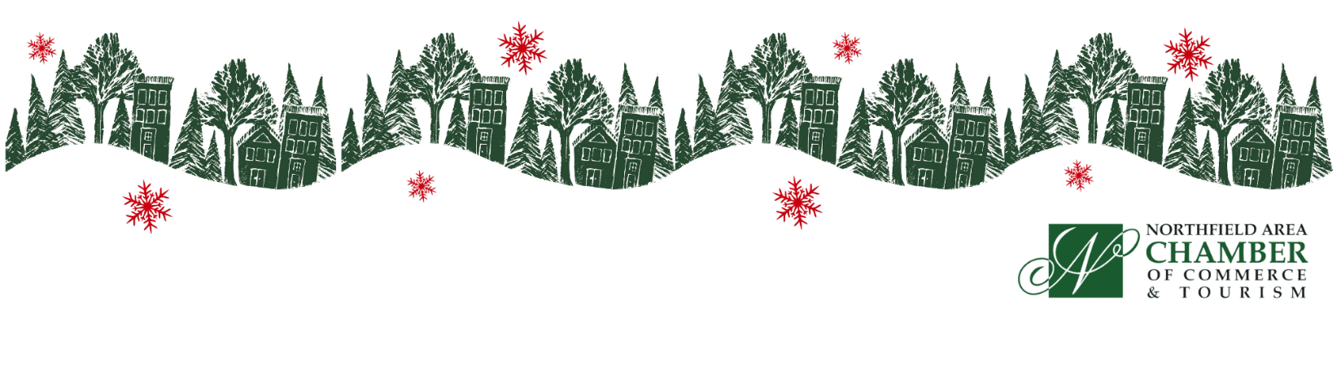

Winter Walk 2025
Thursday, December 11, 4:30 pm

Winter Walk is a magical time for our community. Last year, over 5000 people attended!! They came for the lighted streets, the horse and wagon rides, the music, holiday treats, cocoa, s’mores, bon fires, and, of course, Santa, Frosty, Rudolph and the Grinch!!

Although it is a magical event, Winter Walk does not happen by magic, there is much planning, prep, promotion and participation behind the scenes. That includes the cost of running such a large-scale community event, as well.

If you enjoy Winter Walk and appreciate the community atmosphere that Winter Walk brings to downtown, please consider supporting this event with a contribution of $100, more if you can. Winter Walk is a major economic impact to our community.

Winter Wonderland | Tree Lighting Ceremony at 5:00 on the Square | Luminaria | Horse Drawn Wagons | Snowflake Ornament Hunt | Festive specials | Santa | Rudolph | Frosty | The Grinch | Music on the Showmobile| Carolers | Fire pits | Magical | Tree Decorating Contest | Gingerbread House Contest | Window Decorating Contests | and MORE, so Much MORE.

Here’s a list of things you can do to support the event and help make it magical:

- Contribute: Please consider a contribution ($100.00 for Chamber Members, $125.00 for downtown non-members) to help cover the event expenses. These expenses include the luminarias, promotion/event advertising, horses and wagons, posters, and barricades. The amount of promotion, advertising and numbers of luminarias are directly tied to the contributions received.
- Advertise: The Chamber will coordinate targeted event advertising and promotion throughout Minnesota and beyond. Businesses/organizations are encouraged to purchase their own individual advertising to promote their winter/holiday merchandise, specials and activities. If you’re not contacted by the local media but want to hear about advertising opportunities, please call them. In your advertising, please promote holiday shopping during Winter Walk and throughout the holiday season. Use hashtags #ThisIsNorthfield and #VisitNorthfield.
- Facebook Event Page/ Social Media: Contributors’ activities will be listed and/or promoted on the Northfield’s Winter Walk Facebook event page: Invite your Facebook friends and share on your businesses page.
- Posters: All contributors will receive a Winter Walk poster to display their support of the event. We will send a pdf and jpg of the poster for you to print additional posters if you would like. You are also encouraged to put the jpg in your newsletter, website and social media to encourage your customers/clients to shop during this fun event.
- Lights: To help light up Division Street we are encouraging businesses that are able, place clear holiday lights on the trees outside of their business. Please be cognizant of electrical cords.
- Streets Closed: Please be supportive of the closures. Roads are closed early in the day to ensure all vehicles are off the roads to prepare for the event. It takes several hours to remove cars in violation and for volunteers to place hundreds and hundreds of luminarias.
- Holiday Hospitality: Offer some special “holiday hospitality” such as cider, holiday cookies, gift wrapping, or drawing.

Please Remit Your Entertainment / Activity & Contribution to Chamber as soon as possible to be included in our paid advertising!
Sponsorship Opportunities for Chamber Members

Main Christmas Tree Sponsor: $1,000 (Pending first right of refusal) SOLD
- Decorate a tree on Bridge Square
- Your business name and logo on a sign next to the tree, with time on stage, if you’d like
- Logo will be included on Winter Walk digital and print advertising: ads, posters, website and social media
Santa House Sponsor: $1,000 (Pending first right of refusal) SOLD
- Your business name and logo on a sign next to the Santa House on Bridge Square, with time on stage, if you’d like
- Logo will be included on Winter Walk digital and print advertising: ads, posters, website and social media
4th Street Bridge Lighting Sponsor - $800
- Your business name and logo on a sign on both sides of the bridge, with time on stage, if you’d like
- Logo will be included on Winter Walk digital and print advertising: ads, posters, website and social media
Snowflake Ornament Hunt Sponsor - $750
- Lots of attention! Business name and/or logo will be included with each clue given, and you can award the winner on the Showmobile stage!
- Logo will be included on Winter Walk digital and print advertising: ads, posters, website and social media
Horse and Wagon Sponsor - $600 (2 Available)
- Signage displayed on one side of a horse-drawn wagon as it strolls for hours
- Logo will be included on Winter Walk digital and print advertising: ads, posters, website and social media
Reindeer Sponsor- $500
- Your business name and logo on a sign by the Reindeer, you are welcome to set up a stand here
- Logo will be included on Winter Walk digital and print advertising: ads, posters, website and social media
Winter Candy Land- $500
- Your business name and logo on a sign within Winter Candy Land, you are welcome to set up a stand here
- Logo will be included on Winter Walk digital and print advertising: ads, posters, website and social media
Luminaire Sponsor - $450
- Logo will be included on Winter Walk digital and print advertising: ads, posters, website and social media
Showmobile (Music) Sponsor - $300
- Logo is on a banner hung on the back or front of the Showmobile
- Logo will be included on Winter Walk digital and print advertising: ads, posters, website and social media
Wagon Start Line - $300
- Logo on a sign by 1 of the 3 Horse & Wagon Lines, you are welcome to set up a stand here
- Logo will be included on Winter Walk digital and print advertising: ads, posters, website and social media
Custom Sponsorship with a custom amount and custom creation… call us!

Contribution amount enclosed $ __________________
(Suggested contribution is $100.00 for Chamber Members, $125.00 for downtown non-members)
- Name: ____________________________________________________________________________________
- Business:__________________________________________________________________________________
- Business Address: ___________________________________________________________________________
- Business Email: ____________________________________________________________________________
- Holiday entertainment/activity: ________________________________________________________________
Your contribution means A LOT!
Please submit this to: Winter Walk| Northfield Area Chamber of Commerce & Tourism| 19 Bridge Square | Northfield MN 55057
- Please Remit Your Entertainment / Activity & Contribution to the Chamber as soon as possible to be included in our paid advertising!

We count on your support to make the magic happen!
Feel free to ask to be invoiced. Thank you VERY much.

