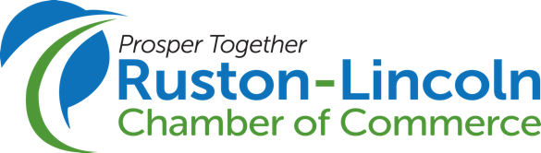

Workforce Development Grant Program Application
Submission Deadline August 31, 2025

As Ruston-Lincoln Parish grows, this grant program is designed to empower local businesses as they educate and train individuals. These grants will help meet current and future business needs, contributing to a robust and sustainable economic environment.

Business Name:

Contact Name:

Contact Phone Number:

Contact Email:

Industry:

Number of employees:

Is your company based in Lincoln Parish? Yes No

Is your company a member of the Ruston-Lincoln Chamber? Yes No

Describe the workforce challenge/need you’re facing:

Grants will range from $500 to $10,000. What is your grant amount request?

How will you utilize this grant?

Do you agree to allow the Chamber to document the awarding and implementation of the grant for Chamber marketing purposes? Yes No

After receiving all submissions, a grant review committee will rank each application before final review and approval by the Executive Committee of the Chamber Board of Directors. The Ruston-Lincoln Chamber will contact you with details about the status of your application once reviews are completed. Grants will be awarded in December. Please contact wdearmon@rustonlincoln.org with questions.

