Blog Post content for the Dakota County Chamber of Commerce Website
Author: Melissa Obermoller, Senior Human Resource Specialist at Insperity
With so much new employment legislation coming at Minnesota organizations in 2023, it’s hard to know where to start! Over the next few newsletters, we’ll break down these regulations and share what you need to know and what steps to take.
The biggest takeaway for most of the regulations in the Omnibus Jobs Bill below is to review your current policies and work with your HR team, a Professional Employers Organization (PEO) such as Insperity, a local employer’s council, or an attorney to ensure compliance.
Here is a timeline of the major milestones passed in 2023 and their effective dates:
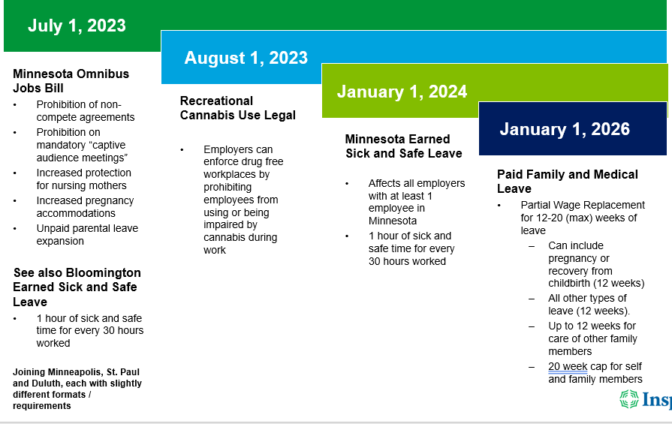
This month let’s review the Omnibus Jobs Bill, which went into effect on July 1, 2023, and includes the following:
- Non-compete agreements between employers and employees, as well as independent contractors, are prohibited.
  - The law is not retroactive. Therefore, existing non-compete agreements may still be enforceable in Minnesota.
  - Next steps: Consult with your attorney on what is enforceable and how to proceed if you currently use non-compete agreements.
- Increased protections for nursing mothers
  - Requires employers to provide reasonable breaks to express milk for as long as there is a need (previously required protections for up to 12 months following the birth of a child).
  - Employers may not deny reasonable lactation breaks.
    - Lactation space must be a “clean, private, and secure” room or other location close to the work area. It must not be a bathroom and must include an electrical outlet.
  - Next steps: Review policies for compliance and ensure there is a private lactation space available in the workplace.
- Increased pregnancy accommodations
  - Law expands coverage to include all employers with at least one employee.
  - Requires employers to provide the following modifications as reasonable accommodations:
    - More frequent or longer break periods: breaks requested for food, water, or restroom may not be denied.
    - Temporary leaves of absence
    - Modification in work schedule or job assignments
  - Requires reinstatement to the same position or one with comparable duties.
  - Employers must notify employees of their rights under this law at the time of hire and when an employee inquires about or requests parental leave.
    - The state of Minnesota will provide sample text for this required notice.
  - Next steps: Review policies for compliance and update managers and supervisors on new regulations. Create and execute a procedure to provide the required document to employees.
- Unpaid parental leave
  - Law expands coverage to all employers with at least one employee in Minnesota (previously 21+ employees)
  - Eliminates minimum service and hours requirements
    - All employees are immediately eligible to take up to 12 weeks of unpaid parental leave upon hire.
  - Next steps: Review policies for compliance and update managers and supervisors on new regulations.
- Mandatory employer-sponsored “captive audience” meetings are prohibited
  - Prohibits employers from threatening to take, or taking, adverse action against employees who fail to attend mandatory meetings, or who refuse to receive communications related to unionization or topics that are political or religious in nature.
  - Next steps: Educate managers and supervisors on this requirement..
- Veterans benefits poster
  - The new law requires every employer with more than 50 full-time employees in Minnesota to display a poster describing the benefits and services available to veterans. The poster must be displayed in a conspicuous place accessible to all employees in the workplace. The state of Minnesota will create and provide the poster.
  - Next steps: Display poster in workplace and/or distribute to remote Minnesota employees.
For more information check out:
Littler: Big Changes to Minnesota's Employment Laws Are Coming Soon
Ogletree Deakins: Minnesota Legislature Moves Omnibus Jobs and Economic Development Bill Forward
Next month we will discuss the new recreational cannabis law and what that means for the workplace.

