DONELSON HERMITAGE CHAMBER OF COMMERCE

2024

Holiday Market at the Mansion

Sponsor Opportunities

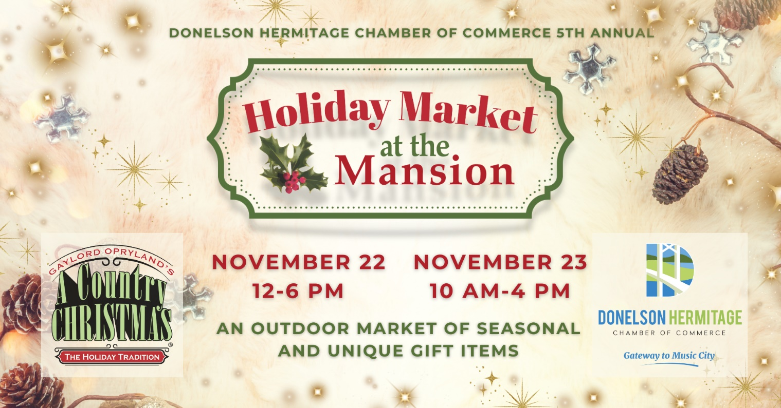

November 22 & 23

at

Andrew Jackson’s The Hermitage

Donelson Hermitage Chamber of Commerce

**2024 Holiday Market at the Mansion**

|  |  |  |  |  |  |  |
| --- | --- | --- | --- | --- | --- | --- |
| **Sponsorship Opportunities** | **~~Presenting Sponsor:~~**  **~~$5,000~~** | **Golden Rings:**  **$2,000** | **Silver Bells:**  **$1,000** | **Holly Berries**  **$750** | **Snow**  **Balls:**  **$250** | **Thankful Sign:**  **$100** |
| Logo or Company name displayed on “Welcome” Entrance Banner | **~~✓~~** |  |  |  |  |  |
| Name of Event with sponsoring company listed as “Presented by” | **~~✓~~** |  |  |  |  |  |
| Logo or Company name placed on print, social media, press releases | **~~✓~~** |  |  |  |  |  |
| Logo or Company name  in individual post on  Chamber Socials | **~~✓~~** | **✓** |  |  |  |  |
| Booth at Event  (10 x 10) | **~~✓~~** | **✓** | **✓** |  |  |  |
| Logo or Company name on shopping bags | **~~✓~~** | **✓** | **✓** | **✓** |  |  |
| Company swag inserted in shopping bag | **~~✓~~** | **✓** | **✓** | **✓** | **✓** |  |
| Logo or Company name with a “Thank You” sign lining the driveway | **~~✓~~** | **✓** | **✓** | **✓** | **✓** | **✓** |

Thank you for your consideration in sponsoring Holiday Market at the Mansion. This event is an outdoor market of seasonal and unique gift items taking place at the historic Andrew Jackson’s Hermitage.

The Donelson Hermitage Chamber of Commerce is organizing this event in partnership with The Hermitage. The Holiday Market will be held rain or shine on Friday, November 22 from 12-6 pm and Saturday, November 23 from 10 am – 4 pm.

Please return the following Sponsorship Form no later than October 11, 2024 at 3:00 pm.

Donelson Hermitage Chamber of Commerce

**2024 Holiday Market at the Mansion**

We are pleased to support the Donelson Hermitage Chamber of Commerce with a *Holiday Market at the Mansion* sponsorship at the level indicated below:

Company/Individual Name: ______________________________________________________

Contact Person: ___________________________________________________________

Address: ___________________________________________________________

City/State/Zip: ___________________________________________________________

Phone(s): ___________________________________________________________

Email Address: ___________________________________________________________

Special Notes: ___________________________________________________________

**Please indicate the desired sponsorship level:**

~~[ ] Presenting Sponsor ($5000)~~ [ ] Holly Berries ($750)

[ ] Golden Rings Sponsor ($2000) [ ] Snow Balls Sponsor ($250)

[ ] Silver Bells Sponsor ($1000) [ ] Thankful Sign Sponsor ($100)

[ ] We are unable to sponsor the event, but would like to show our support for the Donelson Hermitage Chamber of Commerce with the enclosed contribution of: $______

Please choose your form of payment:

[ ] Check is enclosed and made payable to Donelson Hermitage Chamber of Commerce.

[ ] Send an invoice to the above address.

**If applicable, please email your high quality resolution logo to** [**media@d-hchamber.com**](mailto:events@d-hchamber.com)**. Please provide .eps, .png, and .jpeg file formats (vector file preferred) in color and B/W if possible.**

If you have any questions, please do not hesitate to contact Chamber Executive Director, Terri Williams Nutter at [exec@d-hchamber.com](mailto:exec@d-hchamber.com).

Donelson Hermitage Chamber of Commerce

(615) 883 7896

P.O. Box 140200

Nashville, TN 37214

Donelsonhermitagechamber.com