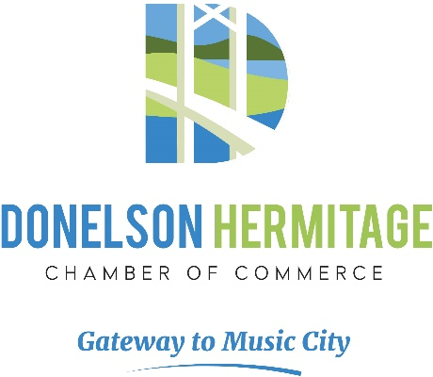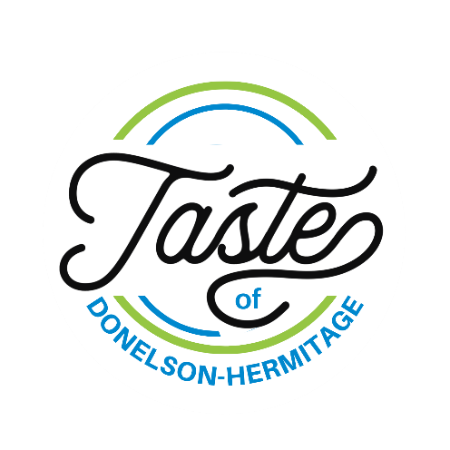

Vendor Agreement
This Taste of Donelson-Hermitage Vendor Agreement (hereinafter the “Agreement”) is by and between __________________________ (hereinafter “Vendor”) and the Donelson Hermitage Chamber of Commerce (hereinafter the “Chamber”).

WHEREAS, Vendor is an entity, partnership, or sole proprietor that wishes to participate in the Taste of Donelson Hermitage event;
WHEREAS, the Chamber has accepted Vendor’s application and has agreed to allow Vendor’s aforementioned participation;

NOW THEREFORE, in consideration of the promises and covenants herein contained, and for other valuable consideration received, the sufficiency of which is hereby acknowledged, it is mutually agreed, by and among the Parties hereto, and each of them, as follows:

1. That Vendor agrees to attend the Taste of Donelson Hermitage event (hereinafter the “Event”) on September 14, 2024, from 4:00 P.M. to 8:00 P.M. at Andrew Jackson’s Hermitage, located at 4580 Rachels Lane, Hermitage, Tennessee, 37076.
2. That Vendor Booth Fees are non-refundable.
3. That if Vendor does not attend the Event, for any reason, Vendor hereby agrees to pay a fee of $100.00 to the Chamber.
4. That if Vendor does not pay the $100.00 fee described above, that Vendor must pay all attorneys’ fees and costs of collections associated with the collection of said fee.

Pg 2

5. That Vendor agrees to protect, indemnify, defend, and hold harmless the Donelson Hermitage Chamber of Commerce, Andrew Jackson’s Hermitage, and all of their collective, directors, members, managers, agents, and employees from all third-party claims, actions, liabilities, losses, damages, expenses, and costs, including but not limited to reasonable attorneys’ fees, that may at any time be incurred by any of them by reason of any claims, suits, or proceedings related to or arising out of Vendor’s participation in the Event. Said claims, suits, or proceedings include, but are not limited to, claims suits and proceedings arising out of products liability or Vendor’s provision of any food or beverage consumed during or any time after the Event and consumed by patrons of the Event or non-patrons of the Event.
6. That Vendor hereby agrees to maintain general liability insurance during the course of performance under this Agreement and during Vendor’s participation at the Event.

Vendor:
Printed Name:
Signature:
Date:

Return to:
Taste of Donelson-Hermitage
Donelson Hermitage Chamber of Commerce
P.O. Box 140200
Nashville, Tennessee 37214-0200
Or email signed copy to events@d-hchamber.com

