Advancing Community Education (A.C.E.) Leadership Program

Building Better Leaders for Stronger Communities

2024/2025 Application – Due 9/3/2024

Unlock Your Potential!

Enroll in the

Advancing Community Education (A.C.E.) Leadership Program!

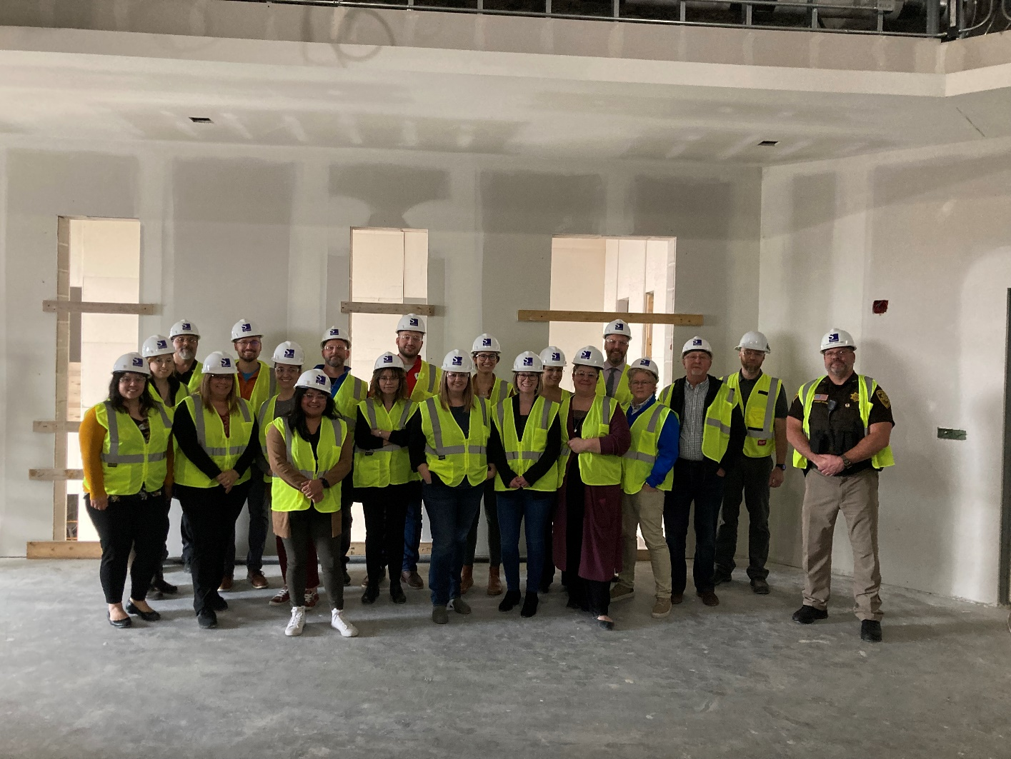

What is the A.C.E. Leadership Program –

• An eight-month program, running from October to May, designed to equip business professionals of all ages and titles with the skills and knowledge for community engagement and leadership development.

You will gain impactful leadership skills, broaden your business and community network, and engage in hands-on community experiences to become a catalyst for positive change.

Program Highlights:

• Complete coursework from Mid-State Technical College focused on leadership development, covering essential topics such as power dynamics and various leadership styles. Upon completing the program, participants earn a 1-credit leadership development credit, which can be transferred to Mid-State’s Leadership Development program or other institutions.

• Each full-day session features a different theme, providing a variety of information and experiences. Examples include Economic Development, Government Service, and Non-Profit.

• Participate in a group project that provides practical applications and directly benefits the community.

• Address community challenges while gaining an understanding of community development.

• Explore a variety of community roles to further develop and enhance your leadership skills post-program.

Program Goals:

• Enhance Personal Leadership Style: Refine and personalize your leadership approach through experiential learning and reflective practice during themed sessions, group projects, and Mid-State Technical College leadership development coursework.

• Foster Collaborative Community Solutions: Collaborate effectively within diverse teams to develop and implement innovative solutions to community challenges identified during the program.

• Establish Long-Term Community Impact: Create lasting positive change within the community by leveraging acquired skills, networks, and initiating ongoing community development beyond the program duration to sustainably improve community well-being over time.

Program Schedule – (Tentative)

Date | Program Session | Overview | Approximate Time
10/10/24  To  10/11/24 | Day and a Half Retreat  Session 1 | Leadership begins with self-awareness and team cohesion. This immersive retreat fosters team building, self-reflection, and goal setting, helping participants connect deeply, establish trust, and set the foundation for collaborative leadership throughout the program. | Arrive day one at 12:30 PM through  Noon the second day
11/14/24 | Non-Profit  Session 2 | Leaders must understand and support the vital role of non-profits in addressing community needs. This session explores the inner workings of non-profits, their challenges, and how effective leadership can partner with these organizations to drive social change and support community welfare. | 8:00 AM – 4:30 PM
12/12/24 | Diversity & Inclusion  Session 3 | Inclusive leadership is essential for building strong, diverse communities. This session focuses on fostering an inclusive mindset, understanding diverse perspectives, and developing strategies to create environments where everyone feels valued and respected, which is crucial for effective leadership. | 8:00 AM – 4:30 PM
1/9/25 | Education & Workforce Development  Session 4 | Visionary leaders recognize the importance of education and workforce development for community prosperity. This session examines the education system, workforce trends, and how leaders can advocate for and implement initiatives that promote lifelong learning, economic opportunity, and the development of a skilled workforce. | 8:00 AM – 4:30 PM

Date Cont. | Program Session | Overview | Approximate Time
2/13/25 | Government Service  Session 5 | Civic leadership requires a thorough understanding of government operations and public service. This session provides insights into how local government functions, the importance of civic engagement, and ways to collaborate with public officials to address community issues, influencing policy and driving change. | 8:00 AM – 4:30 PM
3/13/25 | Economic Development  Session 6 | Effective leaders play a crucial role in fostering economic strength. This session covers the principles of economic development, strategies for attracting and retaining businesses, and the role leaders play in creating a resilient and prosperous economy, emphasizing strategic thinking and proactive planning. | 8:00 AM – 4:30 PM
4/10/25 | Community Exploration  Session 7 | Experiencing community dynamics firsthand is invaluable for informed leadership. This session includes visiting a different community, offering participants a deeper understanding of diverse landscapes, challenges, and success stories, which enhances their ability to lead with insight. | 7:00 AM – 5:00 PM
5/8/25 | Leadership in Action  Session 8 | The final session focuses on practical application of leadership skills. Participants learn how to leverage their leadership abilities to get involved in their community, join committees, boards, and other civic organizations. This session provides actionable steps and strategies for making a meaningful impact and sustaining their leadership journey. | 8:00 AM – 4:30 PM

2024/2025 A.C.E. Leadership Program Application
Applicants may apply independently or be nominated by an individual or organization, with their employer sponsoring and supporting their participation in the program.
Application Due September 3, 2024

Name Home Address
City Zip
Cell Phone Work Phone Email
Are you being represented through a business or organization? Yes No
If yes, name of business: Business Mailing Address City Zip Phone Contact Person Title

Briefly describe your current job responsibilities:

Provide a brief background on yourself, including any involvement in community activities:

What do you consider your most important achievement to date?

What do you consider your best skills (Examples: planning, organization, communication, etc.)?

In your opinion, what are three problems facing the South Wood County area today? Explain these problems, then give recommendations for approaching a possible resolution.

What do you expect to gain from your participation in the A.C.E. Leadership Program?

I understand this is an eight-month course and I fully agree to the following:

- Attend every full-day session including the one and a half day (overnight) retreat and the End-of-Year celebration.
- Be an open-minded participant as well as fully engaged in one’s own learning.
- Attend community project meetings as needed!
- If you cannot make a session, you must contact the Workforce & Community Development Director

**Session Make-up Activity: In the event of a class absence, participants are strongly encouraged to connect with a fellow leadership participant to determine what they missed from the session.

Participant Signature

The fee for the A.C.E. Leadership Program is $800.00 for Chamber members and $960.00 for non-members. Payment is due upon acceptance of your application, with installment plans available
* Contact the HOW Chamber of Commerce for possible Scholarship Opportunities. *
* Member priority will be given in the admission process of this program. *

Make checks payable to: Heart of Wisconsin

Return your completed application and supervisor consent form if applicable by September 3, 2024.
Please return to:
Heart of Wisconsin 1120 Lincoln Street
Wisconsin Rapids WI 54494

EMPLOYEE CONSENT FORM

Dear Supervisor,

Your employee has chosen to participate in the Heart of Wisconsin Chamber of Commerce A.C.E. Leadership Program! We are excited about their involvement. Review the program and tuition requirements, as well as expectations and commitments found in the application. Please discuss them with your employee(s) to minimize schedule conflicts and maximize their opportunities in the program.

Leadership Participant Name:

Employer:

Supervisor Name:

Supervisor Phone Number:

Supervisor Email:

- Why do you think your employee will be a good candidate for participation in the program?

- As an employer, what are your short – and long-term expectations of sending your employee through this program?

Consent
I understand the purpose of the A.C.E. Leadership Program and that attendance, participation, and willingness to experience new activities are key to successful completion. I agree to support the above-named employee by letting them devote the time and resources necessary to complete all components of the program. I realize that if the employee misses more than two of the sessions, they may be asked to withdraw from the program without reimbursement.

I understand the above commitments and agree to be bound by them by signing this application.

Employer’s Signature: Date:

