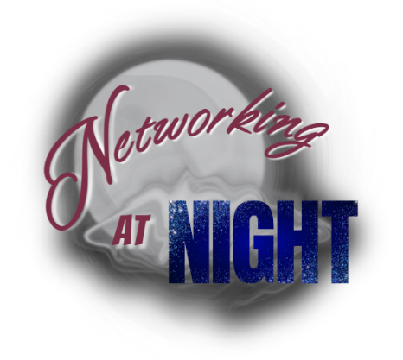

Networking at Night Agreement Form

Description and Purpose:
We extend a warm welcome to you and your company for hosting Networking at Night this month for the Heart of Wisconsin Chamber of Commerce. Networking at Night is an exclusive professional networking and social event designed to help create business contacts and gain exposure for members of the Heart of Wisconsin Chamber and your business contacts. This event promotes awareness of members businesses in a fun, social, and interactive atmosphere after work hours.

General Information:
- Networking at Night hours are typically from 5:00-7:00 p.m., on the 3rd Monday of each month.
- Host must be a member of the Heart of Wisconsin Chamber in good standing.
- The event may be held on the host's business premises or any location designated by the host, if appropriate, with proper permits if necessary, and approved by the Chamber.
- The host is responsible for all costs associated with hosting this event.

Chamber Responsibilities:
- Provide guidance on event coordination and promote the event to members in print and electronic communications, as well as on social media.
- Contact the Host at least three months before the scheduled event to verify the set date and answer any questions.
- Supply Host with copies of registered guest list upon request
- Manage all registration operations, including staff/ambassador support for collecting sign-ins, selling raffle tickets and other questions attendees might have during the event.
- Will communicate with host at the following intervals prior to the event: 3-months, 2-months (marketing/flyer information), 1-month, and 1-week.
- Provides the raffle license needed to sell raffle tickets.
- Will provide two, $25.00 Chamber Gift Certificates as raffle prizes.
- Provide beer/malt beverage license if needed.

Host Responsibilities:
- Payment of $50.00 is required to secure your spot. This cost is non-refundable but will be reimbursed at the event in the form of two, $25.00 Chamber Gift Certificates as raffle prizes.
- Provide information (i.e. information, photos, directions and/or parking instructions) for pre-promotion to the Heart of Wisconsin Chamber of Commerce to announce Networking at Night event.
- Have available staff to host the event and allow for optional tours.
- Food & Beverage: Finance, coordinate, and supply an adequate amount of complimentary appetizers and beverages. If you will be providing alcohol beverages and do not have a license, instruction will need to be given by the Chamber.
- Provide one table with two chairs for registration near the main entrance.
- Prepare a brief (5 minutes or less) presentation to welcome guests and share insight into your business.
- Provide two to four raffle prizes to be used for raffle drawings. Chamber Ambassadors will sell raffle tickets during registration.
- Provide updated logo.
- Entertainment is optional at the host’s discretion.
- Network with new and familiar guests and have a great time showcasing your business!
3-months before event:
- Fill out form and return to the Chamber
- Check relevant information related to alcohol
- I will be serving alcohol at the event and I carry a license
- I will be serving alcohol at the event and I need a license provide by the Chamber
- I will not be serving alcohol
- I would like to use the street/City property outside my business during this event
- The Chamber will provide business with a list of Chamber businesses that may help with the event such as food trucks, entertainment, etc.
2-months before event:
- Let the Chamber know if you are planning on having entertainment
- Let the Chamber know what types of refreshments you will be having (such as appetizers, hors d’oeuvres, snacks)
- Get the Chamber any pictures or ideas you have in relation to the flyer that the Chamber is putting together for this event.
1-month before event:
- Reach out to the Chamber with any questions you have pertaining to the event
- Share the Facebook event that was created by the Chamber on your social media pages
- Invite your customers to attend!
- Put together 2-4 raffle prizes for the event (raffle prize donations go to the continuing support of our business community through the Heart of Wisconsin Chamber)
- Confirm any drinks, food
- Share event flyer in-store and on social media platforms
Please return this form and deposit to the Heart of Wisconsin Chamber of Commerce to secure your spot for hosting this event. It is our pleasure to partner with you to ensure your event is successful.

The Heart of Wisconsin staff, board of directors, ambassadors and fellow members appreciate your participation hosting a successful Networking at Night event and hope it will be a fun opportunity for you as well.

By signing this form, I agree to the responsibilities of the host business. I agree to work with the Chamber of Commerce to promote this event. This includes providing event information 90 days prior to the event, not creating a separate flyer for the event, and understanding that the proceeds of the raffle prizes go to the Heart of Wisconsin Chamber of Commerce to continue support area businesses.

Name of Host Business: _____________________________________________

Contact Name: ____________________________________________________

Preferred Phone Number: ___________________________________________

Contact Email Address: _____________________________________________

Venue Address: ___________________________________________________

Preferred method of communication: (circle) Phone Email

Will there be a co-host for this event? (circle) NO YES…..if so, WHO ____________________

I will need the Chamber to provide an alcohol license for the event. (circle) YES NO

Event Date: ____________________________ Second-Choice Event Date: _______________________

Host Signature: ________________________________________________ Date: _____/_____/_______

For questions, please contact the Heart of Wisconsin Events & Engagement Director, Lacy Alling at communications@wisconsinrapidschamber.com or by phone at 715-422-4859.

