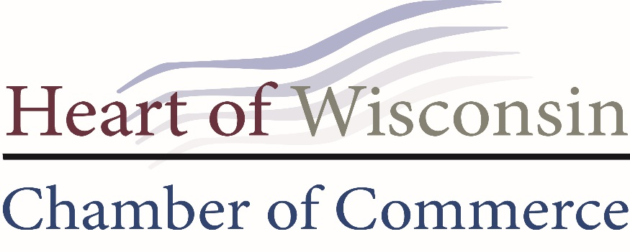

AMBASSADOR HANDBOOK
2024
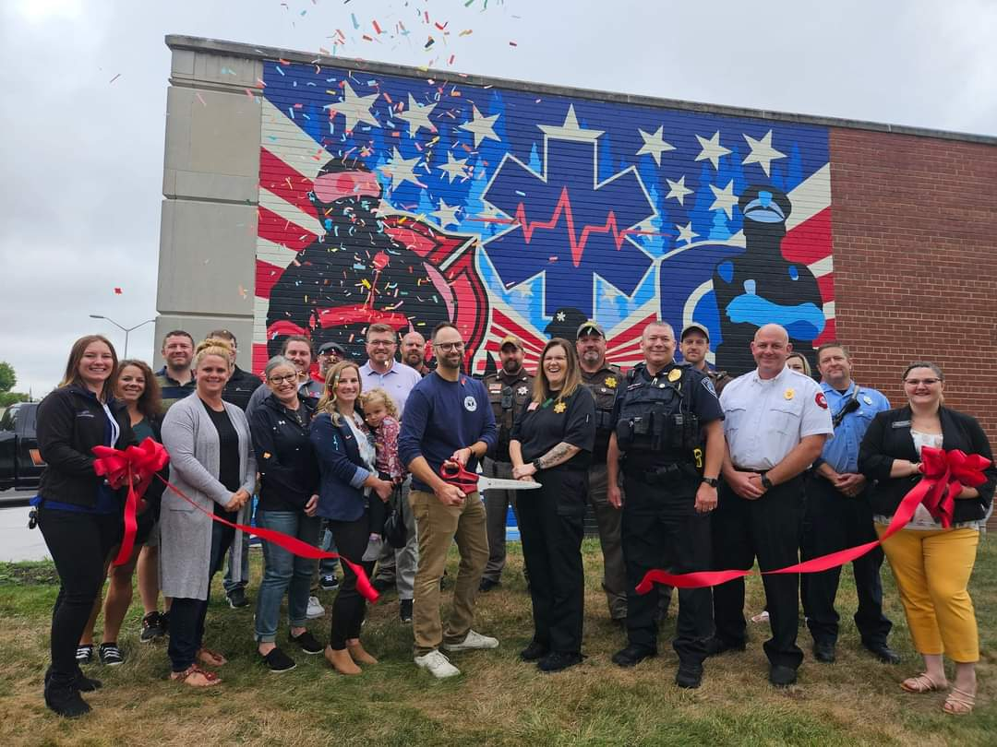

WHO WE ARE
The Ambassador Committee is an enthusiastic and dedicated group of professional business volunteers. The committee acts as a goodwill arm of the Chamber and is an extension of the Chamber team, working with staff to provide value for investors and actively support recruitment efforts. The Ambassadors serve as the backbone of the Chamber’s volunteer force.

All ambassadors must be an investor themselves or an employee/representative of an investor. Ambassadors must be members in good standing and must have the full support and endorsement of their employer to allow the flexibility required to effectively carry out their responsibilities. The Ambassadors represent both the Chamber and their business/organization. As such, committee members are responsible to uphold the committee’s code of conduct and may be removed in the event of a breach/they fail to meet expectations.
Interested parties may apply to serve as a Chamber Ambassador. Applications are reviewed and approved for acceptance and renewed by the Committee Chair and Chamber Ambassador Liaison. A one-to-one interview shall follow applications to determine if the applicant’s goals and values meet or exceed those of the Ambassador Program. There is no limit to the number of years an ambassador may serve.

WHAT DOES AN AMBASSADOR DO
Ambassadors help promote the Heart of Wisconsin Chamber of Commerce to the business community and support Chamber functions. Ambassadors actively advocate for the Chamber, communicating the benefits, programs, and privileges of becoming a Chamber investor. The Ambassadors act as public relations representatives on behalf of the Chamber, not only at Chamber events, but other community events as well.

Through enthusiastic Chamber representation, Ambassadors seek opportunities to educate, promote and share the benefits of being a Chamber investor with the business community. Serving as an Ambassador offers a great deal of visibility and builds credibility for your own business, while generating stronger relationships.

WHAT’S IN IT FOR YOU
As front runners in the business community, Ambassadors build relationships within the community, expand visibility for yourself and your business/organization, grow your knowledge of the business community activities and events, and gain access to leadership and volunteer opportunities. By volunteering at Chamber events and attending Ambassador meetings, you are kept current on what is happening within the Chamber and our community. Awards and/or other incentives are also available based on point expectations (explained on page 3).

L ET’S GET TOGETHER
The Ambassadors will meet monthly, on the first Friday of the month, at 7:00 am at different businesses in the community. Each Ambassador is expected to attend.

AMBASSADOR QUALIFICATIONS
- Must be a Heart of Wisconsin Chamber of Commerce Investor in good standing
- No outstanding invoices with all event invoices paid by event date
- Complete and return the Ambassador application
- Make a 1-year commitment to the Ambassador Program from January-December (if you start during an another month, you will be asked to renew in January)
- Willing to volunteer their time towards Chamber events and programs
- Wear your Ambassador name tag to all Chamber functions
- Meet once per month as a committee
- Possess a working knowledge of the Chamber, its staff, board, and benefits of membership
- Adhere to the Chamber Code of Conduct
- Meet or exceed the minimum requirement of annual activity points (see Ambassador points below)
**During an extraordinary busy time for their business, an Ambassador may take a 90-day leave of absence without it counting against them. Anyone desiring to do so, must submit this in writing to the Chamber staff liaison. No points will be taken or given during this time. Only one 90 day leave per year will be allowed.

AMBASSADOR POINTS
Ambassadors can earn recognition and rewards through their involvement. Ambassadors should strive to achieve a minimum number of points annually to remain an ambassador. Those falling short of the annual goal may be asked to a meeting with the Committee Chair and the Chamber CEO to discuss if this committee is still a good fit.
Annual Point Minimum = 40 points
AMBASSADOR/GREETER ROLES:
- Volunteer at an event as greeter, table host, etc..(i.e. Networking @ Nite, Lunch by the River, Vendor Fairs, Business Expo) – 2 points (each event)
- Attend a Ribbon Cutting/Groundbreaking – 1 point (each event)
- Attend Ambassador Committee Meeting – 2 points (each meeting)
- Assist with Shop Local campaigns – 3 points (each event)
- Assist with parades – 3 points (each event)
- Assist with Chamber Signature Events (Annual Meeting/Golf Classic) – 4 points (each event)
CHAMBER GROWTH:
- Recruit a new Chamber investor (must submit payment and must have been inactive a minimum of 1 year) – 5 points
- Meeting with new/current investor (includes investor renewal) – 3 points (each meeting)
- Bring a prospective investor to any Chamber event – 2 points (each guest)
- Make welcome call to new investor – 1 point (each call)
- Investor portal training upon request – 2 points (each training)
- Business advocacy (includes bringing issues/concerns/suggestions to Chamber) – 1 point (each)
- Active member of a Chamber or approved community committee or Leads group – 2 points (each committee group)

RECOGNITION / BENEFITS
Being a Chamber Ambassador puts you and your business in the spotlight! That gives your company free publicity as a support of new businesses coming to the area. Events also provide a great opportunity to have a few minutes of fun and network with other business owners, movers and shakers in the community. Remember, Chamber Ambassadors are often one of the first community representatives a new business owner meets so it’s the perfect opportunity to make new business connections.
As a Chamber Ambassador, you will receive:
- Listing on the Ambassador page of the Chamber website – This listing will include your contact info including business name and a picture of you (please submit a picture).

- Acknowledgement at Annual Dinner as Ambassadors – please wear your nametags.

- Opportunity to be Ambassador of the Year – The top three Ambassadors with the highest point total will be eligible for the award during Annual Meeting. This will include an award, mention at Annual Meeting, press release, and acknowledgment on the website and Facebook page.

- Additional Ambassador Perks:
- Gold Level Ambassadors – Ambassadors who receive 100+ points in a calendar year.
Will receive a complimentary ticket to the Annual Dinner ($75.00 value)

- Silver Level Ambassadors – Ambassadors who receive 75-99 points in a calendar
year.
Will receive a complimentary ticket to one of the following (Legislative Breakfast, Women in Business Luncheon, or Diversity in Business Luncheon - $35.00 value)

- Bronze Level Ambassadors – Ambassadors who receive 50-74 points in a calendar year.
Will receive a complimentary breakfast at an Ambassador meeting (up to a $15.00 value)

AMBASSADOR APPLICATION/COMMITMENT FORM
Thank you for your interest in the Heart of Wisconsin Chamber of Commerce Ambassador Committee!

Personal Information Date:___/___/____
Your Name: __________________________________________________________________________
First M.I. Last

Business Name: _______________________________________________________________________

Mailing address: _______________________________________________________________________
Street City State Zip

Business Phone: ________________________ Email: _________________________________________

Website: _______________________________ Birthday: _____________________________________

General Questions:
- Business Description: ____________________________________________________________
______________________________________________________________________________
- What is your current position: ______________________________________________________
______________________________________________________________________________
- How long have you worked for your current employer/been self-employed? _______________
______________________________________________________________________________
- What is your impression of the Heart of Wisconsin Chamber of Commerce and what services do you find most beneficial and why? ________________________________________________________________________
______________________________________________________________________________
______________________________________________________________________________
AMBASSADOR QUESTIONS:
- Why are you interested in serving as an ambassador? ___________________________________
______________________________________________________________________________
______________________________________________________________________________
- How did you hear about the Ambassador Committee? __________________________________
______________________________________________________________________________
______________________________________________________________________________
- How will you promote our Chamber? _______________________________________________
______________________________________________________________________________
______________________________________________________________________________
______________________________________________________________________________
- I like to receive recognition by: _____________________________________________________
- Favorite local store(s): ____________________________________________________________
- Favorite thing about our community: ________________________________________________
- This or That (circle)
    - Books OR Movie - Tea OR Coffee - Donut OR Bagel
    - Sweet OR Salty - Call OR Text - Flower OR Plant
    - Come Late OR Leave Early - Candy OR Chocolate
TELL US WHERE YOU SHINE AND HAVE THE TIME
- Make a welcome call (phone or in-person) to new investors.
- Delivering renewal investor packets, along with touching base with that investor
- Investor visits
- Provide Investor portal training upon request.
- Attend ribbon cuttings as an official representative of the Chamber.
- Greeting and welcoming new and current Chamber investors and introducing them to other investors at Chamber events
- Participate in Chamber or approved Community Committees
- Business advocacy
- Inviting investors to Chamber networking events.
- Volunteer for Events
  - Networking @ Nite
  - Vendor Fairs
  - Lucky’s Summer Golf Classic
  - Annual Meeting & Awards
  - Shop Local events.
  - Lunch by the River
  - Gather by the Gazebo
  - Rendezvous in the Park
  - Parades
  - Business Expo
  - Selling Chamber Cash
AMBASSADORS CODE OF CONDUCT
In accepting the position as an Ambassador of the Heart of Wisconsin Chamber of Commerce, I recognize that with this comes a commitment to support the organization, its programs and policies, and to assist in meeting the mission and vision of the Chamber. As a representative of both the Chamber and my employer/business/organization, I agree to:
- Consistently and positively promote the Heart of Wisconsin Chamber of Commerce.
- Exhibit courteous and professional behavior while representing the Chamber at all programs and events, as Ambassadors have a profound effect on the Chamber membership and the community at large.
- Honor my commitment to Ambassadors. This includes prompt and consistent attendance at Ambassador meetings and completing any tasks for which I have volunteered and being responsible to find a replacement for work assignments when I am unable to meet a commitment.
- Demonstrate an appropriate image of the Chamber by wearing my official Ambassador badge and professional business attire at networking events and ribbon cuttings or wearing appropriate, event-specific attire for special Chamber events and activities.
- Display the highest standards in communication and responsiveness; promptly return calls and emails. This includes communication with investors, fellow Ambassadors, and Chamber staff.
- Actively engage with the Chamber as someone who enjoys the benefits of the organization and has a desire to serve by sharing these benefits with others.
- Refrain from publicly disparaging the business practices of fellow investors and refrain from condoning or engaging in misrepresentation or unethical practices.
- Practice restraint if I choose to consume alcohol beverages, which are offered at Chamber events.
- Respect all persons with whom I interact by honoring boundaries, recognizing there are different opinions, understandings and comfort levels, and accepting that it is possible to agree to disagree. Conduct which is discriminating or harassing in any way, or making sexual, racial, political, or other inappropriate comments, jokes, or innuendo is strictly prohibited.
- Regard my status as an Ambassador to speak only for myself and make it clear that it is my personal stance, and not that of the Chamber, when asked my opinion while serving in an official capacity.
- Maintain neutrality regarding political candidates and refrain from wearing campaign buttons or displaying campaign literature while serving in an official capacity. The Chamber does not endorse candidates, it only takes positions on issues related to business impact.
- Support and adhere to decisions made by the Ambassador Committee, the Chamber’s Board of Directors, and the Chamber’s President/CEO, regardless of individual feelings or opinions.
I intend to uphold these policies and become an active and contributing member of the Ambassador Committee. I understand that violations of this Code of Conduct may result in disciplinary actions, including the removal from the committee. I acknowledge that I have received a copy of the Chamber Code of Conduct and that I am responsible for reading and following it.
______________________________ _____________________________________ ___/___/____
Printed Name - Ambassador Signature Date

______________________________ _____________________________________ ___/___/____
Printed Name – Employer if applicable Signature Date

