CHBA’s GrowthZone Website
Web pages to recreate (and why we picked them)
Website credentials to access locked-down areas on current CHBA site:
login: kim.stout@growthzone.com
p/w: CHBA150459
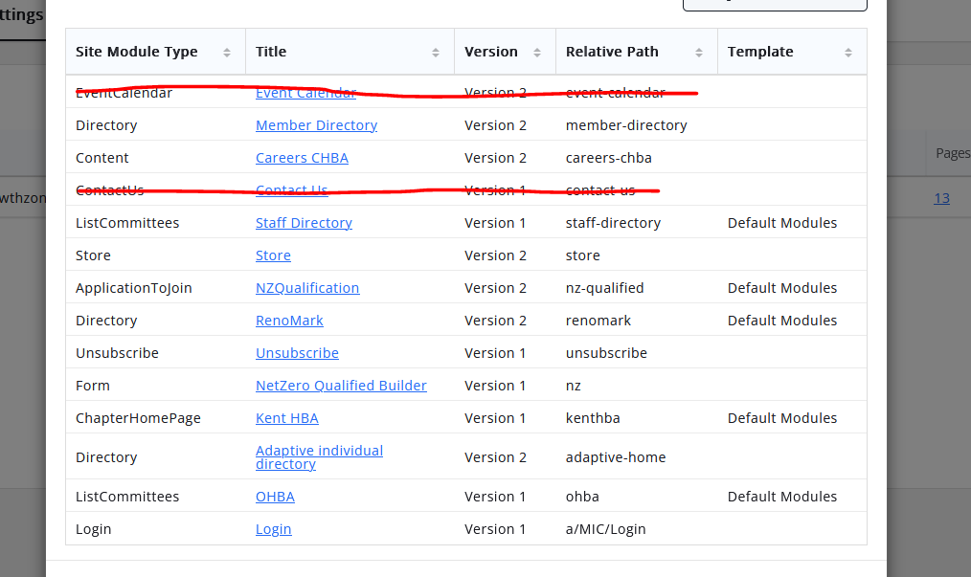
- DONE Events page (why: is there a way to have the events page that you already mocked up be a bit more visual, e.g. with an image involved? Note that not all of our events that we display have registration, and if they do, we often display the event weeks or months before registration is ready to go. https://www.chba.ca/CHBA/About/Events/CHBA/Events.aspx?hkey=bdefc3ea-dede-4679-8bfc-d92490e3cdbe
- DONE Net Zero Homes page (why: in addition to being a lot of work (thank you!) this page has several elements (including embedded video, buttons, collapsed content, a map directory, and carousel slideshows) – it’s quite complex. We actually have a revamp planned for our existing page which we’d like you to build off of, rather than the one that’s currently live on our website. They’re very similar though. Exisitng page can be found here https://www.chba.ca/CHBA/BuyingNew/Net_Zero_Homes/CHBA/BuyingNew/Net-Zero-Homes.aspx?hkey=3f12d1b0-f1d8-4f70-8983-2a090aa10839 and draft redesign page can be found here: https://canadianhomebuilders-my.sharepoint.com/:b:/g/personal/chloe_perreault_chba_ca/EeMZ-X6hwe5BkJoJluoW2sMBvNOul2AIbANNehy7p38Eyw?e=RTtwWQ
- DONE Careers in Residential Construction Page (why? We’d like an example of having a video banner (ideally it’s full width as per the template, which we were unable to do on our current website, a grid layout, and a bunch of links) https://www.chba.ca/CHBA/HousingCanada/Careers_In_Residential_Construction/CHBA/Careers_in_Residential_Construction/Careers_in_Residential_Construction.aspx?hkey=899ca649-ae6b-4506-8a6c-eea625b7ae15
- DONE Builders’ Manual (why? This page has links to store items, and link to a PDF that’s currently saved on our server, so we want to see how that process works in GrowthZone) https://www.chba.ca/CHBA/Publications/Builder-Manual.aspx
- DONE Newsroom (why? This page has links to our news items, including the title, when they were published, and a summary/teaser which is automated. We’d like to see what the comparable looks like in GrowthZone, and if GrowthZone has the ability to tag news items by topic. The page also includes buttons and how a content box with a border displays) https://www.chba.ca/CHBA/About/Newsroom/CHBA/NewsPage.aspx?hkey=4cadb8f0-43a7-49b5-8176-3a274f6f23a8
- DONE? Linking to Info Hub/pending decision. Webinar archive (why? This entire page needs to be locked down to members. We want to see what that looks like. It’s also huge and we could use the help getting it set up!) To view, you’ll need to login with credentials. https://www.chba.ca/CHBA/Publications/CHBA-Member-Webinars/CHBA_Member_Webinars.aspx?WebsiteKey=3f616792-1a1f-474b-89e9-e4b665be1d9d
- Housing Awards Page (why? This page makes use of tabbed content and we’d like an example of how it displays and how to do it) https://www.chba.ca/CHBA/Housing_in_Canada/Canadian_Housing_Awards/REFERENCE_Housing_Awards.aspx
- Executive Officers Council Page (why? This page is open to the public but ALSO has content that is locked down to a specific group (in this case, our Executive Officers). We want to see how that displays in GrowthZone and have an example of how to do it. It also has a Wikipedia style content search function that only pulls up content from a specific sub-folder. To access the page you will need to be logged in with the credentials provided. https://www.chba.ca/CHBA/CommitteesCouncils/Executive_Officers__Council/CHBA/CommitteesCouncils/EOC.aspx?hkey=3394dc2a-32e8-4122-a788-9accb34af5e4
- Industry Impacts (why? Looking to see how PowerBI is displayed) https://www.chba.ca/impacts
- Local Associations (why? Looking to see how google maps (or another map feature) displays… plus there’s a lot of links that will help us out!) https://www.chba.ca/CHBA/About/Local_Associations/CHBA/Local_Associations.aspx?hkey=2dabd2a9-8b2b-4b99-8355-540e9e6eb433
- My Association Page (why? This page has several queries embedded based on the user’s HBA – it’s pulling lists of contacts from our database that are pre-filtered, and we’d like to see how that displays) https://www.chba.ca/CHBA/My_HBA/My_Association/CHBA/My_HBA/My_HBA.aspx?hkey=659ed870-53f5-4329-b058-8e61c0f97b93
- Blog homepage (why? We’re interested to see how the GrowthZone blog function works, or how to manipulate it so that it works the way we want it to. Core functions include needing categories, showing the latest posts, being very visually appealing (right now we have key images for posts that dynamically display on the lists of recent posts or when searching by category), and ideally having some sort of automated further reading at the bottom of blog posts (e.g. most popular from that category, or next/previous posts). https://blog.chba.ca/

