NAIOP
MEMBERS ONLY
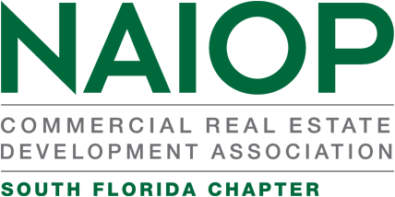

2023 Committee Registration Form

Name: ___________________________________________________________________________ Member #: __________________________________
Last First Middle
COMPANY: _____________________________________________________________________________________________________________________
Name Address City Zip
Contact Information: __(____) ______________________(____)__________________________________________________________________________
Telephone Fax Email

Below are listed the NAIOP South Florida Standing Committees. Please indicate on which Committee you would like to serve. Please rank your top three (3) preferences. Please rank your preferences from 1 to 3. While we will guarantee your placement on a committee, we cannot guarantee you will get your first choice.
For those who make their living within the commercial real estate industry, NAIOP has become a major resource for networking, educational programs, workshops, and special events that elevate the level of professional expertise. To maximize the benefits of NAIOP Membership, involvement is the key. What We Do
- Each year, our Chapter plans bus tours showcasing the latest commercial real estate projects by sub-market in Broward, Miami-Dade and Palm Beach.
- Our Chapter hosts an annual Trade Show Event featuring over 70 exhibitors, presenting our diversity in commercial real estate.
- NAIOP recognizes the best of the best in our business with our annual “Awards of Excellence Event” for projects and peers.
- We plan events with a select speaker panel, addressing solutions to vital issues to our commercial industry, and foster the education of the real estate professional by offering special courses of study in those areas that impact the industry (Capital Markets, Financial Analysis, and Legal aspects of the real estate contract).
- Our Chapter is considered actively engaged in political advocacy.
- Our Annual Golf Tournament has contributed more than $250K to local charitable organizations from its proceeds over the years (Habitat for Humanity, 4Kids of S. FL, Jack and Jill, His House Children’s Home, Taylor’s Closet, and Home Safe foster care programs).
BE AN ACTIVE PART OF WHAT WE DO. GET INVOLVED! CHOOSE A COMMITTEE.

____ AWARDS OF EXCELLENCE COMMITTEE
____ BROWARD COUNTY BUS TOUR COMMITTEE
____ COMMUNICATIONS COMMITTEE
____ DEVELOPING LEADERS COMMITTEE
____ EVENT REGISTRATION COMMITTEEE
____ GOLF COMMITTEE
____ MEMBERSHIP COMMITTEE
____ MIAMI DADE BUS TOUR COMMITTEE
____ MIAMI STEERING COMMITTEE
____ PALM BEACH COUNTY COMMITTEE
____ PROGRAM COMMITTEE
____ PUBLIC AFFAIRS COMMITTEE

