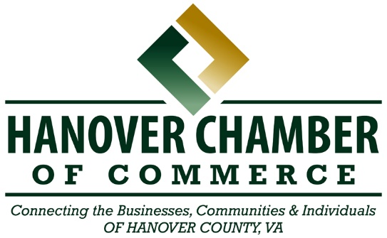

Ribbon Cutting Reservation

The Hanover Chamber of Commerce is excited to celebrate your Ribbon Cutting! Please complete the following reservation form and email it to Audrey Biringer, audrey@hanoverchamberva.com, so we can publish your event on our website calendar.
Company Information
Company Name: Click or tap here to enter text.
Contact Name: Click or tap here to enter text. Contact Email: Click or tap here to enter text.
Physical Business Address: Click or tap here to enter text.
Company Website: Click or tap here to enter text.
Facebook/Instagram: Click or tap here to enter text.
Event Dates & Times
Requested Date of Ribbon Cutting: Click or tap to enter a date.
Event Start Time: Click or tap here to enter text. Event End Time: Click or tap here to enter text.
Ribbon Cutting Time: Click or tap here to enter text.
Additional Details
1. Please share a few sentences about your company and/or the event. We will use this section in our online announcement.
Click or tap here to enter text.
2. Be sure to email our office a copy of your logo in jpeg format, at least 400 pixels in size.
☐Yes, we have already sent our logo. ☐Yes, we are sending our logo with this form.
3. Ribbon Cuttings are complimentary for new/existing Chamber members. We are happy to work with non-member businesses for a one-time $150 ribbon cutting services fee, due at the opening event. This covers marketing and administrative efforts, inclusion in e-blasts and photo-sharing.
☐ I/We have submitted a membership application. ☐ I/We will pay the $150 services fee.

Thank you!

