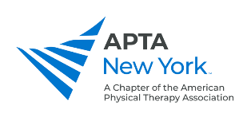
2023 Lobby Day Summary Report
Please use this form to report on meetings with your Senators and Assembly Members.
Names of Meeting Attendee(s)*
APTA New York District Represented*
Email*
City*
State*
Zip Code*
Meeting Date
Name of Legislator*
Name of Staffers Present
If the legislator offered to sponsor, which bill(s) will they sponsor?

Bills/Issues Discussed*
Please note specific bill numbers in your response.

Legislator/Staff Response*

