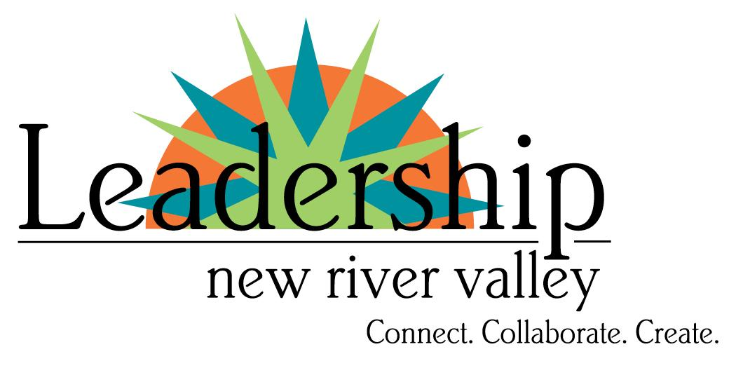

Application for Position of Dean
Service Term 2027-2028

Created by:


Facilitated by:
Marianne Washington, 2026 Chamber Board Chair
Paige Guynn, Chamber Board
Whitney Stokes, Chamber Board
Terri Welch, Chamber Board
Steve Baffuto, President & CEO
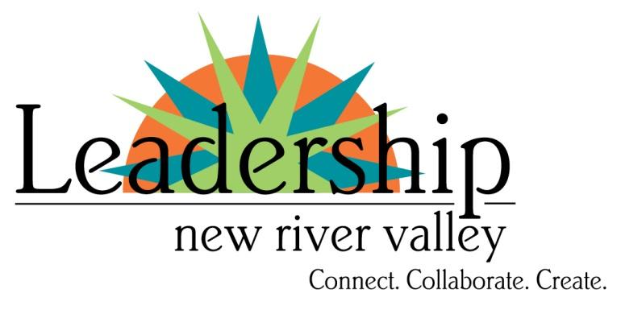
PURPOSE
The objective of Leadership New River Valley is to assist in the development of community leaders by providing participants from diverse backgrounds with an understanding of the strengths, weaknesses, opportunities, and issues facing the community. The program will also foster the development of leadership skills and techniques in an environment that encourages the establishment of new relationships and communication networks between the participants.

SELECTION PROCESS
The job description will be posted in July. It will be posted in the newsletter, Facebook, and sent to all members. Applications will be accepted until July 15. Interviews will be conducted and selected deans will be introduced to the board of directors at the following board meeting.

POSITION TRADE AGREEMENT
If selected to serve as Leadership NRV Dean for 2027 & 2028, there is no payment for this volunteer position. The employer of the alumni serving as Dean will be given an annual sponsorship for Leadership NRV valued at $500. The employer must sign this agreement stating they understand the responsibilities and trade agreement.

POSITION RESPONSIBILITIES
See job description.

Type or print legibly in black ink. It is important that each section is fully completed. Please feel free to add or attach additional information. The application must be signed by both applicant and employer/sponsor; unless the business is owned by the applicant. Please return the completed application to the LNRV Team by August 15 at lnrv@montgomerycc.org.

PERSONAL
Name ___________________________________________________________________________________
(First) (Last) (MI)
Home Address:

________________________________________________________________________________________________________

Business Address:

________________________________________________________________________________________________________
__________________ | _____________________ | _______________________ | ___________________________
Home Phone | Business Phone | Cell Phone | Email Address

LEADERSHIP NRV
When did you graduate from Leadership NRV? _________________
Who was the program facilitator? ___________________________
Did you enjoy the readings? What book was used to guide you and your learning?
_________________________________________________________________________________

EMPLOYMENT
Present Employer________________________________________________________________
Starting Date________________
Please circle the one category which best describes the area in which you presently work/serve.
Community/Non-profit ~ Business ~ Education ~ Government ~ Healthcare ~ Media ~ Religion ~ Law ~ Trade
Other (Please specify) _____________________________________________________________________
Briefly describe your responsibilities in your employment & Job Title: ________________________________________________________________________________________________________________________________________________________________________________________

THE WHY (why do you find this opportunity appealing?)
________________________________________________________________________________________________________________________________________________________________________________________________________________________________________________________________________________________________________________________________________________________________________________________________________________________________________________________________________________________________________________________________________________________________________________________________________________________________________________________________________________________________________________________________________________________________________________________________________________________________________________________________________________________________________________________________________________________________________________________________________________________________________________________________________________________________________________________________________________________________________________________________________________________________________________________________________________________________________________________________________

COMMUNITY INVOLVEMENT
Since your graduation from Leadership NRV, what programs, policies or non-profits have you focused your energies and passion?
- Organization_________________________________________________________________________________

Assignment/position_________________________________________________________________________
Describe responsibilities or leadership position held _______________________________________________
____________________________________________________________________________________________________________________________________________________________________________
- Organization_________________________________________________________________________________

Assignment/position_________________________________________________________________________
Describe responsibilities or leadership position held _______________________________________________
____________________________________________________________________________________________________________________________________________________________________________

GENERAL INFORMATION
How will holding this position help you professionally?
__________________________________________________________________________________________________________________________________________________________________________________
How will holding this position help Leadership NRV?
__________________________________________________________________________________________________________________________________________________________________________________

TRADE AGREEMENT UNDERSTANDING
I understand that this position is unpaid. I understand that my employer, who is a Chamber member, will receive a $500 Annual Leadership NRV Sponsorship which can elevate the Invest for Success.
__________________________________________/___________________________________________________
Person responsible for contract Date Billing Address

COMMITMENT
If selected as a Dean for Leadership NRV, I am willing to commit to the functions of the job description.
I hereby certify that the information in this application is complete and correct. I understand the above commitment and agree to be bound by it in signing this application.

________________________________________/________ |  | ________________________________________/__________
Applicant’s Signature | Date | Employer’s Signature Date
Application Checklist:
______ Application signed by applicant
______ Application signed by employer/sponsor (if appropriate)

