T H E M O N T G O M E R Y C O U N T Y C H A M B E R O F C O M M E R C E P R E S E N T S

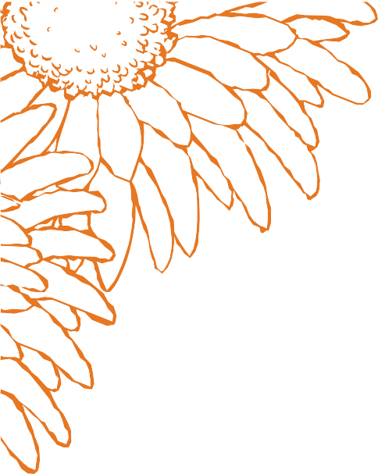

LEADERSHIP NRV & BUSINESS

AFTER HOURS

Opening Session and Business After Hours 2/20

History & Culture Day and Business After Hours 3/20 Business After Hours 4/7 at Auburn Hills Golf Club

Healthcare Day 4/17

Bocce Ball Tournament and Business After Hours 5/8 Arts Day 5/15

Infrastructure Day and Business After Hours 6/26

Government & Rec Day and Business After Hours 7/17 Economic Development & Housing Day and

Business After Hours 8/21

Education Day and Business After Hours 9/18

Public Safety Day and Business After Hours 10/16 Closing Retreat 11/13

Leadership NRV Graduation 11/19

Annual Meeting & Awards Dinner 12/4

**2025**