

Beginner’s Guide to Using Generative AI Tools

Section 1: Overview – Using Generative AI Tools: Prompts, Priming and Personas 1
Prompts: The Heart of Interaction 1
Priming: Setting the Stage 1
Personas: Tailoring Interactions 2
Section 2: Prompts – Writing Effective Instructions 2
Helpful Prompting Tips 4
Section 3: Priming – Understanding Priming for Context 4
Impact of Priming 4
Helpful Priming Tips 5
Section 4: Personas – Developing Tailored Personas 5
Why Personas Matter 5
Making the Most of Personas 5
Helpful Tips for Personas 6
Section 5: General Tips and Tricks 6
Section 6: Use Cases 7
Section 7: Comparison Chart – ChatGPT vs. Google Gemini 8
Section 8: Examples 9

Section 1: Overview – Using Generative AI Tools: Prompts, Priming and Personas
Generative AI tools are powerful AI tools designed to understand and respond to your requests in creative ways. This guide will equip you with the basics of using Generative AI tools including prompts, priming, personas, and their potential applications in the workplace.
Prompts: The Heart of Interaction
Prompts are instructions or starting points that guide the AI in what to generate. The clearer and more specific your prompts are, the better the AI tool will understand your needs and deliver the desired output. Here are some examples:
- Simple questions: “What is the purpose of an employee handbook?”
- Creative prompts: “Write blog post about humorous HR experiences.”
- Informative prompts: “Summarize the key points of the article on employee engagement.”

Priming: Setting the Stage
Priming refers to how users interact with a generative AI tool through prompts. Effective priming involves crafting clear, concise prompts that provide enough context and direction for the AI to understand the desired output.
Think of priming as providing the AI tool with background information to enhance its understanding of your request.
For instance, if you want a factsheet about documentation, a simple prompt like “documentation” might result in nonsensical gibberish. But a prompt like “Write a factsheet about how to document employee misconduct” gives the AI more information to work with, increasing the chances of a successful outcome.
Why Priming is Important
- Better Outputs: Clear priming helps the AI understand your intent and generate outputs that are relevant, accurate, and aligned with your expectations.
- Reduced Bias: A well-primed model that’s trained on balanced data is less likely to produce biased or discriminatory outputs.
- Efficiency: Effective priming saves time and effort by guiding the AI toward the desired outcome from the start.

Personas: Tailoring Interactions
AI tools can adapt their communication style based on the persona you assign it. This allows for more natural and engaging interactions.
- Informative persona: Use this for research and factual inquiries.
- Creative persona: Ideal for brainstorming ideas, generating creative text formats like poems or scripts.
- Instructive persona: When you need guidance or step-by-step instructions.

Why Personas Are Important
- Better user experience: By understanding your target audience through personas, you can design AI tools that cater to their specific needs and expectations. This leads to a more intuitive and enjoyable experience for the users.
- Improved decision-making: When developing AI features, personas can help you prioritize which functionalities to focus on. You can see things from the user’s perspective and make choices that benefit them the most.
- Targeted marketing: AI can be used to analyze data and generate personas, which can then be used for marketing campaigns. This allows you to tailor your message to resonate with specific user groups, leading to better engagement.

Section 2: Prompts – Writing Effective Instructions
First and foremost, AI tools are just a tool, not a brain – you need to instruct it on what you want it to do by using prompts. Developing effective prompts is important to lead the AI to develop the output you desire. Here is how prompts help:
- Shape the Output: A vague prompt like “write a blog” will lead to vague results. By specifying the genre, tone, or even including a starting sentence, you shape the AI's generation to better match your desires.

- Increase Accuracy: Specific prompts can improve the accuracy of the AI’s output. If you're looking for factual information, providing context or keywords helps the AI find relevant data and avoid making things up.

- Control Style and Tone: Want a funny or thought-provoking blog? Prompts can influence the writing style and emotional tone of the AI’s creation.

- Provide Inspiration: Overcoming writer’s block? Prompts can provide a springboard for new ideas and help you get past creative roadblocks.
Getting Started
- Understand the Task: What do you want the tool to accomplish? Be clear and concise. Instead of saying “Write something creative,” try “Write a humorous article about a manager coaching a new employee.”

- Use Natural Language: Talk to the tool like you would a friend. Avoid overly technical jargon or complex sentence structures.

- Provide Context: The more information you give, the better the tool can understand your request.
- Example: “Write a blog post about how employers can overcome resistance to DEI work. Target audience: Business executives looking for ways to stay committed to sustaining drivers, equitable and inclusive working environments.”

- Leverage Keywords: Include relevant keywords to guide the tool in the right direction.
- Example: “Generate a business proposal for a new marketing campaign. Keywords: social media marketing, brand awareness, target audience.”

- Break it Down: Complex tasks can be overwhelming for AI. Break them into smaller, more manageable prompts.
- Example: Instead of asking for an entire sales presentation, ask for “A description highlighting the key features of our training series.”

Examples:
- Task: Social Media Post
- Prompt: Generate 3 social media post ideas for a new training series, highlighting the key learning objectives. (Link to online registration page)
- Task: Summarize information
- Prompt: Briefly summarize the key points of this article [link to article].
- Task: Brainstorm ideas
- Prompt: Give me some creative ideas for marketing a new service we are offering.
- Task: Writing tool
- Prompt: Write a 500-word blog post in a friendly and informative tone targeted toward new HR professionals on how to be successful in their new HR role.

Helpful Prompting Tips

- Start simple: Begin with basic prompts and gradually increase complexity as you get comfortable.
- Use examples: If possible, provide the tool with examples of the desired output (e.g., a specific writing style or tone).
- Proofread and refine: Don’t be afraid to rephrase your prompt for better results.
- Experiment and have fun! The more you explore, the better you’ll understand the tool’s capabilities.

Additional Resources:
- You can find more information and examples on the Prompt Engineering Guide https://www.promptingguide.ai/

Section 3: Priming – Understanding Priming for Context
Priming is like setting the context for a conversation or priming a wall before painting it. First set the conditions for a successful outcome. Priming allows the AI tool to leverage the provided information and tailor its responses accordingly. This can be beneficial for tasks like generating different writing styles, summarizing specific viewpoints, or translating languages with a desired tone.

Impact of Priming
- Accuracy: Proper priming can steer Gemini toward providing more accurate and relevant information based on the introduced context.
- Creativity: Priming can spark the model’s creativity by introducing new concepts or references that can be woven into its response.

Examples:
- Scenario: You want Gemini to write a blog on coaching.
- Without Priming: The response might be generic.
- With Priming: “Write a conversational blog article on the benefits of coaching for an employee with a lot of growth potential, but that is struggling to perform in their current role.” This primes Gemini with a specific scenario potentially leading to a more realistic article.

- Scenario: You need a factual summary of a current event.
- Without Priming: The response might lack crucial details.
- With Priming: “Provide a summary of the recent increase in unionization efforts across the United States from the perspective of employees.” This steers the AI toward a specific viewpoint within the historical event.

Helpful Priming Tips
- Focus on relevant information: Provide context directly related to the desired outcome.
- Be clear and concise: Avoid overwhelming the model with excessive information.
- Use diverse priming: Experiment with different phrasings and perspectives to achieve well-rounded results.

Section 4: Personas – Developing Tailored Personas
Imagine having a conversation with someone and tailoring your words to their specific interests and background. Large language AI tools benefit similarly when you introduce personas.
A persona acts as a virtual character representing your target audience. By providing details about this persona, you guide the AI tool toward crafting outputs that resonate better with them.

Why Personas Matter
- Targeted Communication: Specifying a persona allows the AI tool to mimic the voice, tone, and style that would connect best with your intended audience.
- Increased Relevancy: Content generated with a persona in mind is more likely to address the specific needs, wants, and challenges of your target group.
- Enhanced Engagement: When users feel the communication aligns with their perspective, they are more likely to be engaged and receptive to the information presented.

Making the Most of Personas
- Define Your Audience: Start by outlining the key characteristics of your target audience. Consider demographics like age, profession, and interests.
- Craft the Persona: Give your persona a name and flesh out their background. What are their goals, challenges, and preferred communication style (formal, informal, humorous)?

Example:
Prompt: Write a blog post about the benefits of using a fitness tracker.
Without Persona:
- The post might use generic language, applicable to a broad audience.
With Persona:
- Persona: Sarah, a busy professional in her 30s, looking to improve her overall health and activity level.
- Tailored Post: The language would be direct and solution-oriented, highlighting features like step counting and sleep monitoring relevant to Sarah’s goals.

Helpful Tips for Personas
- Be Specific: The more details you provide about your persona, the better the AI tool can understand their perspective.
- Use Descriptive Language: When describing your persona, use adjectives and phrases that reflect their personality and communication style.
- Provide Context: Briefly mention the situation or purpose of the communication to further guide the AI tool.

Section 5: General Tips and Tricks
- Google Gemini creates drafts. This allows you to see multiple versions of content from the prompts entered. You may find various parts of the drafts you like to incorporate into your work. ChatGPT does not create drafts.
- Ask the tool questions like: What am I not asking that I should? What am I missing? What else should I ask?
- Ask the tool to “cite sources” to verify your information.
- Ask the tool to edit and condense content.
- Ask the tool to check for plagiarism.
- Google Gemini allows you to easily modify the response as well.
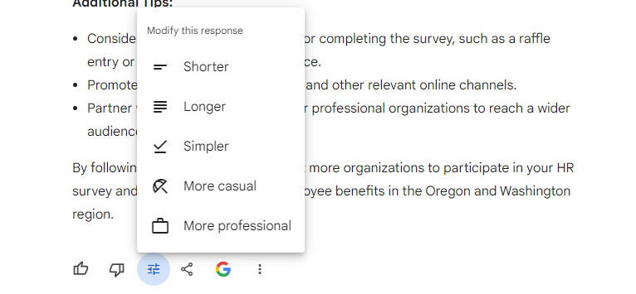

Section 6: Use Cases
- Case studies
- Breakout room activities
- Blogs
- Promotions
- Guides
- Factsheets
- Training descriptions
- Summarizing content, including websites
- Practicing difficult conversations
- Simple explanations to more complex concepts
- Excel formulas
- Language translation
- Forms and templates
- Policies
- Training content
- Editing and condensing content
- Comparisons (comparing websites, products, articles, etc.)
- As an assistant or advisor
- Idea generation

Section 7: Comparison Chart – ChatGPT vs. Google Gemini
 | ChatGPT | Google Gemini
Creators | OpenAI | Google Gemini
Models | GPT-4o (all users); GPT-4 (paid tiers only) | Gemini Pro; Gemini 1.5 Pro (Gemini Advanced only)
Context window | 128,000 tokens | Up to 1 million tokens
Supported languages | Over 50 | Over 40
Platforms | Web, mobile, and desktop | Web and mobile
Sign in | Requires any email address. | Requires a Google account (work or personal)
Sources of Data | Pre-trained on a huge set of data. Includes Common Crawl, articles, books, and Wikipedia. | Pre-trained with data from webpages, source codes, and other datasets in multiple languages + access to Google in real-time.
Pricing | Free; ChatGPT Plus is available for $20/month | Free; Gemini Advanced is available for $19.99/month (first 2 months free)
Languages | 95+ languages | 40+ languages
Research | Can also crawl the web and cite sources, but often provides fake sources called hallucinations. | Can click double check response - fact check - can cite if you tell it to
Images | Cannot retrieve images from the web but will provide links to relevant images if prompted to do so. | Can surface relevant images from Google search. Can click on image and Gemini will open web page with image source in new browser tab.
Analyze images | Can upload images with prompt and ask it to analyze the image. Can also ask it to caption an image. | Can upload images with prompt and ask it to analyze the image. Can also ask it to caption an image.
Conversational learning | Can learn from the conversations it has with people and “hold context” | Gemini does this in a very limited way at present
Drafts | ChatGPT only produces a single answer to each query. | Gemini will produce multiple responses to queries you propose to it which you can access by pressing “View Drafts”
Capacity to read responses aloud | ChatGPT does not have text-to-speech capabilities. | Gemini has native text-to-speech capabilities

Section 8: Examples
Example: Using ChatGPT as an Assistant/Advisor
Prompt: I need you to act as a marketing expert and assist me with designing a 3-month marketing campaign to announce a new product feature. Let us start off easily and begin building the plan. To start, I would like you to ask me several questions that you would need to know to start the marketing plan (Please note SEO on our existing site is not part of the scope). Can you please provide a list of questions that you will need to design a marketing campaign and wait for my answers to begin building the plan?
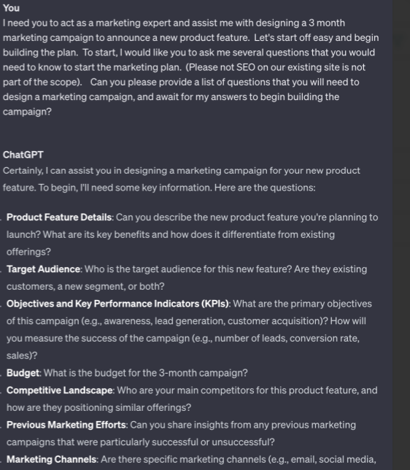

Example: Prompting-Only vs. Prompting + Priming vs. Prompting + Priming + Persona with Google Gemini
Version 1 – Prompt Only: Write a short announcement for open enrollment.
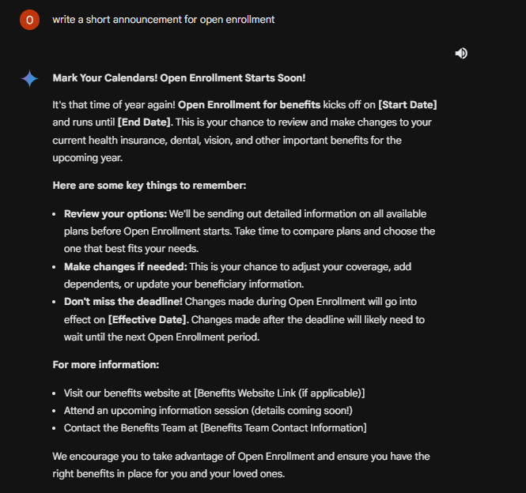

Version 2 – Prompt + Priming: Write a short announcement for open enrollment. (Prompt) Be brief and to the point in tone. Highlight the importance of participating in a timely manner. (Priming)
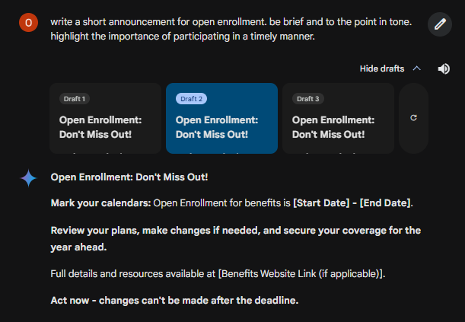
Version 3 – Prompt + Priming + Persona: Write a short announcement for open enrollment (Prompt). Be brief and to the point in tone. Highlight the importance of participating in a timely manner (Priming). Busy employees who need quick and actionable information will receive this announcement (Persona).
