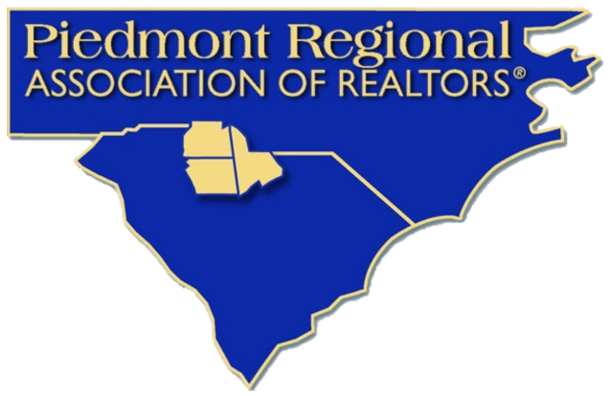
2026 PRAR Member Survey Results
Member Summary Report
109 total survey responses

Thank You for Sharing Your Voice
Thank you to every member who completed the 2026 PRAR Member Survey. Your feedback helps the Board of Directors and staff make informed decisions about programs, services, advocacy, communications, and future priorities for the Association.
We received 109 member responses. Here is what we heard and how PRAR will use your feedback.

What Members Told Us
Measure | Count | Percent
Overall satisfied/very satisfied | 92 of 106 | 87%
Membership valuable or better | 94 of 105 | 90%
PRAR communication effective | 94 of 99 | 95%
Connected/somewhat connected | 79 of 106 | 75%
Open to change | 83 of 99 | 84%
Community/housing role important | 77 of 92 | 84%

Major Takeaways
- Members are highly satisfied with PRAR overall.
- Continuing education, staff support, MLS access, and legal/industry updates are among the most valued benefits.
- Email remains the most preferred way to receive important information.
- Time and scheduling are the biggest barriers to participation.
- Members want PRAR to keep focusing on education, professionalism, technology/AI, broker support, and advocacy.
- Housing affordability, interest rates, and economic uncertainty are the top regional challenges identified.

Overall, how satisfied are you with PRAR as your REALTOR association?
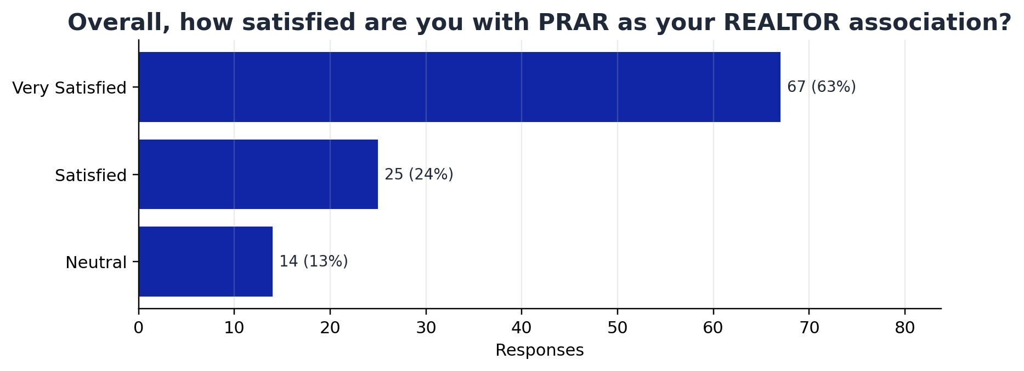
What this suggests: Member sentiment is strongly positive. Among those who answered, 87% were satisfied or very satisfied, and no respondents selected dissatisfied options.
Response option | Count | Percent
Very Satisfied | 67 | 63.2%
Satisfied | 25 | 23.6%
Neutral | 14 | 13.2%

Which PRAR services or benefits do you value MOST?
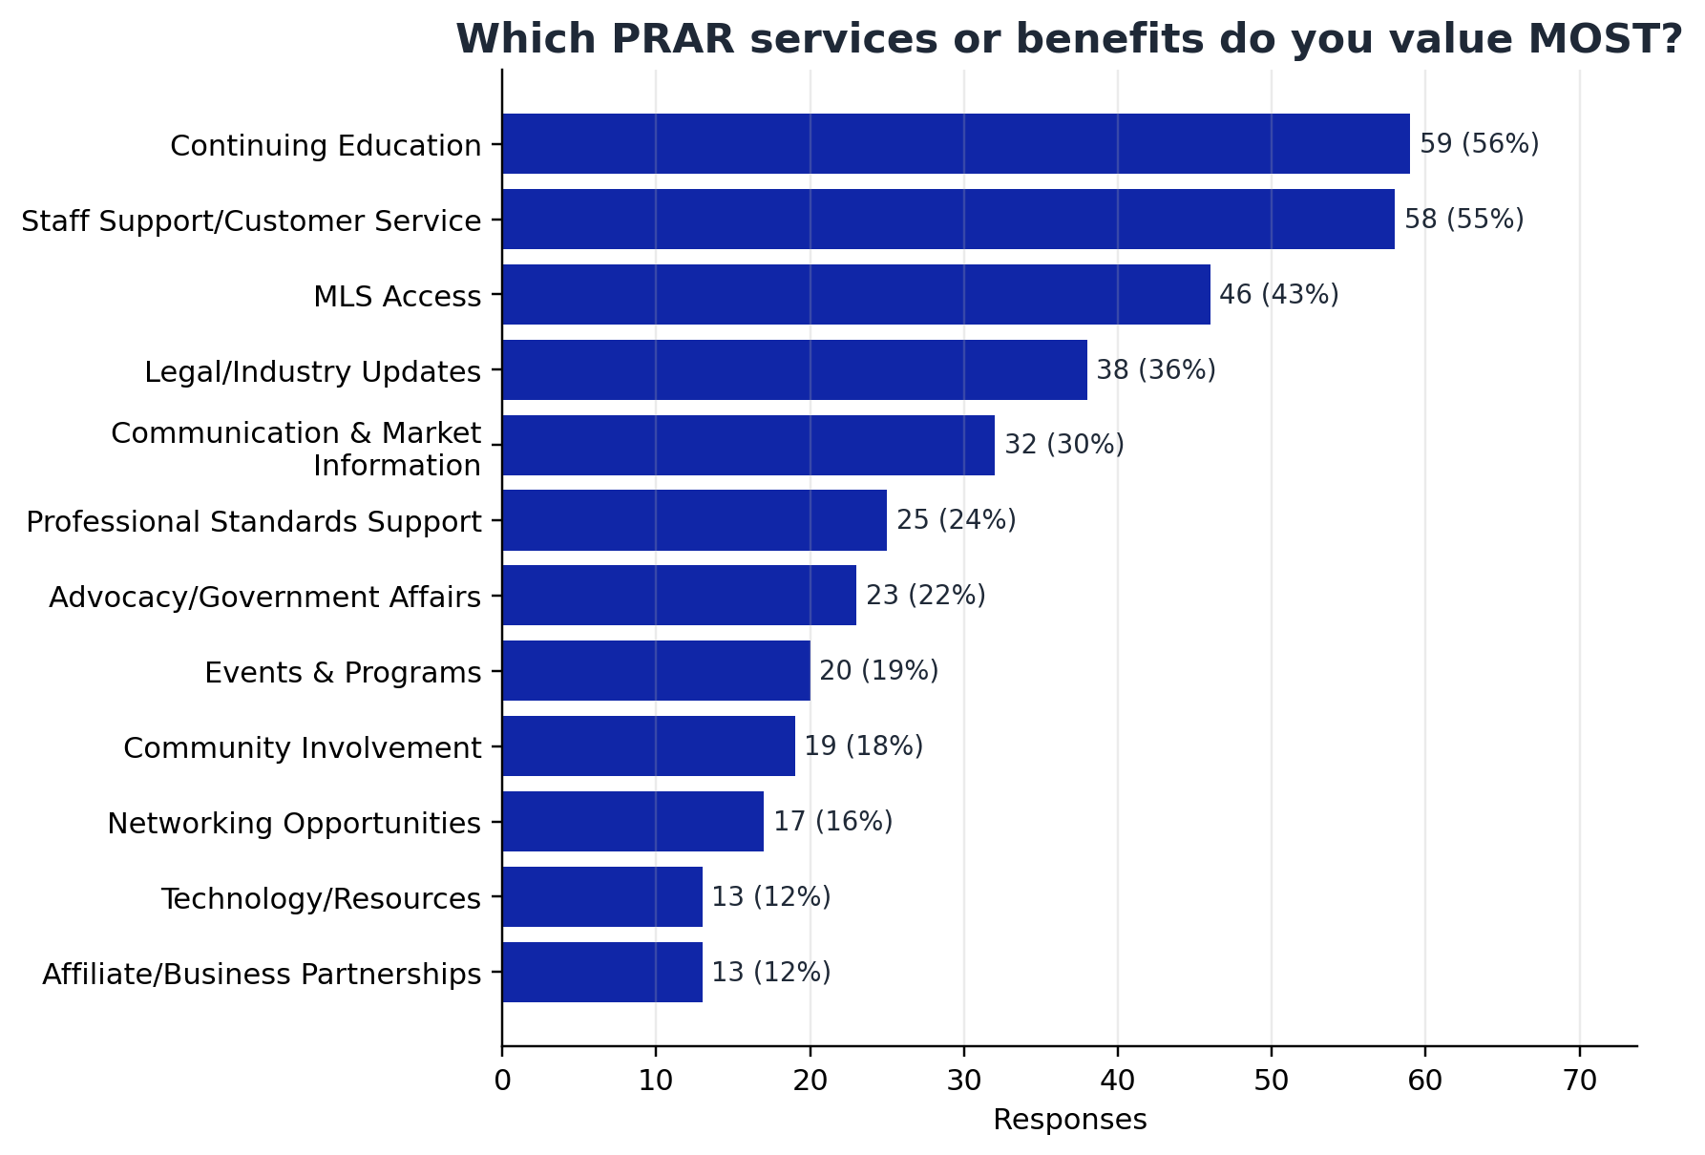
What this suggests: Continuing education and staff support/customer service are the top perceived benefits, followed by MLS access and legal/industry updates.
Response option | Count | Percent
Continuing Education | 59 | 55.7%
Staff Support/Customer Service | 58 | 54.7%
MLS Access | 46 | 43.4%
Legal/Industry Updates | 38 | 35.8%
Communication & Market Information | 32 | 30.2%
Professional Standards Support | 25 | 23.6%
Advocacy/Government Affairs | 23 | 21.7%
Events & Programs | 20 | 18.9%
Community Involvement | 19 | 17.9%
Networking Opportunities | 17 | 16.0%
Technology/Resources | 13 | 12.3%
Affiliate/Business Partnerships | 13 | 12.3%
Leadership Opportunities | 6 | 5.7%
Other | 2 | 1.9%

How Effectively does PRAR keep members informed with timely updates and information?
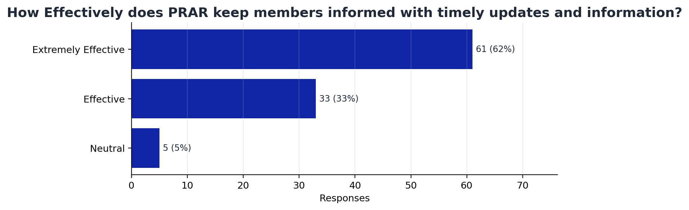
What this suggests: Communication is one of PRAR's strongest performance areas. 95% of respondents who answered said PRAR is effective or extremely effective at keeping members informed.
Response option | Count | Percent
Extremely Effective | 61 | 61.6%
Effective | 33 | 33.3%
Neutral | 5 | 5.1%

What prevents you from participating more often in PRAR events, programs, or committees?
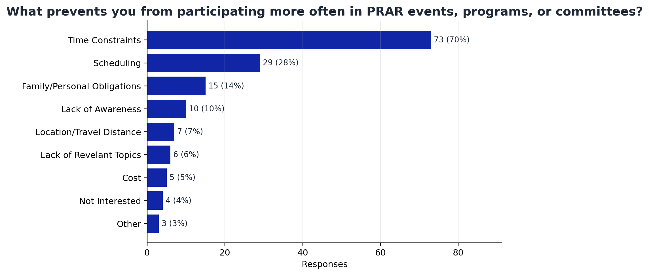
What this suggests: Time constraints and scheduling are the main participation barriers. This suggests value in varied program times, concise formats, virtual options, and strong advance notice.
Response option | Count | Percent
Time Constraints | 73 | 70.2%
Scheduling | 29 | 27.9%
Family/Personal Obligations | 15 | 14.4%
Lack of Awareness | 10 | 9.6%
Location/Travel Distance | 7 | 6.7%
Lack of Revelant Topics | 6 | 5.8%
Cost | 5 | 4.8%
Not Interested | 4 | 3.8%
Other | 3 | 2.9%

Whate should PRAR prioritize MOST over the next 3-5 years?
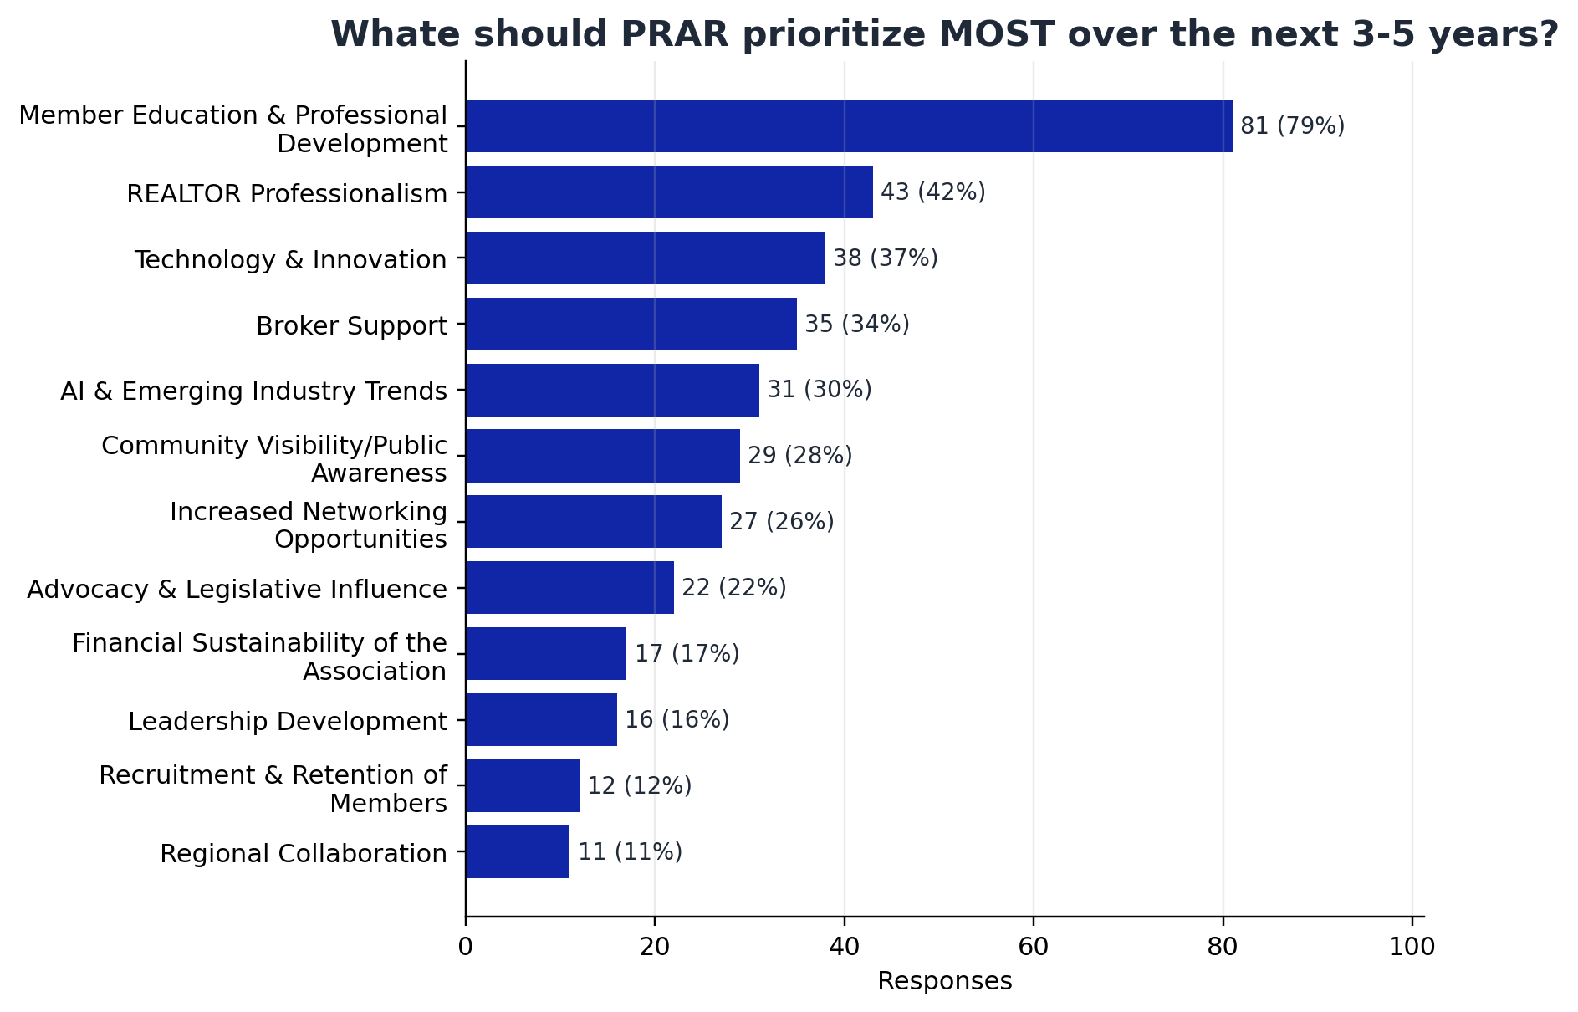
What this suggests: Education and professional development is the clearest future priority, followed by professionalism, technology/innovation, broker support, and AI/emerging industry trends.
Response option | Count | Percent
Member Education & Professional Development | 81 | 79.4%
REALTOR Professionalism | 43 | 42.2%
Technology & Innovation | 38 | 37.3%
Broker Support | 35 | 34.3%
AI & Emerging Industry Trends | 31 | 30.4%
Community Visibility/Public Awareness | 29 | 28.4%
Increased Networking Opportunities | 27 | 26.5%
Advocacy & Legislative Influence | 22 | 21.6%
Financial Sustainability of the Association | 17 | 16.7%
Leadership Development | 16 | 15.7%
Recruitment & Retention of Members | 12 | 11.8%
Regional Collaboration | 11 | 10.8%
Consumer Outreach | 5 | 4.9%
Diversity & Iclusion | 5 | 4.9%

What do you believe are the biggest challenges facing REALTORS in our region over the next 5 years?
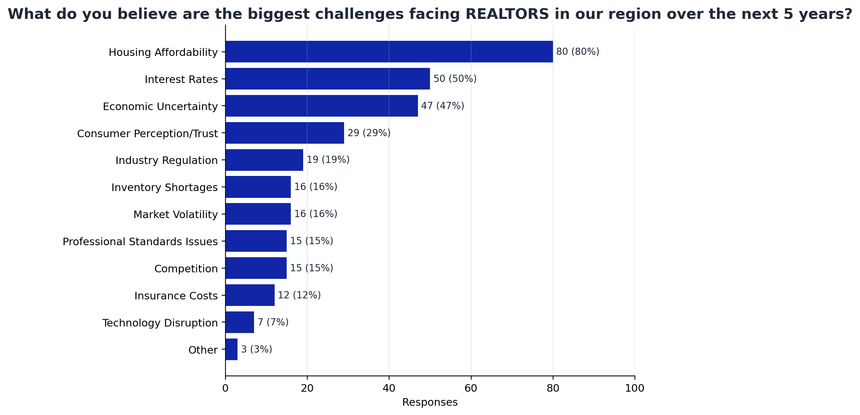
What this suggests: The leading regional concerns are housing affordability, interest rates, and economic uncertainty. These findings align well with PRAR's advocacy and community-facing work.
Response option | Count | Percent
Housing Affordability | 80 | 80.0%
Interest Rates | 50 | 50.0%
Economic Uncertainty | 47 | 47.0%
Consumer Perception/Trust | 29 | 29.0%
Industry Regulation | 19 | 19.0%
Inventory Shortages | 16 | 16.0%
Market Volatility | 16 | 16.0%
Professional Standards Issues | 15 | 15.0%
Competition | 15 | 15.0%
Insurance Costs | 12 | 12.0%
Technology Disruption | 7 | 7.0%
Other | 3 | 3.0%
Agent tecruitment/Retention | 2 | 2.0%

How important is it for PRAR to play a stronger role in community and housing issues?
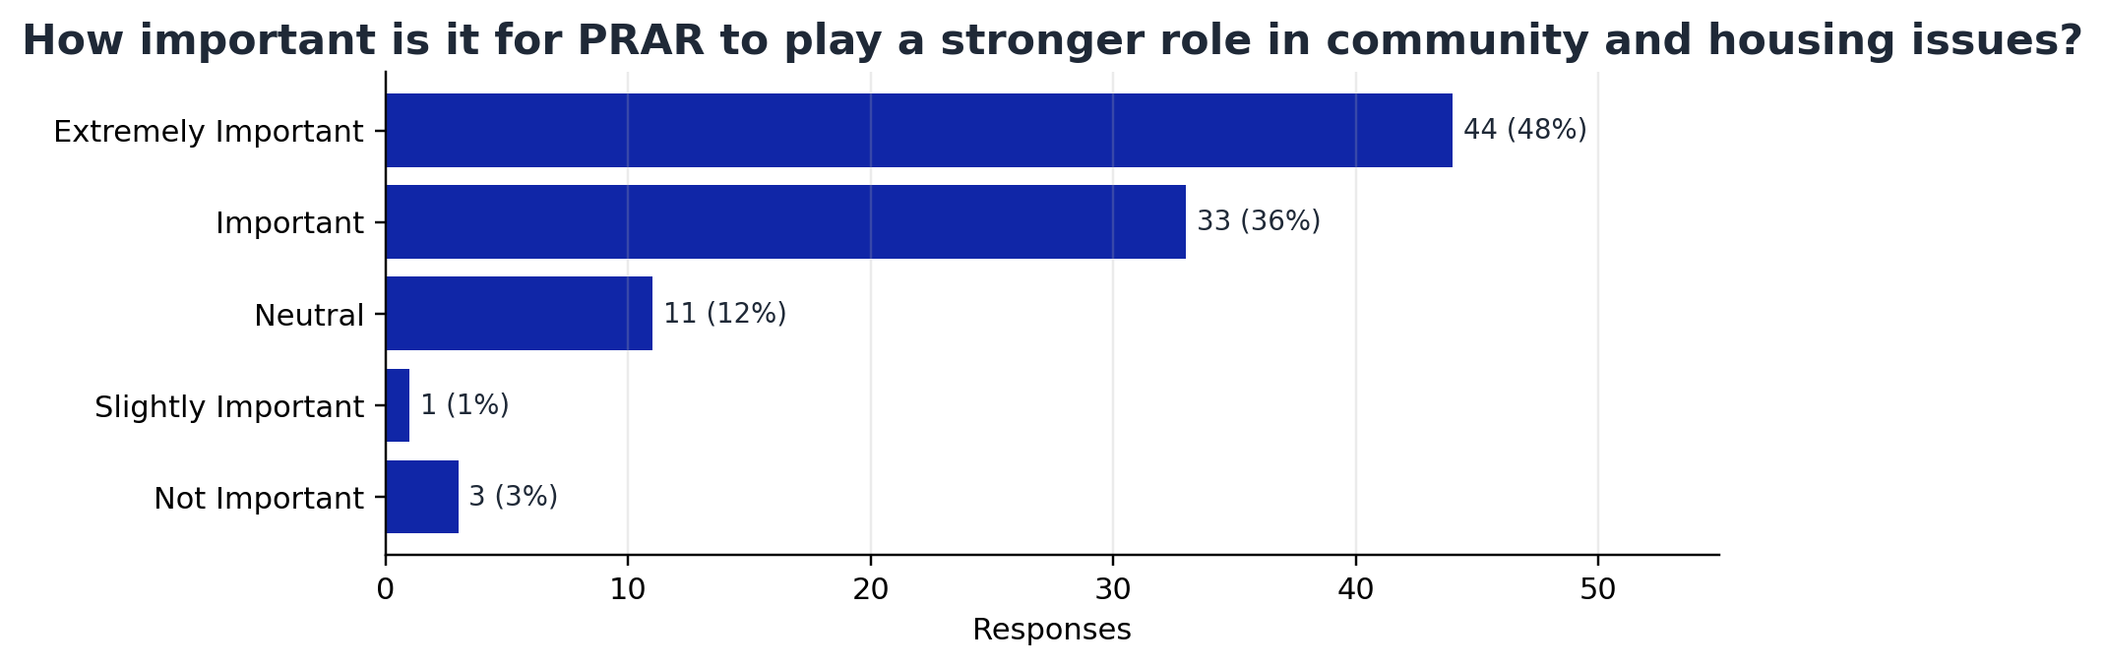
What this suggests: Members support PRAR having a stronger role in community and housing issues. 84% of respondents who answered rated this important or extremely important.
Response option | Count | Percent
Extremely Important | 44 | 47.8%
Important | 33 | 35.9%
Neutral | 11 | 12.0%
Slightly Important | 1 | 1.1%
Not Important | 3 | 3.3%

Would you be interested in participating in future focus groups, planning sessions, or leadership
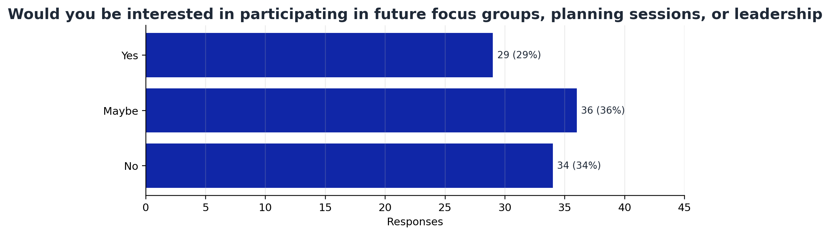
What this suggests: There is a leadership pipeline opportunity. 29 respondents said yes and 36 said maybe to future focus groups, planning sessions, or leadership participation.
Response option | Count | Percent
Yes | 29 | 29.3%
Maybe | 36 | 36.4%
No | 34 | 34.3%

What PRAR Will Do With This Feedback
- Continue building high-value education and professional development programs.
- Look for more flexible ways for members to participate despite time and scheduling challenges.
- Keep email as the primary communication tool while using social media and the website as supporting channels.
- Share more updates about advocacy, housing, and community issues affecting the real estate industry.
- Invite interested members to participate in focus groups, planning sessions, committees, and future leadership opportunities.
Thank you for helping guide the future of PRAR. Your feedback is a valuable part of shaping how the Association serves members, protects the profession, and supports our region.

