Personal Behavior Styles Takeaways

The most effective salespeople are those who are able to quickly identify the buyer's personality, then adapt their communication and approach accordingly. This approach is what separates DISC selling from other sales approaches.
Using DISC method , the salesperson can follow a framework of questions that will help them understand their buyers' problems, interests, and concerns and build trust to advance the sales process.
Having the knowledge of how to adapt your communication to suit your client's unique needs can make all the difference in how they feel about you and their purchase decision. A DISC Sales Report also gives managers the insights they need to guide their sales teams.

The colors themselves are not representative or relevant to the actual styles in any way. They are design and branding choices

A quick easy way to determine a person DiSC behavior style is to to choose ONE OPTION of the 4 styles by answering the short question.
You can also rank them 1- 4 (1 being MOST like them and 4 LEAST like them).

How would your partner, spouse, best friend, or you describe your personality /behavior style?
(D) Straight to the point
(I) Social & Outgoing
(S) Steady & Dependable
(C) Cautious & Perfectly Accurate

Once you have determined the behavior style, review the characteristics of each style on the attached charts. When you understand your style you can adjust your communication to build better relationship with others of similar and different styles.
The (D)Dominant & (I)Influencer types are on the extrovert spectrum while the (S) Steady & (C ) Compliant are on the introvert spectrum.
D styles are motivated by winning, competition, and success. They prioritize taking action, accepting challenges, and achieving results and are often described as direct and demanding, strong-willed, driven, and determined. D styles tend to be outspoken but can be rather skeptical and questioning of others.
- Fears: being seen as vulnerable or being taken advantage of
Values: competency, action, concrete results, personal freedom, and challenges
Overuses: the need to win, resulting in win/lose situations
Influences others by: assertiveness, insistence, competition
In conflict: speaks up about problems; looks to even the score
Could improve effectiveness through: patience, empathy
i styles are motivated by social recognition, group activities, and relationships. They prioritize taking action, collaboration, and expressing enthusiasm and are often described as warm, trusting, optimistic, magnetic, enthusiastic, and convincing.
- Fears: loss of influence, disapproval, being ignored, rejection
Values: coaching and counseling, freedom of expression, democratic relationships
Overuses: optimism, praise
Influences others through: charm, optimism, energy
In conflict: expresses feelings, gossips
Could improve effectiveness through: being more objective, following through on tasks
S styles are motivated by cooperation, opportunities to help, and sincere appreciation. They prioritize giving support, collaborating, and maintaining stability and are often described as calm, patient, predictable, deliberate, stable, and consistent.
- Fears: change, loss of stability, offending others, letting people down
Values: loyalty, helping others, security
Overuses: modesty, passive resistance, compromise
Influences others by: accommodation, consistent performance
In conflict: listens to others’ perspectives; keeps their own needs to themselves
Could improve effectiveness through: displaying more self-confidence, revealing their true feelings
C styles are motivated by opportunities to gain knowledge, show their expertise, and produce quality work. They prioritize ensuring accuracy, maintaining stability, and challenging assumptions. They are often described as careful, analytical, systematic, diplomatic, accurate, and tactful.
- Fears: criticism and being wrong; strong displays of emotion
Values: quality and accuracy
Overuses: analysis, restraint
Influences others by: logic, exacting standards
In conflict: focuses on logic and objectivity; overpowers with facts
Could improve effectiveness through: acknowledging others’ feelings; looking beyond data
Just like a chameleon, we each have a natural state (the way we prefer to behave and communicate) and we have an adapted state (what we perceive our environment requires for success or survival).

The Natural State/Behavior Style represents the person's most natural (or comfortable) behavioral preference. This is how a person would choose to behave when around close friends, family or at home when nobody is around.

The Adapted Behavior Style represents the person's response to the environment (usually the workplace). Some people call this graph the 'Work Style' or 'Social Mask'. It can be thought of as how a person will tend to act around strangers, colleagues and acquaintances that they don't know very well. This graph, in many cases, reflects the behavior that the person believes is appropriate in order to meet the demands of the job.

Think "Battery Power"
When we are in our Natural state, we are plugged into the mains power outlet (i.e. we have full power). As soon as we start adapting our behavior we are running on "battery" power. Hence, if we habitually need to adapt our behavior for long periods, we will eventually run out of energy and need to revert back to our normal behavioral preference.
Have you ever met someone at work who you thought was a tyrant, but then they were significantly less dominant when at a social function? Or have you ever met a polite, deferential team member that seemed to come out of their shell and transform into a party animal when dealing with others outside the office?

This chameleon-like behavior; an on-duty/off-duty masquerade, is one of the intriguing aspects of how we present ourselves to the world. Just like our reptilian friend, we each have a natural state (the way we prefer to behave and communicate) and we have an adapted state (what we perceive our environment requires for success or survival).

Are you interested in learning more about your individual behavior style and how you can become more self-aware of your communication style and improve the communication with your clients, co-workers or family members?

Contact Stefani Havel to set up a customized training workshop session for yourself, your team or coworkers to get a detailed personalized report where you'll learn about your unique behavioral style, your tendencies, needs, preferred environment, and strategies for effective behavior.

Each profile report also includes information about other DiSC styles to help you learn more about others as well as the opportunity to have Everything DiSC Comparison, Group Culture, or other reports to provide a greater understanding of your team, group, clients, or colleagues.

Everything DiSC is normed so there is an even distribution of styles. A person is only D relative to the people around them. If DiSC is going to be useful, it must help us understand our individual differences, not what everyone has in common.

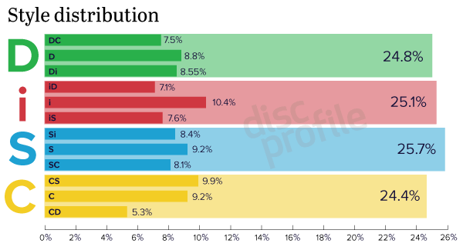



Stefani Havel
Certified DiSC Trainer -Wiley Institute
612-940-7335
Sparklotta711@gmail.com

