CHRONIC KIDNEY DISEASE: HOW TO STACK THE ODDS IN YOUR PATIENT’S FAVOR
Kelly Cairns, DVM, MS, DACVIM (SAIM)
Thrive Pet Healthcare
Austin, TX

WHAT IS CHRONIC KIDNEY DISEASE AND WHY SHOULD YOU CARE?
Chronic kidney disease (CKD) is irreversible, progressive loss of kidney function and/or structure. Kidney damage must exist for at least 1-3 months to be classified as chronic. CKD is the most common form of kidney disease of dogs and cats and has many causes, both congenital and acquired. The most common cause of CKD is idiopathic tubulo-interstitial nephritis in the cat, whereas dogs are affected by glomerulonephritis of various etiologies with almost the same prevalence as tubule-interstitial lesions.
Regardless of etiology, CKD is a progressive disease, and once there has been critical nephron loss there is inexorable progression despite removal of initial inciting insult if known. The three hallmarks of CKD are hyperfiltration of surviving nephrons, tubulointerstitial inflammation and fibrosis and renal mineralization. As renal mass decreases, the remaining functional nephrons lose autoregulation and systemic arterial pressure is transmitted to the glomerulus, which leads to glomerular hypertension, hypertrophy, hyperfiltration and continued damage to remaining nephrons. Proteinuria exacerbates progression of CKD through further glomerular and tubulointerstitial damage. Upregulation of the renin-angiotensin-aldosterone system (RAAS) occurs early in CKD and leads to progressive renal injury.
CKD causes polyuria with compensatory polydipsia, and dehydration can develop without adequate fluid intake. Hyperphosphatemia results from decreased GFR. Azotemia results from the inability of kidneys to excrete uremic toxins. Hypokalemia can occur from kaliuresis, transcellular shifting and/or decreased food intake. Metabolic acidosis can occur with advanced CKD from inability to excrete hydrogen ions and impaired renal tubular bicarbonate resorption. Decreased erythropoietin synthesis can result in anemia, which can be exacerbated by GI blood loss and decreased red blood cell lifespan. Decreased calcitriol synthesis results in renal secondary hyperparathyroidism. Proteinuria can occur with glomerular or tubular lesions and is directly nephrotoxic and associated with a poorer prognosis. RAAS activation results in intraglomerular hypertension, systemic hypertension and fibrosis. Systemic hypertension is one of the most common complications of CKD and speeds the progression of disease due to end-organ injury. CKD can cause vomiting from the effects of uremic toxins.

DIAGNOSE FIRST, THEN STAGE
It is important to accurately diagnosis CKD prior to staging the disease. Signs and PE findings are very variable, ranging from no signs or PE abnormalities to severe PU/PD, weight loss and decreased appetite with many PE abnormalities including dehydration, oral ulcerations, gingivitis, poor body condition, pale mucous membranes, tachycardia, tachypnea, halitosis, and cardiac arrhythmias. Kidneys may be small, firm, irregular or normal on palpation. Minimum database for diagnosis and staging includes CBC, chemistry profile, SDMA, urinalysis, urine culture, blood pressure, abdominal radiographs, abdominal ultrasound, urine protein creatinine ratio and parathyroid hormone level. The reader is referred to other texts for detailed discussion of all abnormalities and relevant pathophysiology for each of these tests in the setting of CKD.
The International Renal Interest Society (IRIS) has created a staging system for CKD. The staging system should be applied only after diagnosis of non-decompensated CKD. IRIS staging is based on serum creatinine or fasting symmetric dimethylarginine (SDMA) concentrations and sub staging is based on presence of proteinuria and systemic hypertension.

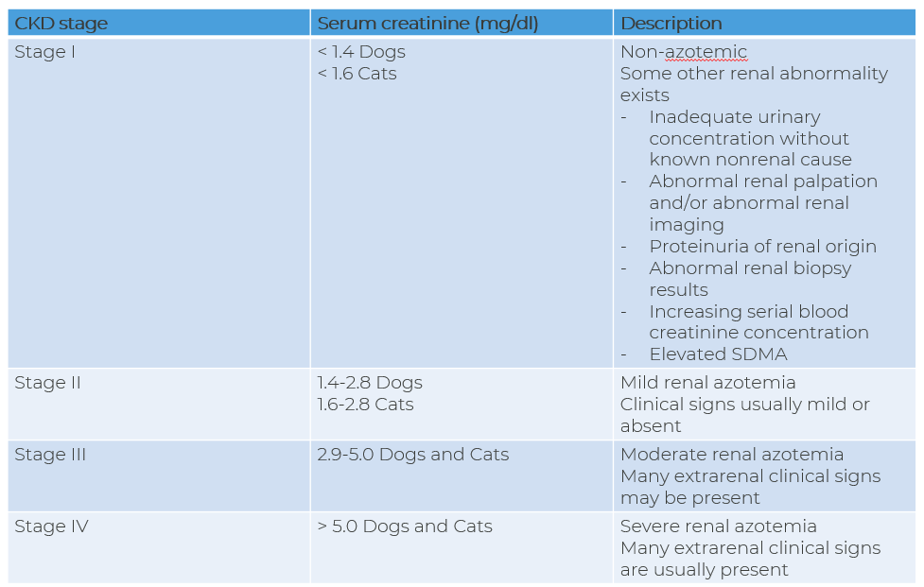
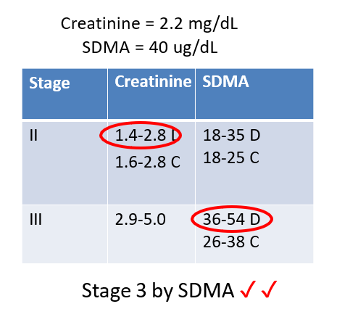
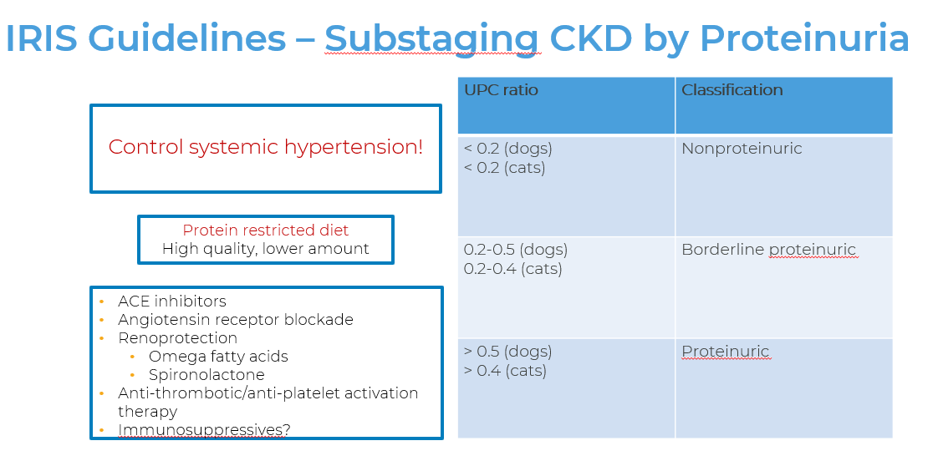

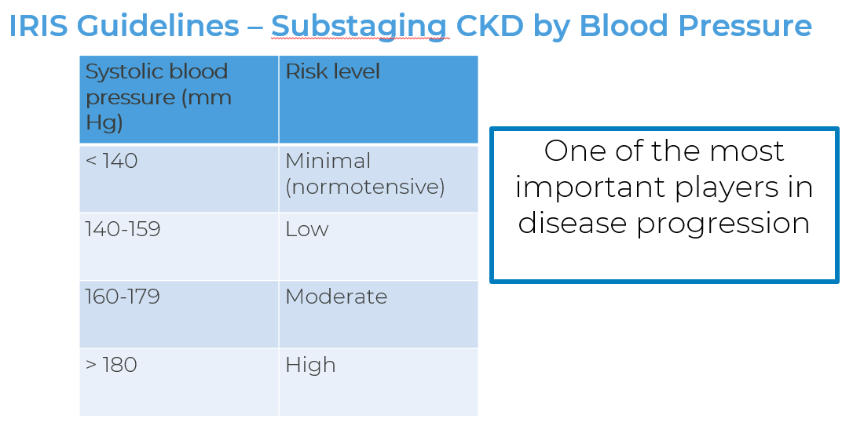

MANAGING CKD: THE PLAYERS AND WHY THEY MATTER
Managing CKD consists of three pillars: identifying and treating underlying cause when possible, treating clinical signs and preventing and/or treating complications of the CKD and any relevant comorbid conditions. It is key to slow progression of the functional nephron loss through mitigating impact of players which are deleterious to these nephrons.
Decompensated CKD is often treated on an in-patient basis with IV fluid therapy, electrolyte and acid-base regulation and other symptomatic, supportive or specific therapies. Compensated CKD is managed through outpatient care with frequent rechecks and client-veterinarian communication as indicated based upon the specifics of the case and patient needs.
Dietary therapy is one of the most commonly recommended therapies. Prescription diets designed to treat CKD contain less protein, phosphorus and sodium, and more soluble fiber than maintenance diets. They have higher caloric density, are supplemented with omega 3 fatty acids and antioxidants and promote normal acid-base status. Dietary protein restriction alone does not appear to slow progression of renal disease, but dietary phosphorus restriction can slow progression of disease and enhance survival.
Hyperphosphatemia may require additional therapy with intestinal phosphate-binding agents in addition to dietary phosphorus restriction. These are given with food. Most common choices include aluminum containing agents, such as aluminum hydroxide or calcium-containing agents such as calcium acetate or calcium carbonate. Calcium containing agents should not be used in the setting of hypercalcemia. Sevelamer hydrochloride and lanthanum carbonate are additional non calcium containing phosphate binders that have been used.
RAAS Inhibition is important in the setting of CKD to treat proteinuria, systemic hypertension and decrease progression of fibrosis. Most commonly, ACEi, ARBs and spironolactone are used alone or in combination to achieve these goals based upon individual needs of the patient. ACEI or ARB therapy is contraindicated for patients that are clinically dehydrated or hypovolemic. Monitoring BP, electrolytes and BUN/creatinine along with clinical signs is important when using these agents.
Patients with proteinuria are at increased risk for thromboembolism. Administration of low-dose aspirin or clopidogrel may be considered, especially if hypoalbuminemia is present.
Systemic hypertension should be treated with goal systolic BP <160 mmHg to minimize risk of target organ damage. Most common medications used include the calcium channel blocker amlodipine and ACE inhibitors such as enalapril or benazepril. More recently antgiotensin receptor blockers such as telmisartan have gained popularity. Blood pressure, BUN, creatinine and potassium must be monitored when using these agents and the reader is referred to other texts for detailed discussion of ACEi, ARBs and multi modal therapy.
It is key to recognize when renal secondary hyperparathyroidism is present and to treat it when it is. Calcitriol is the main therapy used to achieve this goal, and the reader is referred to other texts for detailed discussion.
Anemia is a common complication of advanced stage CKD. Treatment is considered if anemia is clinically relevant, and in such cases is treated with hormone replacement therapy with either recombinant human erythropoietin (Epogen) or darbepoetin alfa. Darbepoetin is a longer-acting form and causes formation of anti-erythropoietin antibodies less often than Epogen. Systemic hypertension can occur with these hormone therapies and should be monitored.
It is important to recognize and treat concurrent urinary tract infections with appropriate antimicrobial therapy and discontinue use of nephrotoxic drugs whenever possible.
Hydration should be maintained. Typically, oral food and fluid intake is sufficient for low stage patients. As stage advances, patients may need SQ fluid therapy, or even IV fluid therapy to correct deficit if dehydrated.
Hypokalemia is more common in cats than dogs with CKD. Renal diets are usually supplemented with potassium citrate, but some patients may require additional potassium supplementation through giving potassium gluconate or potassium citrate orally.
Metabolic acidosis may be seen with advanced stage CKD and in severe cases may need to be treated with oral sodium bicarbonate or potassium citrate. Potassium citrate may be preferred since it contains potassium and also treats hypokalemia from CKD.
Treatment of inappetence, nausea and/or vomiting from CKD can be accomplished through giving H2 receptor antagonists, ondansetron, omeprazole, mirtazapine, maropitant, capromorelin or cyproheptadine as indicated. A feeding tube may be needed and can be helpful in some cases.
Routine physical exam and diagnostic testing is required to monitor progression of disease, identify and treat secondary complications and determine efficacy of therapy. Assessment of CBC, serum biochemistry panel, urinalysis, urine culture, UPC ratio, PTH and peripheral BP measurement is recommended at interval dependent on patient and specific therapies. Long term monitoring of the patient with CKD is often between every 2 and 6 months based upon stage of CKD and nuances of patient and client needs.

REFERENCES

- Polzin DJ, Ettinger SJ: Chronic Kidney Disease. Textbook of Veterinary Internal Medicine., 7th ed. St. Louis, Saunders Elsevier 2010 pp. 1990-2021.
- Sparkes AH, Caney S, Chalhoub S, et al: ISFM Consensus Guidelines on the Diagnosis and Management of Feline Chronic Kidney Disease. J Feline Med Surg. 2016 Vol 18 (3) pp. 219-39.
- Boyd LM, Langston C, Thompson K, et al: Survival in cats with naturally occurring chronic kidney disease (2000-2002). J Vet Intern Med 2008 Vol 22 (5) pp. 1111-17.
- Lawson J, Elliott J, Wheeler-Jones C, et al: Renal fibrosis in feline chronic kidney disease: known mediators and mechanisms of injury. Vet J. 2015 Vol 203 (1) pp. 18-26.
- Chalhoub S, Langston CE, Farrelly J: The use of darbepoetin to stimulate erythropoiesis in anemia of chronic kidney disease in cats: 25 cases. J Vet Intern Med 2012 Vol 26 (2) pp. 363-69.
- Langston C: Diagnosis and Management of Glomerulonephritis. Diagnosis and Management of Glomerulonephritis 2019.
- Miyakawa H, Ogawa M, Sakatani A, et al: Evaluation of the progression of non-azotemic proteinuric chronic kidney disease in dogs. Res Vet Sci. 2021 Vol 138 (0) pp. 11-18.
- Rudinsky AJ, Harjes LM, Byron J, et al: Factors associated with survival in dogs with chronic kidney disease. J Vet Intern Med. 2018 Vol 32 (6) pp. 1977-1982.
- Perini-Perera S, Del-Angel-Caraza J, Pérez-Sánchez AP, et al: Evaluation of Chronic Kidney Disease Progression in Dogs With Therapeutic Management of Risk Factors. Front Vet Sci. 2021 Vol 8 (0) pp. 621084.
- White JD, Stevenson M, Malik R, et al: Urinary tract infections in cats with chronic kidney disease. J Feline Med Surg 2013 Vol 15 (6) pp. 459-65.
- Hindar C, Chang Y-M, Syme HM, et al: The association of bacteriuria with survival and disease progression in cats with azotemic chronic kidney disease. J Vet Intern Med. 2020 Vol 34 (6) pp. 2516-2524.
- International Renal Interest Society: Treatment Recommendations for CKD in Dogs (2019)
- King JN, Font A, Rousselot J-F, et al: Effects of Benazepril on Survival of Dogs with Chronic Kidney Disease: A Multicenter, Randomized, Blinded, Placebo-Controlled Clinical Trial. J Vet Intern Med. 2017 Vol 31 (4) pp. 1113-1122.
- Miyagawa Y, Akabane R, Sakatani A, et al: Effects of telmisartan on proteinuria and systolic blood pressure in dogs with chronic kidney disease. Res Vet Sci. 2020 Vol 133 (0) pp. 150-156.
- Boyd LM, Langston C, Thompson K, et al: Survival in cats with naturally occurring chronic kidney disease (2000-2002). J Vet Intern Med 2008 Vol 22 (5) pp. 1111-17.
- Tolbert MK, Olin S, MacLane S, et al: Evaluation of Gastric pH and Serum Gastrin Concentrations in Cats with Chronic Kidney Disease (Abstract NU09). ACVIM 2017.
- McLeland SM, Lunn KF, Duncan CG, et al: Relationship among serum creatinine, serum gastrin, calcium-phosphorus product, and uremic gastropathy in cats with chronic kidney disease. J Vet Intern Med. 2014 Vol 28 (3) pp. 827-37.
- International Renal Interest Society: IRIS Treatment Recommendations for CKD in Cats (2019)
- Hall JA: What Do We Know about Requirement of Protein Intake in Feline CKD?. ECVIM-CA Online Congress 2021.
- Chakrabarti S, Syme HM, Elliott J: Clinicopathological variables predicting progression of azotemia in cats with chronic kidney disease. J Vet Intern Med. 2012 Vol 26 (2) pp. 275-81.

