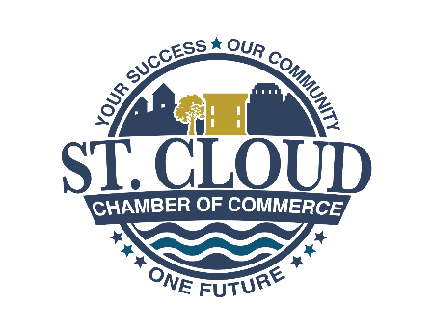

**2025 St. Cloud Chamber Board Retreat at Wild Florida**

***Meeting Agenda***

**8:30 – Arrival and Working Breakfast**

* Welcome/ Introduction of Board Attendees – Lisa Bertossa, Chamber Board Chair
* Wild Florida
* Format for the day

**9:00 – 9:30 a.m. October Board Meeting and 2024-25 Review**

* Board Meeting
* This Year’s Board Structure

**9:45 a.m. – 10:30 a.m. – Membership Committee – Bridget Jackson**

* Update on Membership Goals and Retention Rates
* Industry Wide Trends
* Action Items for this year.
* Events to support the Vision

**10:30 – 11:30 a.m. – Economic Development Committee – John Barna**

* Review of last year’s activities
* For 2026 – Economic Forecast
* This year’s priorities
* Action Items for this year.
* Events to support the Vision

**11:30 – 1:00 p.m. – Lunch and Visiting the Wild Florida Zoo**

**1:00 p.m. – 2:00 p.m. – Business Training Committee (Appoint a Chair)**

* The Training Calendar
* Action Items for this year.
* Events to support the Vision

**2:00 p.m. – 2:30 p.m. – Events Analysis and Marketing**

* Events Matrix and Planning Cycle
* Politics in the Barn
* The Insider newsletter review/Social Media
* Action Items for this year.
* Events to support the Vision

**2:30 p.m. – 3:00 p.m. Wrap Up Conversation**