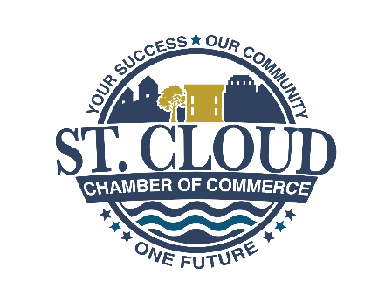

**2025 St. Cloud Chamber Board Retreat at Wild Florida**

***The Future is Now!***

Welcome to the 2025 St. Cloud Chamber Board of Directors Retreat. We believe you will find this time refreshing, stimulating and thought provoking.

**In this packet, please find the following:**

* Meeting agenda
* 2025-26 Board Roster
* Board of Directors Handbook
* Rosenberg’s Rules of Order
* Commitment to Serve form (please sign and return)
* Confidentiality form (please sign and return)
* Conflict of Interest
* 2025-26 Master List of Events
* Chamber Bylaws
* Current Membership Application
* 2025 Annual Report

We hope you come away from this Retreat energized with a new vision and new purpose.

Respectfully,

Lisa Bertossa, Chair

Dirk Webb, President & CEO

St. Cloud Greater Osceola Chamber of Commerce