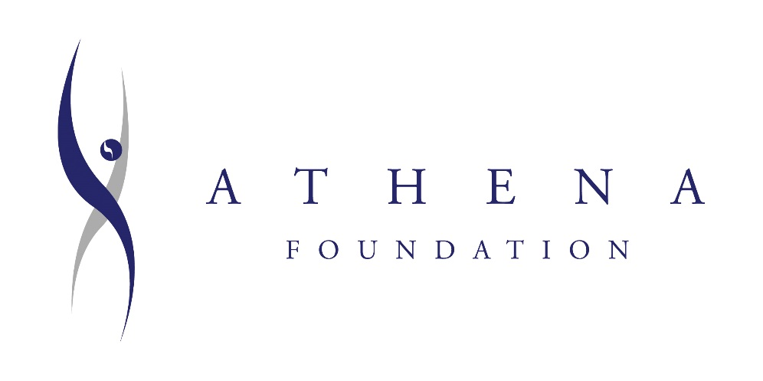

2025 ATHENA® Awards Nomination Form

*Supporting, developing, and honoring leaders*

*Presented by The Chamber Foundation of the*

*Dutchess County Regional Chamber of Commerce*

**To be named an ATHENA honoree is a remarkable distinction and fulfills ATHENA International’s mission of supporting, developing, and honoring those who inspire women to achieve their full potential.**

**The ATHENA Award recognizes those, regardless of gender, who strive toward the highest levels of professional accomplishment by:**

* ***Actively guiding or mentoring women to become great leaders.***
* ***Excelling in their chosen profession***
* ***Devoting time and energy to their community in meaningful ways***

**ATHENA Honorees become part of a global community of individuals who inspire, encourage and challenge – nominate your candidate today!**

*NOMINATION GUIDANCE:*

***\*\*NOTE** This is a very competitive and prestigious award. To best support your nominee, please be as thorough as possible in writing your responses and in providing supporting materials. Those reviewing all nominations will only have the information presented to them to help guide their decisions.***

* ATHENA Recipients must meet each of the following three criteria:
* *Demonstrate excellence, creativity and initiative in their business or profession.*
* *Provide valuable service to improve the quality of life for others in their community.*
* *Assist women in reaching their full leadership potential.*
* Please answer each question thoroughly and with specific examples. Collaborative nominations are encouraged.
* Please attach resume or curriculum vitae if possible, however, please do not use this as a substitution for providing detailed information in the nomination form.
* *Resume/curriculum vitae will only be used as supplemental information to what is presented in nomination form.*
* You may include supporting documents (articles, testimonials, etc.) with your completed nomination form.
* Nominee’s successes should not just be related to work achievements. Achievements outside of work should also be documented.
* Please type in or print entire form and use additional space as necessary.

**\*\*\*Nominee MUST live or work in the Hudson Valley***It is not limited to Dutchess County**

***Counties in the Hudson Valley: Albany, Columbia, Dutchess, Greene, Orange, Putnam, Rensselaer, Rockland, Sullivan, Ulster, and Westchester***

*Since 2006, The Chamber Foundation has recognized over 100 of its own*

*ATHENA Honorees and recipients who are proud to be included in this national program.*

Date ___________

**NOMINEE**

|  |  |
| --- | --- |
| Name | __________________________________________ |
| Home Address | __________________________________________ |
| City, State ZIP | __________________________________________ |
| Home Phone | __________________________________________ |
| Home Email | __________________________________________ |
| Company/Organization Name | __________________________________________ |
| Title/Position | __________________________________________ |
| Business Address | __________________________________________ |
| City, State ZIP | __________________________________________ |
| Work Phone | __________________________________________ |
| Business Email | __________________________________________ |

**NOMINATOR(S)**

|  |  |
| --- | --- |
| Name | __________________________________________ |
| Company/Organization Name | __________________________________________ |
| Title/Position | __________________________________________ |
| Address | __________________________________________ |
| City, State ZIP | __________________________________________ |
| Phone | __________________________________________ |
| Email | __________________________________________ |

# How do you know the nominee? __________________________________________

**One Civic Center Plaza, Suite 400, Poughkeepsie, NY 12601**

**Phone: 845-454-1700**

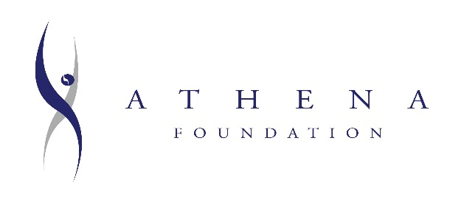**2025 ATHENA**® **Awards Nomination Form**

**NOMINEE______________________________**

**I. DEMONSTRATES EXCELLENCE, CREATIVITY AND INITIATIVE IN PROFESSION:**

Provide **specific examples** of how the nominee has demonstrated excellence, creativity and initiative in their business or profession. Include information such as positions held, special projects led/completed and their impact, professional awards or recognition, patents held or pending, etc.

**II. PROVIDES VALUABLE SERVICE BY CONTRIBUTING TIME AND ENERGY TO COMMUNITY:**

List local, state, national and international level participation. Include length of service and titles/offices held in civic and service organizations such as charitable activities, political pursuits, religious groups, chambers of commerce, merchants’ associations, etc. Please include **and explain** areas of impact from this level of participation.

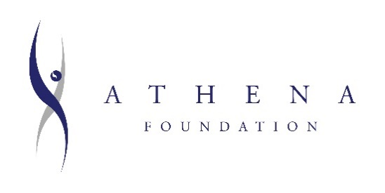**2025 ATHENA**® **Awards Nomination Form**

**NOMINEE____________________**

**III. INSPIRING WOMEN TO ACHIEVE THEIR FULL POTENTIAL:**

Provide **specific** **examples** of how the nominee has assisted women in reaching their full leadership potential, and/or demonstrated support for their professional advancement. Examples might include efforts such as mentoring, teaching, creating work/educational opportunities, initiating leadership opportunities for women, encouraging balance in leadership roles, etc.

*This is the place to elaborate. Talk about impacts on people working with the nominee, get personal, give specific examples, and use multiple sources.*

**IV. ADDITIONAL INFORMATION PERTAINING TO CRITERIA:**

List educational level achieved, degrees earned, or any specialized training. List awards, honors received, publications or articles supporting service to their profession, industry or community. Include any additional information, such as personal challenges, you feel may be important for consideration of your nominee.

**PAST ATHENA**® **AWARD HONOREES:**

**2006 HONOREES**Sheila Appel

Deborah Bailey Browne

Betsy Brockway

Lisa Daniels

Karen Hansen-Simon

Colette Lafuente

Mary Madden

Regis Obijiski

Joan Pagones

Kelley Redl Hardisty

**2007 HONOREES**Ann Armater

Jennifer Bates

Judith “Kip” Bleakley-O’Neill

Anne N. Conroy

Susan LaFosse

Suzanne McLaughlin

Rita McPeck

Marjorie Rovereto

**2008 HONOREES**

Renee Bulla

Sandra Cassese

Arlene Chiaramonte

Brian Giorgis

Sabrina Marzouka

Hilda Merolli

Patricia Prunty

Lori Traboldt

Mary Kay Vrba

Carole J. Wolf

**2009 HONOREES**

Eleanor Charwat

Teri Egitto

Clara Lou Gould

Alexandra Putman

Sandra Ludlum

Donna McAleer

Lisa Morris

Janet Ready

Andrea Reynolds

Lillian S. Weigert

**2010 HONOREES**

Laurie Cohn

Denise Doring VanBuren

Carol Gordon

Fran Knapp

Barbara Kram

Danielle Marxer

Carmen McGill

Ann Pinna

**2011 HONOREES**

Irene Andujar

Maureen Crush, Esq.

Jen Dunn, CPCU

Marcine Humphrey

May Mamiya

Nancy O’Donnell

Caryn Solomon

Cathy Varunok

**2012 HONOREES**

Joan Crawford, LCSW

Geeta Desai

Cecilia Dinio Durkin

Jacqueline Goffe-McNish

Maureen Kangas

Dr. Kathleen Mantaro

Sharon Matyas

Sister Rose Marie Mullen, osf

Dr. Michele Winchester-Vega

**2013 HONOREES**

Ellen L. Baker

Natalie Borquist

Linda G. Campbell

Lisa M. Cathie

Steven J. Chickery

Peter Maher

Michelle Martin

Gertrude O'Sullivan

Kelly Outwater

Angelline Smalls

Sue Sywetz Sullivan

**2015 HONOREES**

Dana Diorio-Casey

Jeffery Fox, Ph.D.

Carla Goldstein, JD

Perrinella F. (Penny) Lewis

Lara Litchfield-Kimber

Gaye Mallet

Lori Rivenburgh

Rev. Luader Smith

Marjorie Smith

Karen Zobel

**2016 HONOREES**

Gloria Cukar

Pamela R. Edington, Ed.D.

Renee Fillette, Ph.D.

Lauren Gillett

Krista Jones

Cynthia Keller

Kelly Lyndgaard

Ruth Mahoney

Major Kathleen Sileno

Catherine O. Spratt

Bettina “Poet Gold” Wilkerson

**2017 HONOREES**

Molly Ahearn

Diane Allenbaugh

Kathleen Durham

Ruthfen Faircloth

Nicole Fenichel-Hewitt

Pari Forood

Lori A. Jiava

Annette Marzan

Irene Monck

Dr. Greer Rychcik

Rachel Saunders Esq.

**2018 HONOREES**

Shirley Adams

Filomena Fanelli

Holly Kramer

Maureen Lashlee

Tina Ludwig

Dr. Carol Ann Malizia

Melissa McCoy

Alexis Mills

Dr. Lubna Somjee

Elizabeth Waldstein-Hart

**2020 HONOREES**

Elizabeth Donohue

Ellen Gambino, EdD

Theresa Giovanniello, LMSW

Donna Johnson-Klonsky

Cammie Jones

Crys McCuin

Mecca Mitchell, Esq.

Lauree Ostrofsky

Kate Rabe

**2021 HONOREES**

Michele Babcock

Cheryl Bowers

Erin Cafarelli

Marie Cole

CMSgt Elizabeth Colton

Londina Cruz

Jasmin Nicole Davis

Christine Manning

Tina Tarquinio

Robyn Williams

**2022 HONOREES**

Cara Mia Bacchiochi

Brittany Cataldo

Patty Driever

Jenny Fox

Amy Greiner

Catherine Merryman

Christine Pellegrino

Dr. Patricia Shannon

Rebecca Simpson

**2023 HONOREES**

Maria Boonie

Jill Brodsky, MD, MBA

Jo Ann Brown

Anne Constantinople, PhD

Leah Feldman

Faezeh Gholami, PhD

Rachel Johnson

Christie VanHorne, M. Ed, MPH

Nicole Wong, LMS

**2024 HONOREES**

Lori Cassia-Decker

Michelle Cherubini

Kathryn Collins

Jessica Glass

Karen Hochhauser

Danielle Mass

Jacqueline Montfort

Kelly Ryan

Pam Tarquinio