**2025-2026 Personal Recommendation Form**

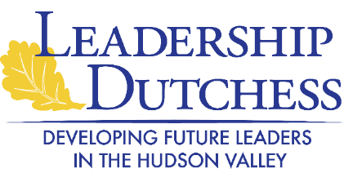

Leadership Dutchess is a program intended for persons in positions of leadership or influence in the Dutchess County area who can benefit from additional educational and practical experience. This program can enhance their capacity for greater communications, understanding of community issues, and improving the quality of life in the Dutchess County area. The program is sponsored by The Chamber Foundation, Inc.

Your response(s) will be kept strictly confidential. A recommendation by a personal reference is an integral part of the application process.

Applicants Name:

Your Name: Mr. Mrs. Ms.

Your Address:

(Street) (Apt.) (City, ST) (Zip)

Your Telephone Number: Your Email

Your Community Involvement:

How long have you known the applicant? _____ years

Why do you feel this applicant would benefit from the program?

In your opinion, does the applicant have the potential to emerge as a community leader -- to hold leadership positions on boards of directors, to lead fund drives, to run for elected office? **YES or NO** (circle one) and why?

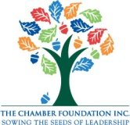

**Please return this form to:** foundation@chamberfdn.org

*The Chamber Foundation, Inc.*

One Civic Center Plaza, Suite 400

Poughkeepsie, NY 12601

(845) 454-1700