Grand Prairie Chamber of Commerce Presents:
Health Care Summit & Expo
Presenting Sponsor: Medical City Arlington
Gold Sponsor: Methodist Mansfield Medical Center
Silver Sponsor: Texas Health Arlington Memorial & GPISD CTE
9-9:45AM Networking with various vendors
9:45AM- New Healthcare changes in Legislation: Lynn Cowles with Every Texan
10:30AM- GLP 1’s: The New Weight loss Trend: Dr. Silat at Medical City Arlington
11:15-11:30AM Lunch is served
11:30-1PM Panel Presentation
1-1:30PM Final Presentation: Sara Massey- Injury Prevention Outreach Coordinator with Methodist Mansfield

New Healthcare Changes in Legislation
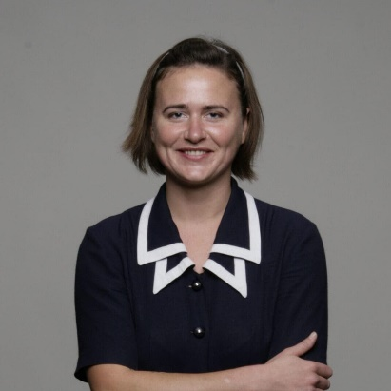
Lynn Cowles, Director of Health and Food Justice at Every Texan
As Every Texan’s Health and Food Justice Director, Lynn Cowles works to increase food security and access to affordable health care coverage for all Texans, regardless of income, immigration status, employment status, education, primary speaking languages, gender identity, or medical history. She is a Community Health Worker and a subject matter expert on the Affordable Care Act, Texas health programs and policies, health education, and health communications. Lynn joined Every Texan in June 2024 and coordinates with enrollment assisters and advocates around Texas who help community members apply for food and health benefits programs and use those programs to have healthy lives. After receiving her PhD in Humanities Research at UT Austin in 2015, Lynn managed a federally-certified health Navigator program, led statewide advocacy efforts to prevent health insurance agent and broker mishandling of health insurance consumers’ personal data, coordinated strategic health partnerships and coalitions across Texas, and initiated a rural enrollment services program that increased enrollment in rural Texas counties more than 100%. For Every Texan, she facilitates the Get Covered Texas coalition, the Children’s Health Coverage Coalition, la coalición de Seguro Texas, and the Cover Texas Now coalition.

GLP1’s: Inside the Newest Trend in Weight Loss

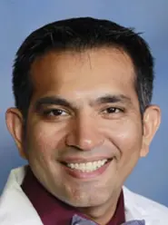
Dr. Nooman Silat, Internal Medicine Doctor at Medical City Arlington
Dr. Nooman Silat is an internist in Arlington, Texas and is affiliated with Medical City Arlington. He received his medical degree from St. Matthew's University and has been in practice for more than 20 years. Dr. Nooman Silat has expertise in treating hypertension & high blood pressure, stroke, diabetes, among other conditions.

Panel Presentations
Healthcare in Focus: A Conversation with Experts
Moderator: Rashad Raynor
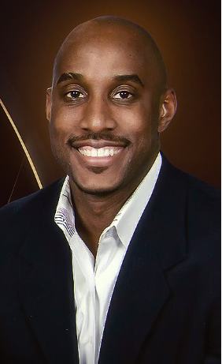
Rashad is a seasoned professional voice over talent, and the owner of Elite Voice Professionals Agency, that has been very active in the DFW community for 31 years. He is also a sports broadcaster that a passion for STEM and building up our youth to help them achieve in every field of human endeavor.
RaShad holds a BBA from Prairie A&M University in Management Information Systems and a Masters of Science degree from Southern Methodist University in Manufacturing Systems Management.

Panel Presentations
Healthcare in Focus: A Conversation with Experts
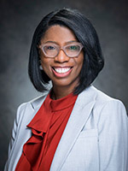
Sharn Barbarin, CEO of Medical City Arlington
LaSharndra “Sharn” Barbarin, MHA, FACHE, is chief executive officer at Medical City Arlington, joining the executive leadership team in 2022.
As CEO, Barbarin provides leadership, strategic direction and direct administrative responsibility for all aspects of financial operations, clinical quality and patient experience for Medical City Arlington.
With more than 20 years of healthcare leadership experience, Barbarin began her career with HCA Healthcare as an administrative fellow at Medical City Las Colinas and was quickly promoted to COO at Medical City McKinney where she served nine years. She was advanced to COO at Medical City Arlington in 2011 before being promoted to CEO at Medical City Lewisville in 2015.
Outside of the hospital, Barbarin has served in community leadership positions including the DFW Hospital Council Board of Trustees, the board of directors for the Lewisville and Flower Mound Chambers of Commerce and the HCA Healthcare Hope Fund Board, among others.
Barbarin has been honored with multiple awards including the Dallas Business Journal “Minority Business Leader,” “Outstanding Alumni” by Tulane University’s School of Public Health & Tropical Medicine, “Top 25 Women in Business” by McKinney Living, “Young Healthcare Executive of the Year” nominee by the DFW Hospital Council and named a “2022 Women in Business” honoree by the Dallas Business Journal.
Barbarin is a graduate of Louisiana State University and earned a Master of Health Administration from Tulane University. She is a Fellow of the American College of Healthcare Executives.

Panel Presentations
Healthcare in Focus: A Conversation with Experts

Becky Calhoun, Chief Nursing Officer at Texas Health Arlington Memorial
As the Associate Chief Nursing Officer at Texas Health Arlington Memorial, Becky Calhoun works with the nursing directors in the med-surg departments, women’s departments, surgery departments, wound care, and administrative supervisors to improve patient outcomes and a healthy working environment for our staff. Becky has taught diabetes classes to help provide resources for a better lifestyle, volunteers at Mission Arlington, participates in career day at elementary schools, and helps with Light Up Arlington to share how people can have healthier lifestyles. Outside of work, Becky spends time with family (her three daughters and her husband of 11 years, Joey).

Panel Presentations
Healthcare in Focus: A Conversation with Experts
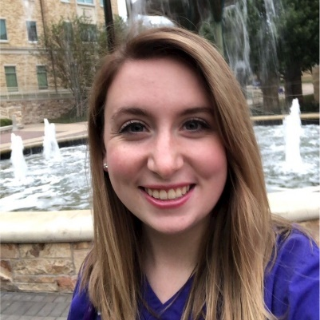
Sara Massey, Trauma Injury Prevention Outreach Coordinator
Sarah Massey, BSN, RN, CEN serves as the Trauma Injury Prevention Outreach Coordinator at Methodist Mansfield Medical Center. A certified emergency room nurse with extensive experience in emergency medicine, Sarah now focuses on community education to help prevent injuries and promote safety. She is passionate about applying her real-world ER expertise to everyday life, empowering families with practical tools and knowledge to stay healthy and safe—and ultimately reduce preventable visits to the hospital.
In fall of 2024, Methodist Mansfield expanded its trauma care services, with trauma surgeons now available on-site 24/7. This enhancement strengthens their ability to deliver immediate, critical care, ensuring that our community has access to life-saving treatment when every second counts.
The availability of comprehensive trauma services means that local first responders and healthcare providers have a trusted partner in Methodist Mansfield to handle emergencies quickly and efficiently. The hospital continues to work toward official recognition as a Level II Trauma Center, with enhanced capabilities already making a meaningful difference in residents' lives.

