DAMA Chapter Quick Start Guide

Tips and tricks to get started quickly from other leaders.

A resource to start a new or enhance a current chapter.
Table of Contents
Purpose for this guide 1
Determining Interest 2
Getting Started 2
Framing up your Mission and Vision 4
Membership Patterns 7
Publicity 7
By-Laws 8
Preparing to Charter & Joining to DAMA-I 8
Funding your Chapter 9
Additional Resources 9
Resources: 9
Contributors to this guide 10
Tips for Struggling Chapters 10
Tips for Event Management (Future Section) 11

Purpose for this guide
The purpose for this guide is to give those wanting to form a new DAMA Chapter or those currently supporting a DAMA Chapter some fundamental resources and best practices. This guide was created by a handful of DAMA Chapter presidents who have started or managed DAMA chapters over the years. It is not intended to overshadow or replace any rules or policies established by DAMA International for chartering chapters, but rather to give experienced guidance on getting started with some sample ideas that have shown success in the past.

Determining Interest
You should start your journey by determining if there is interest in forming a chapter. You may want to:
- Plan a kick-off event to determine interest in your area
  - Invite 20 or so friends and colleagues from the Data industry
  - This should be a casual gathering
- Send out a survey to your data community
- Seek Volunteers

Getting Started
Generally starting a DAMA chapter by yourself is extremely difficult. You would be best to find at least a couple of other committed individuals who can start to form your team. There is a lot of work and it is easier to share it with others. Any of these volunteers may or may not be interested in being officers in the future, but can be instrumental in establishing a good initial plan. We recommend including at least one recognized local data management professional on your initial board to generate more opportunities to present your DAMA Chapter or any key data management topic in any public or private sector event.

There are three things that are considered minimal to get started:
- Understand the legal considerations for incorporation or formation.
- Identify the essential board positions (minimum of three – in some places this is a legal requirement).
- Determine at least a skeleton board to begin. Here are some common DAMA Chapter board roles (you can build out duty rosters later). Note below there are several title labels that can be used. It is best to be consistent:
  - President – this person is the official representative to DAMA I and the DAMA-PC
  - VP Education (some orgs drop off the VP or say ‘Officer of Education’)
  - VP Events or Programs Chair (‘Chair’ is another way to note leadership)
  - VP of Membership
  - VP of Online Services or Web Services Officer
  - Treasurer / Financial Records Keeper
  - Secretary or perhaps Librarian
  - Data Manager
Things to discuss:
- Frequency & timing of meetings
- Size of board – what roles? DAMA-I has guidelines – Bare minimum for an organization legally is three leaders: President, Secretary and Treasurer (These roles are often filled by board members with the eventual titles of President, Vice President of Operations and Vice President of Finance.)
- Purpose of meetings
  - Determine if you want it to be Educational? Networking? Fund Raising?
- Location(s)/Venue
  - One location?
  - Rotating Location?
  - Virtual
DAMA Perú Board’s example for follow-up meetings:
    - Follow-up for Operational tasks:
      - 45-minute virtual weekly meeting.
      - Group chat for any coordination or update.
    - Follow-up for Tactical/Executive tasks:
      - 2-3 hours every 2/3-month meeting. (Virtual or in-person)
- Cost Model (this can depend on how often and where you plan to meet)
  - Paid for by members?
  - Paid for by educational institutions?
  - Paid for by interested corporations?
  - Paid for by relevant Sponsors? (Sensitive to vendor-neutrality -Reference DAMA-I) - some chapters even have scales of sponsorship.

The DAMA-I group has put together a graphic to call out some of the things your board may consider when starting a chapter. Figure 1 – DAMA Chapter Canvas
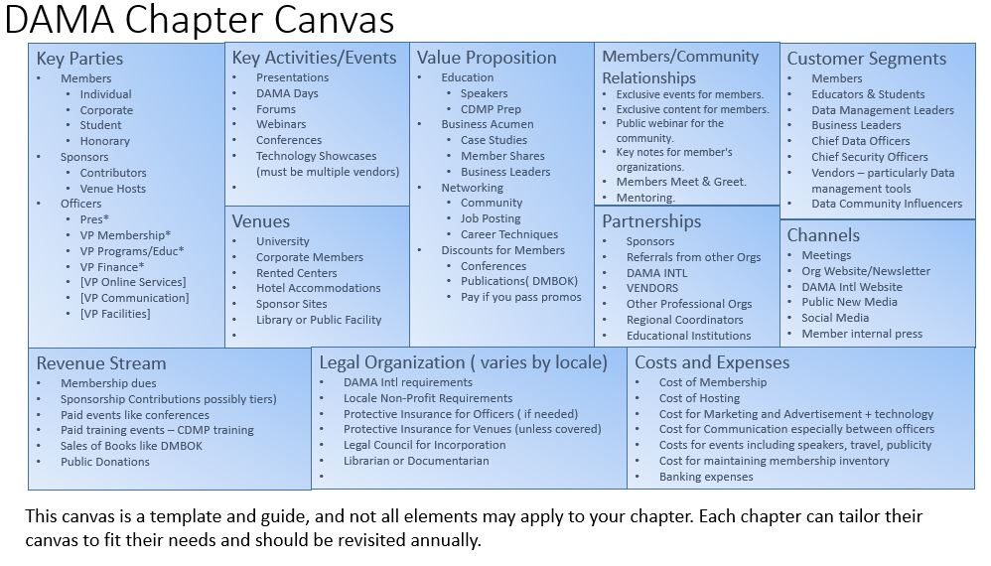
See MS PowerPoint (ppt) sample for editing:

Framing up your Mission and Vision
As you begin to form a charter, it is helpful to have a clear direction for your chapter. The answers to those previous preliminary questions might give you and your board some guidance into writing your mission, vision, or purpose.
Here are a few examples of Mission statements:
Mission Sample 1:
DAMA-Calgary – To provide a non-profit, vendor-independent association where data professionals can go for help and assistance.
To provide the best practice resources such as the DMBOK and DM Dictionary of Terms in a fashion that reaches as many DM professionals as possible.
To create a trusted environment for DM professionals to collaborate and communicate.
Mission Sample 2:
DAMA-MN – DAMA-MN is dedicated to further the understanding of the field of Data Management through providing and supporting on open forum addressing issues related to this field.
Mission Sample 3:
DAMA-RMC – DAMA-RMC is a not-for-profit, vendor-independent, professional organization dedicated to advancing the concepts and practices of enterprise information and data resource management.
Mission Sample 4:
DAMA-Peru: [Spanish] DAMA Capítulo Perú es una organización sin fines de lucro, agnóstica a herramientas y proveedores tecnológicos, dedicada a promover las mejores prácticas en gestión de datos bajo el enfoque del marco de trabajo DMBOK2 en el sector público y privado del Perú.
Mission Sample 5:
DAMA-China [Chinese]
杭州市西湖区国际数据管理协会
宗旨说明
杭州市西湖区国际数据管理协会是由区民政和科委审批同意成立的非营利性机构。协会专注数据管理和数字化，厂商中立。旨在交流国际、国内在数据领域中的最新进展，共享业界的实践、经验和成果，共同促进我国数字化水平的不断提高和创新。协会欢迎相关专业人士加入。
协会主要提供如下四项服务：
- 交流平台：协会是个多元化、专业化、跨行业的会员交流平台。我们会不定期的组织会议交流，对接资源；讨论数据管理和数字化的难点，合力攻克难题
- 研发出版：集合和分享国内外优秀案例；权威书籍；优秀文章；相关热点，包括大数据、人工智能、区块链、Web3.0等
- 培训认证：推广DAMA国际DMBOK数据管理知识体系；开展CDMP等专业培训和考试；通过和第三方培训机构的合作，大力开展数字化人才队伍的建设。
- 咨询合作：协会作为高端智库，联合业界一流专家，为各方提供咨询和设计；通力合作，发起和参与行业调研、相关标准和白皮书的编写等
协会招收：
- 个人会员：接受和支持本协会的章程，品德优良，不限行业、地区、年龄、性别、种族、教育程度等。交付一定的年费。
- 单位会员：接受和支持本协会的章程，无不良记录，不限行业、地区等。交付一定的年费。
Mission Sample 6:
DAMA-Japan [Japanese]
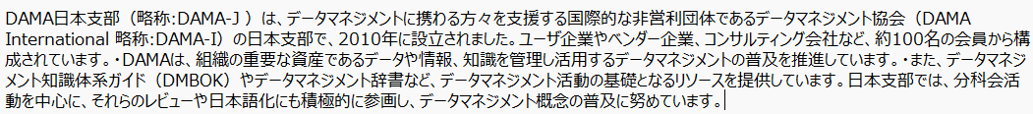

Here are a few examples of Vision statements:
Vision Sample 1:
DAMA-Calgary - Our Vision: To support an empowered local community of information professionals.
Our members span all industries:
- All 3 levels of Government
- Education
- Energy
- Manufacturing
- Retail
- Telecom
Vision Sample 2:
DAMA-Norway - DND-DAMA Norway's Vision is to standardize and formalize data management
in Norway in order to increase competency and knowledge within Data Management.
DND – DAMA Norway will facilitate and encourage the sharing of data management experience,
and wish to have a positive social impact upon society.
Vision Sample 3:
DAMA-Peru [Spanish] - La misión de DAMA Perú es:
Ser un organismo esencial y articulador clave para los profesionales técnicos y de negocios en la Gestión de Datos e Información en el Perú.

Membership Patterns
Membership patterns vary around the world. Some chapters meet monthly with a set of individual and corporate members. Some meet quarterly and membership may just be registering and paying for an event. Alternately, you may choose to allow your chapter events to be open to the public if a sponsor or set of sponsors are involved, although this may be problematic if the sponsor goes out of business or decides to no longer sponsor.
You do not have to stay with the starting membership pattern forever.
Some general suggestions
- Dues Paying members with
  - Exclusive events for dues paying members.
  - Exclusive content for members available on website.
  - Hosted Training for CDMP Certification
- Event Driven with Public webinar for the community with a fee charged
- Sponsor hosted events with a fee, but important to not play preference to one vendor or another per DAMA I rules

Publicity
Your chapter will most likely need to advertise to the public in order to engage new members.
Publication channels to consider include (depending on availability in your area):
- Chapter website
- Registration of your chapter website on the DAMA-I site
- Social Media
- LinkedIn
- Coordination with other DAMA chapters in your region or local data-focused membership groups
- Local educational institutions
- Chapter newsletters
- Word-of-mouth through DAMA members, local professionals, and supportive vendors
To this end, your chapter will want to consider how it presents itself to the public in online and print media. It is important to select the colors and logo to start presenting and promoting your brand at data events. You will need to define your DAMA Chapter colors and logo and prepare templates using your these.
Your chapter may consider additional promotional material, such as small giveaways, apparel, banners, etc.

By-Laws
Developing bylaws can be a daunting effort, so we have provided a few samples here. A couple of tips:
- Keep them simple and somewhat generic, as it can be difficult later to get a quorum of people together to update them.
- Make sure they are written to support the Mission and Vision of your specific Chapter.

Please see an example of DAMA Rocky Mountain Chapter’s Bylaws.

Preparing to Charter & Joining to DAMA-I
When you have been through all the work of gathering active members, designing your membership approach, and creating at least a minimal set of officers – you are ready to consider chartering. Here are a few first steps:
- Contact DAMA-I - you may want to do this early, as they have resources that can help with startup
- Contact DAMA-I President’s Counsel president and plan attend a meetings
- Have officers register on the DAMA-I website as an individual member and sign the ethics agreement

Funding your Chapter
You chapter will be expected to generate revenue for select costs. These costs may include:
- DAMA-I Chapter Dues
- Communication expenses
- Host location fees
- Speaker fees
- Web hosting fees
- Banking expenses
- Brand merchandising
You may choose to fund these by:
- Charging membership dues
- Charging for admission to events
- Sales of the DMBOK
- Donations or sponsorships
- Revenue from vendors at chapter hosted events (remembering DAMA-I rules on vendor neutrality)

Additional Resources
There are a several of good resources provided by DAMA-I which include a Starter Kit and a speakers list. The speakers are generally seasoned data management professionals who have offered to speak at chapters sometimes for free, sometimes for a small to moderate stipend, or just for their expenses only. What your organization needs and can afford will dictate who you might invite, but this can be worked through with the speaker.

Resources:
- PC Council Library – this becomes available once you have
  - submitted a letter of intent signed by the interested leaders in one document
  - then all of those leaders will have signed the current DAMA I Code of Ethics
  - Validate that no more than two people belong to the same company
  - None of the interested leaders are on the OPEC list
  - And the name needs to be Country-City (not just a city)
- DAMA I – Chapter board members manual It is in the process of being updated. It is important to reach out to the VP of Chapter services who has the official flow,
- PC Council Meetings with other Presidents

Contributors to this guide
- 11/11/2021 -Initial draft
  - Marc Nolte – DAMA- Calgary, Canada
  - Dawn Michels – DAMA – MN, USA
  - Marilu Lopez – DAMA -MEXICO
  - Shannon Prince – DAMA-RMC (Rocky Mountain Chapter), USA
  - María Camilla Norgaard, - DAMA - Norway
  - Diego Palacios – DAMA Perú
  - James Wang - China
  - Kelly Bruen – Rocky Mountain
  - Mikitaka Hayashi - Japan
  - Francisco Romero – Mexico
  - Carrie Marston – DAMA-Central Virginia, USA

Tips for Struggling Chapters
This section of this document is still a work in progress but you may find these notes helpful.
- Your chapter may have been deactivated by DAMA-I. Reach out to the chapter services representative for your area to find out your status.
- The DAMA-I organization chapter services representative may also be able to give you advice and/or connect you with successful chapters in your area for mentorship.
- DAMA-I has set guidelines for a minimum number of board members. If you can secure only a few motivated individuals, you may be able to re-engage your chapter by limiting your activities to only what a few board members can handle. We suggest a reorganizing community event to determine and engage interest in your area.
- Reestablish funding suggestions
  - Consider securing sponsorship
  - Hold a fund-raising event leveraging speakers from DAMA I speakers List

Tips for Event Management (Future Section)

More content coming soon!
Here is an example of additional resource information to help chapters
Sample of Event Management Checklist from the Rocky Mountain Chapter.

Change Log
Short Desc | Date | Editor(s) | Published Date
Initial Draft | 8/23/22 | Dawn Michels - Minnesota, USA  Marc Nolte - Calgary, Canada  Marilu Lopez – Mexico  Shannon Prince - RMC (Rocky Mountain Chapter), USA  Maria Camilla Norgaard, Norway  Diego Palacios (Peru)
1st Revision | 9/6/22 | Carrie Marston
2nd Revision | 9/8/22 | Dawn Michels
3rd Revision | 9/20/22 | Carrie Marston
4th Revision | 10/4/22 | Kelly Bruen
5th Revision | 10/23/22 | Carrie Marston
6th Revision | 10/25/22 | Dawn Michels

