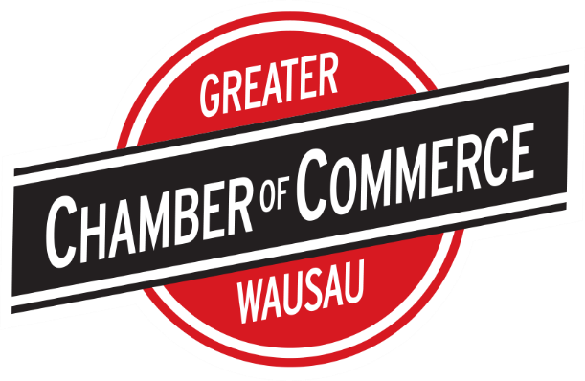

Top of Form

Bottom of Form

**Greater Wausau Chamber of Commerce - Affinity Program Guidelines**

The Greater Wausau Chamber of Commerce is committed in providing its member with an Affinity Program, aimed to not only “Buy Local”, but also helping members save money whenever possible in our fluctuating economic environment. Chamber membership guarantee access to employer’s direct cost-saving and value-added programs on products and services. We believe that by taking advantage of these programs provides potentially significant added value and benefit for membership in the Chamber and can serve as an important tool in attracting and retaining members in the organization.

To assist in the Chamber’s evaluation of these Affinity Program partners, the Chamber has established the following criteria and guidelines below.

* The Greater Wausau Chamber of Commerce has the right to refuse partnership with any member organization if the proposed product or service does not promote the goals of the Chamber or if the proposed benefits to Chamber members are not deemed adequate.
* Affinity Partner must maintain their Chamber membership in good standing.
* Affinity Programs are designed to be direct cost-saving and or value-added benefits of membership and are to be offered only to Chamber members in good standing.
* The product or service being proposed for affinity program status must provide a cost savings and value-added to the Chamber’s members that would not otherwise be available to Chamber members and other businesses on an individual basis or in the general marketplace.
* Products or services proposed for Affinity Program status must have a relatively broad level of appeal to the Chamber’s membership (approximately 10% of members). Those with a very limited potential appeal to the Chamber’s member employers will not be considered.
* Preference in granting Affinity Program status will be given to providers of those products and services that are not broadly or easily accessed by the business community or where the Chamber’s selection of an affinity program provider could ease what would otherwise be a difficult or complex decision for our individual members.
* Affinity Program offerings should result in some form of non-dues compensation to the Chamber on a basis and level to be agreed upon by the Chamber and the Affinity Program provider.
* All Affinity Programs must be evaluated and recommended by Chamber management staff. All affinity programs, once approved by staff, are administered by staff.
* Affinity Programs will be announced by the Chamber by providing lists of Affinity Programs and their offerings to all current, new and prospective Chamber members. Such Affinity Program lists will also be promoted on the Chamber’s web site and periodically included in the Chamber’s newsletter.
* Affinity Partners provide the Chamber with their marketing collateral. The Chamber will market the Affinity Program via its website, at programs, through emails to member and other marketing vehicles.
* At the start of the Affinity Program, the Affinity Partner will be provided with a full membership list including company names, contact names and phone numbers (no e-mails). New member additions are featured on the web site each month. If the partner questions the status of a member organization, they can enter their name on the Chamber web site to validate membership is still in place. They can also contact the Chamber for confirmation.
* Affinity Programs are established for a one-year period. After the initial period, the plan is subject to competitive offers from other members.
* Revenue generated by the plan is remitted to the Chamber on a quarterly basis.
* Each Affinity Program Partner will be expected to meet at least once each year with the Chamber staff to provide an update of their preferred provider activities on behalf of the Chamber.
* Partnerships and agreements are not exclusive and may be canceled at any time.