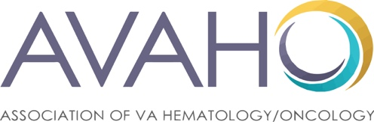

December 12, 2025

Dear AVAHO Partners,

We invite you to participate as an exhibitor at our Lymphoma 2026 Regional Meeting, March 21, 2026, in San Francisco, CA. This event is open to multiple sponsors, and the exhibits will be in a separate room from the CME lectures. Topics for this one-day meeting include: CNS Lymphoma, T-Cell Lymphoma, Diffuse LBCL and Indolent Lymphoma.

AVAHO is the Association of VA Hematology/Oncology, dedicated to improving oncology care for our veterans. AVAHO has been providing educational programs for over 20 years. Our multidisciplinary membership is upward of 1300 now. We anticipate about 60-80 attendees (in-person) for the Lymphoma Regional Meeting ranging from all specialties - physicians, nurses, advanced practice nurses, pharmacists, and other VA healthcare providers.

AVAHO exists to increase the skills and abilities of veteran-centered cancer care professionals across all disciplines so they can provide the best possible care for our veterans. We do this by:
- Offering educational programs to members with the goal of improving the quality of cancer care to Veterans
- Facilitating networking between members to broaden knowledge and best practice
- Exploring and facilitating research across the range of disciplines within the membership

Exhibitor registration will open in mid-December 2025. Space is limited and registrations will be accepted on a first-come/first-serve basis. The exhibit fee for this event is $3,000. It includes the following:
- 6 ft tabletop display with 2 chairs and wastebasket
- 2 registrations to attend the conference
- Acknowledgement of support on website and final program
You may pay by direct deposit, credit card or check. If sending a check, please make check payable to the Association of VA Hematology/Oncology and mail to: 6817 208th Street SW #90, Lynnwood, WA 98046

Please feel free to contact me at 908-581-6110 with any questions. We look forward to seeing you in at the Lymphoma Regional.

Best regards,

JoAnn Wahl

JoAnn Wahl
Director Industry Relations and Partnerships
908-581-6110 joann@avaho.org

