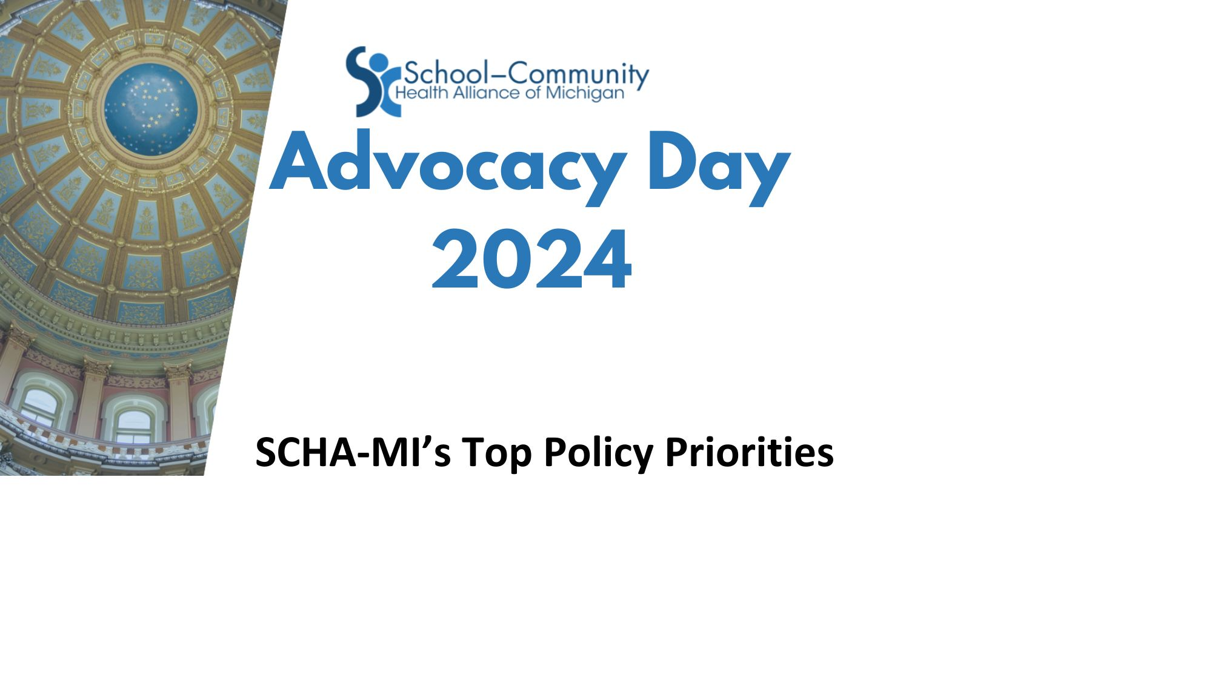

- Preserve funding for Child and Adolescent Health Centers in the FY 2024 Budget:
- Preserve $33 million in 31a of the School Aid Budget for Child and Adolescent Health Centers
- Preserve $14.3 million in line 31n, sub-section 5, of the School Aid Budget for mental health services in schools
- Preserve $1.5 million in the Department of Health and Human Services for Child and Adolescent Health Centers
- Request $25 million in on-going funding for FY25:
  - $15 million for new clinical programs (new Child and Adolescent Health Centers)
  - $ 5 million to expand services at current centers. For example: community health workers, health educators, nutritionist, etc.

- Transfer 31n(5) funding into 31a(7) line item for all funding to be in one location

- Increased location flexibility for providing services to meet both the demand and the realignment of students from virtual to in-person to virtual and to reflect the shift in populations through COVID19

Policy Priorities Supported by SCHA-MI

- The School-Community Health Alliance of Michigan supports numerous policies that improve the health and well-being of youth in Michigan. We believe prioritizing each of these key policies will be beneficial to our centers and their patients:

- Continue to increase mental health services to those children who currently do not have access to such services, including existing sites being able to increase mental health services, with flexibility in programs that meets the needs of the community

- Pursue the sustainability of Community Health Workers through reimbursement for services that currently are not billed

- Increase to telehealth connectivity to support integrated health. Increase training for this modality, including equipment expertise and best practices in telehealth delivery

- Collaborate with other stakeholders to create a strong and robust health care system for Michigan youth

- Expand Medicaid Match to all funding

- Support continuous Medicaid eligibility for children under age 6 as well as changing the redetermination schedule from 12 months to 24 months for kids ages 6-18

