Washington Food Coalition
www.wafoodcoalition.org
PO Box 95752
Seattle, WA 98145
phone: 206.729.0501
fax: 206.729.0504
info@wafoodcoalition.org

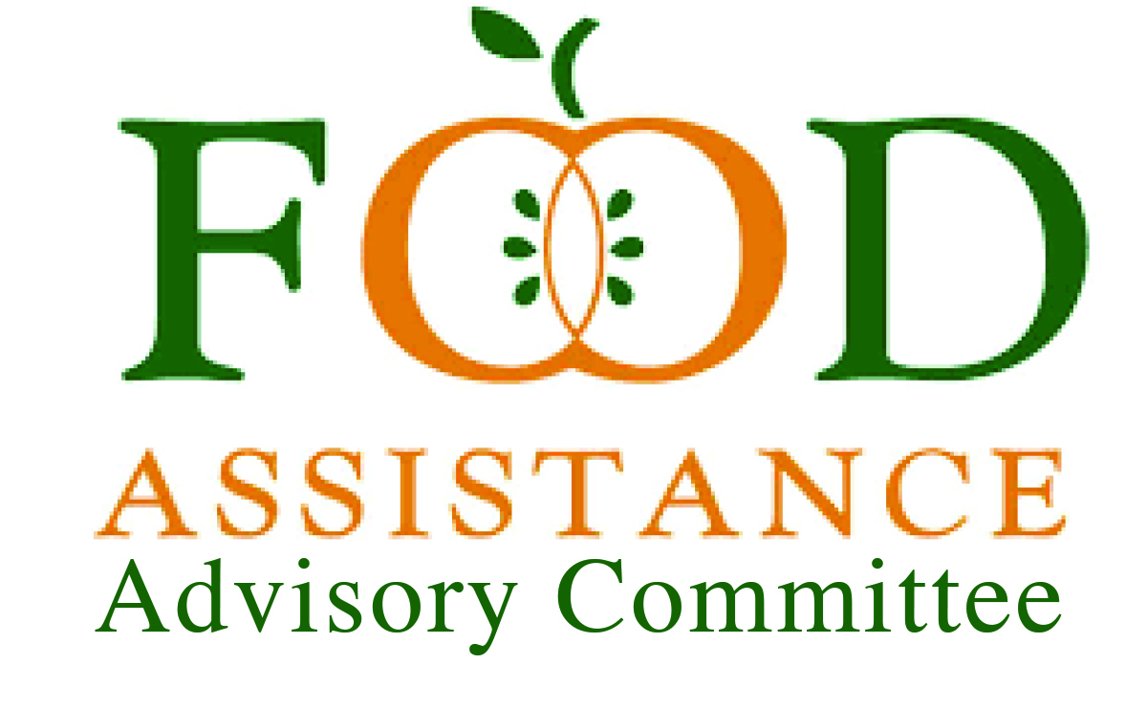

Food Assistance Advisory Committee Mtg
October 23, 2025 1-2:30 PM

AGENDA

Welcome and Get Settled (10 min) – Erik Mora, Chair
- Please share your name, organization, and email in the chat.
- Keep your camera on for the first 15 minutes.
- Approval of June 2025 Minutes

Updates and Feedback from Around the State (15 min)
- This round robin discussion is likely to focus on tracking impacts of the federal shut down

Statewide Food Security Strategy (10 min.) – Aaron Czyzewski, Food Lifeline, Claire Lane, AHNC
- Update on Representative Reeves’s effort to develop a State Strategy for Food Security in Washington
WSDA Updates (15 min) – Kyle Merslich, WSDA FA
- County and Regional Analysis of EFAP Data

Inform WSDA FA Community Engagement Process (35 min.)
- Reflect with WSDA FA on the extent to which community engagement processes should include the following:
  - Serve all
  - Pass through to sub agencies
  - Process to add new organizations

Good of the Order (5 min.)

