The current capacity of the two GDVS homes is **486 beds,** yet only **54% or 262 beds** are fully funded by the state and occupied by veteran patients.

VA will provide State Home Per Diem (SHPD) funding for **1,975 beds** in Georgia. **90% or greater occupancy** is needed to bill and collect full SHPD.

# GDVS requesting **$1.5M** for increased costs in healthcare.

Formula funding **of-5% increase**

**per year** to match healthcare increases.

Georgia War Veterans Nursing Home Augusta

-

•

*I* ◄

*I*

*I*

/ **Milledgeville Subacute**

**Therapy Unit**

73 bed unit designed to provide **skilled nursing and mental/behavioral health treatment.** Currently vacant, this unit can be operational within ***6* months.**

# Requesting **$1M** in startup funds.

GWVH-Milledgeville Funded Beds

**$98/250**

**$144/136**

**$184** VA Funding Funded beds

14 15 16 17 18 19 20 21 22 23 24 25 26 27 28 29 30

**Fiscal Year**

State appropriations have **not** increased in **more than 10 years.** The state must provide **>50%** of funding to receive VA funds. Without being at capacity we **lost $8.3M** in matching federal funds.

A 2022 Senate Study Committee indicated a

need for 1,500 more beds across the state. GWVNH-Augusta is operating at **64%** capacity. GWVH-Milledgeville is operating at **48o/o.**

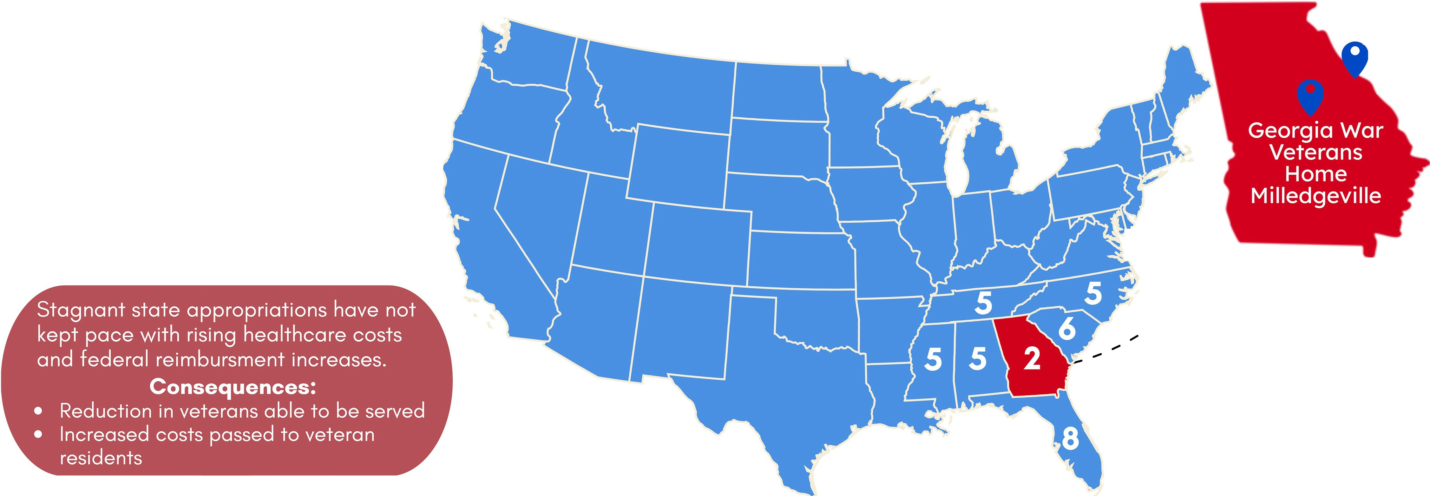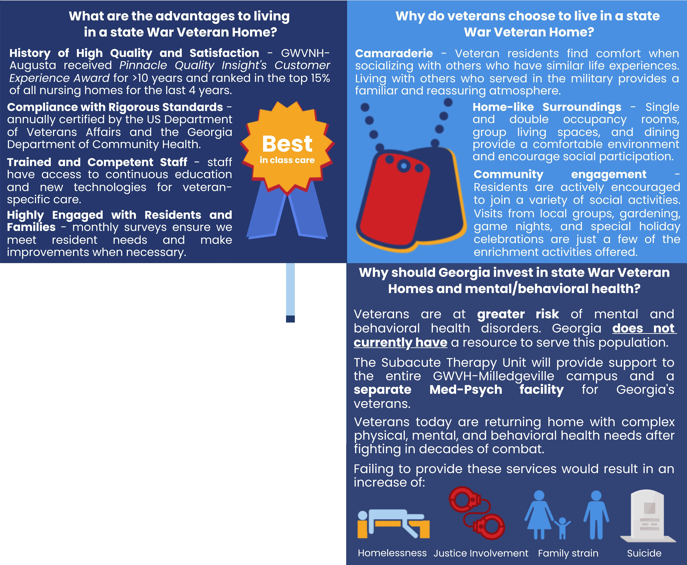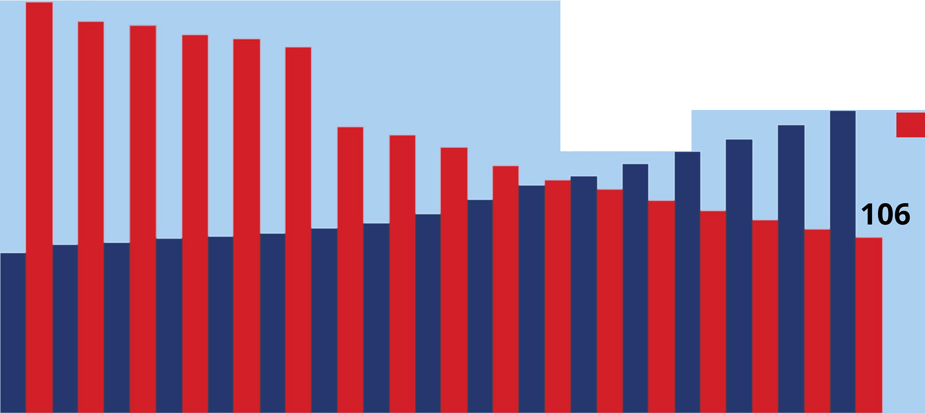

Both homes maintain waiting lists without marketing the facilities.

Only meeting **13%** of obligation for care