EEA Plaque Template Instructions

- Templates are on pages 2 & 3, edit the magenta highlighted text.
- Plaques can include any combination of Firm Names and / or Client Names (multiple clients or members of the project team can be added). Edit the templates below as you want your plaques to read.
- We will reach out to you with proposed edits if your text below exceeds available space.
- 2 Plaques are included in your EEA entry, additional plaques are available for $125.
- Once you have finished editing the template, please save the document with a new file name including your firm name. If you entered multiple projects, please add a short version of the project name when you save this file.
- When finished, please upload your template through this form - https://form.jotform.com/252945279870168
- Pictures of past Honor and Grand plaques below for reference.

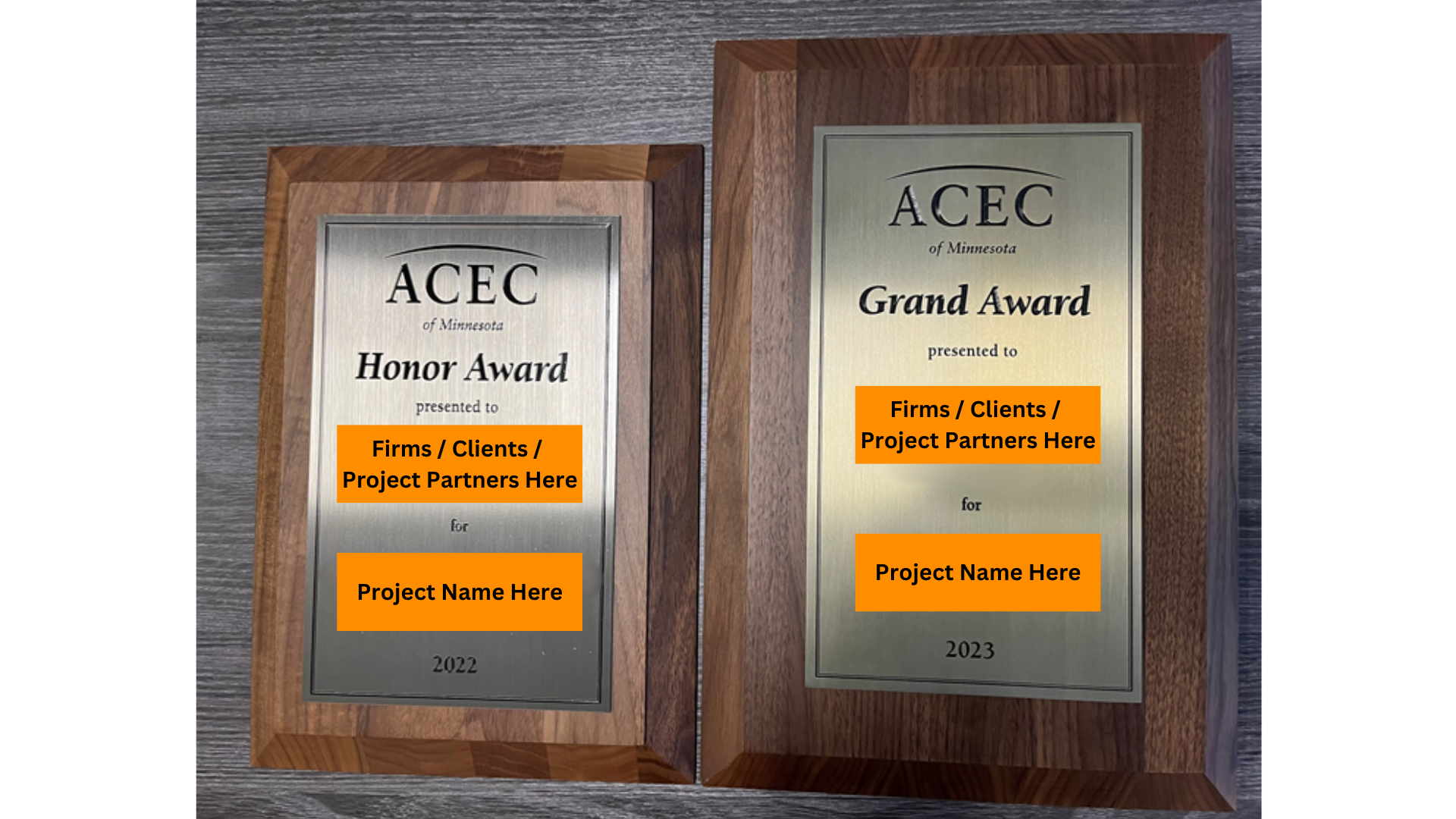

Plaque #1 (included with your entry)

Grand / Honor Award (based on your project results)

presented to

Engineering Firm (edit this line)

for

Project Name (edit this line)
Location (edit this line)

2026

(Reminder: please edit the “presented to” section to include all firms / clients you want to appear on the plaque.)

Plaque #2 (included with your entry)

Grand / Honor Award (based on your project results)

presented to

Client (edit this line)
Engineering Firm (edit this line)

for

Project Name (edit this line)
Location (edit this line)

2026

(Reminder: edit the “presented to” section to include all firms / clients / partners you want to appear on the plaque.)

Plaque #3 (additional $125 cost)

Grand / Honor Award (based on your project results)

presented to

Engineering Firm (edit this line)

for

Project Name (edit this line)
Location (edit this line)

2026

(Reminder: please edit the “presented to” section to include all firms / clients you want to appear on the plaque.)

Plaque #4 (additional $125 cost)

Grand / Honor Award (based on your project results)

presented to

Client (edit this line)
Engineering Firm (edit this line)

for

Project Name (edit this line)
Location (edit this line)

2026

(Reminder: please edit the “presented to” section to include all firms / clients you want to appear on the plaque.)

To order additional plaques, please copy and paste page 2 and edit plaque numbers to reflect the amount you are ordering.

