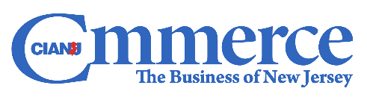

**Anthony Russo**

**President - Commerce and Industry Association of New Jersey**

**CEO/Publisher- COMMERCE Magazine**

Anthony Russo is president of the Commerce and Industry Association of New Jersey (CIANJ), a business association representing the interests of more than 900 companies. In this capacity, Mr. Russo is responsible for all aspects of the association. Mr. Russo is also the CEO and publisher of COMMERCE Magazine. COMMERCE magazine is a business to business magazine with a readership of more than 40,000 professionals.

Prior to his current position, Mr. Russo served as Executive Vice President of Government Affairs and Communications for CIANJ as well as Deputy Executive Director of the National Lime Association in Washington, DC representing the interests of mining companies producing calcium oxide (aka lime) at the federal level.

Mr. Russo started his career at the New Jersey Department of Environmental Protection as a senior engineer issuing water quality permits. He then spent 5 years as an environmental consultant working for two firms, GES and ERM. He began his government affairs career when he served as Director of Regulatory and Legislative Affairs for the Chemistry Council of NJ, representing chemical and pharmaceutical companies in Trenton on legislative and environmental matters.

Mr. Russo is a graduate of the New Jersey Institute of Technology (NJIT) with a degree in mechanical engineering.