Paragon Update: 9/9/2025
The latest Paragon update introduces system enhancements that create a designated space to manage and display floor plans within each listing.

Upload and Manage Floor Plans
To add floor plans to your listings in Paragon Connect, start by uploading one or more files as a PDF or in other standard image formats. Then, choose whether each file is to be public or private by selecting or deselecting the appropriate check box.
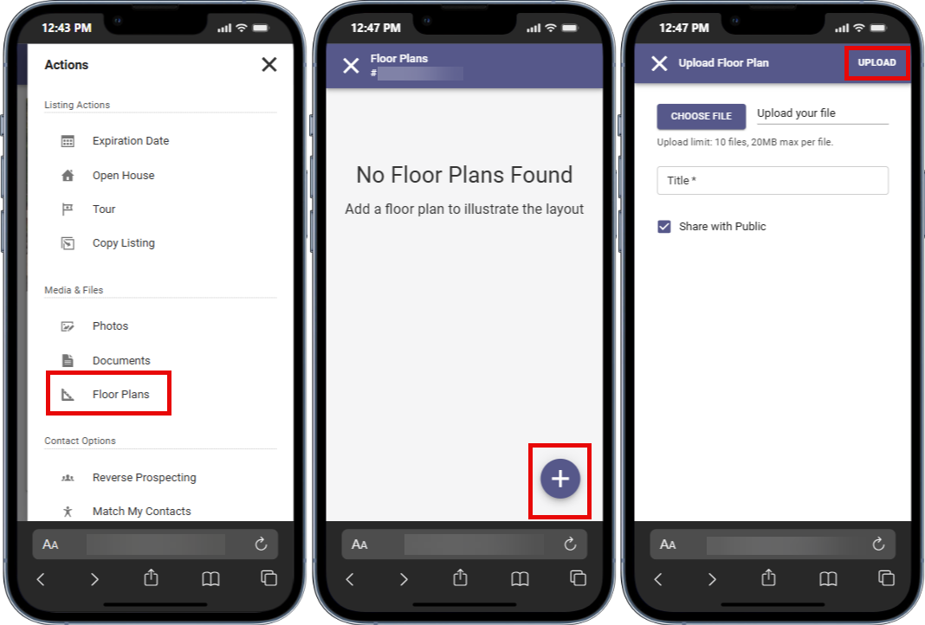

View Floor Plans
Floor plans can be viewed alongside other listing media in the Media Gallery, available in both Paragon Connect and the Collaboration Center.
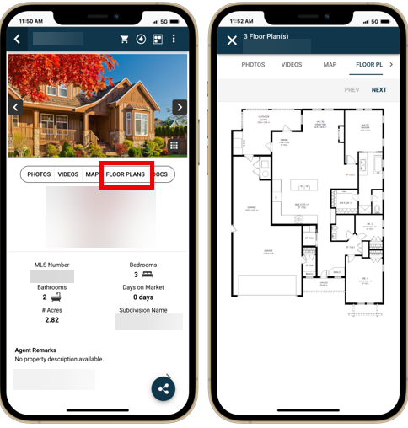

How to Add Floor Plans in Paragon Pro
Click the Add/Edit Floor Plans button on the left panel of the Listing Input & Maintenance (LIM) form, which will bring up a page to help manage your floor plans. Select the Add New button to add your floor plan details and upload your image, which must be no more than 20 MB in size. 